AI BASED MAZE NAVIGATION AND PATHFINDING SYSTEM
A PROJECT REPORT

Submitted by

ALAGAPPAN R (2116241901003)
ASWIN J (2116241901010)

in partial fulfillment for the award of the degree
of

BACHELOR OF ENGINEERING
in
COMPUTER SCIENCE AND ENGINEERING (CYBER SECURITY)

RAJALAKSHMI ENGINEERING COLLEGE
An Autonomous Institute
CHENNAI

NOVEMBER 2026

RAJALAKSHMI ENGINEERING COLLEGE
CHENNAI

BONAFIDE CERTIFICATE

Certified that this project report “AI BASED MAZE NAVIGATION AND PATHFINDING SYSTEM” is the bonafide work of “ALAGAPPAN R (2116241901003), ASWIN J (2116241901010)” who carried out the project work under my supervision.

SIGNATURE
Dr. Bhuvana S, Ph.D.,
ASSISTANT PROFESSOR(SG)
Department of Computer Science and Engineering (Cyber Security)
Rajalakshmi Engineering College
Chennai – 602 105

Submitted to Project Viva-Voce Examination held on
SIGNATURE OF THE INTERNAL EXAMINER
ABSTRACT

AI Based Maze Navigation and Pathfinding System is an artificial intelligence system that finds the least-cost route through a grid maze and guides an agent along it when the maze changes after the route has been planned. Each free cell is a state, the four moves are actions and every move has a cost, so ordinary floor and rough terrain are distinguished. Breadth-First Search, Depth-First Search, Dijkstra’s algorithm, Greedy Best-First Search and A* are implemented on the same maze model and compared on nodes expanded, path cost and time. For navigation, the agent follows its A* plan, senses the walls within a sensing range, records walls it did not expect in a belief map and re-plans with A* from where it stands. A Pygame interface animates the exploration, the path and the route the agent drives. On 400 generated mazes A* always returned an optimal path and expanded up to 87 % fewer cells than Breadth-First Search, while Greedy and Depth-First Search returned costlier paths. When walls appeared after planning, a fixed plan failed in 66 of 80 runs, whereas re-planning A* reached the goal in all 80 at a mean of 12–23 % above the optimal cost of the changed maze. A wider sensing range shortened the detours: with four new walls on 31 × 31 mazes, raising the range from one cell to five cut the mean extra cost from 31 % to 16 %. Maze files are treated as untrusted input: they are size-limited, parsed with an allow-list, validated and protected by a SHA-256 integrity digest.
ACKNOWLEDGEMENT

First and foremost, we thank Almighty God for enabling us to complete this project successfully. We express our sincere gratitude to our Chairman, Mr. S. Meganathan, B.E., F.I.E., for his dedicated efforts in providing quality education at this esteemed institution. We are deeply grateful to our beloved Chairperson, Dr. Thangam Meganathan, Ph.D., for her constant motivation and encouragement, which inspired us throughout the completion of this project. We also thank our Vice Chairman, Mr. Abhay Shankar Meganathan, B.E., M.S., for providing the necessary infrastructure and facilities.
We express our sincere gratitude to our College Principal, Dr. S. N. Murugesan, M.E., Ph.D., and Dr. P. Tamilselvi, Ph.D., Professor and Head, Department of Computer Science and Engineering (Cyber Security), for their support and encouragement.
We are especially thankful to our project guide, Dr. Bhuvana S., Ph.D., Assistant Professor(SG), for her valuable guidance, continuous encouragement, and support throughout the project. Finally, we thank our parents and friends for their direct and indirect contributions, encouragement, and support in the successful completion of this project.

ALAGAPPAN R (2116241901003)
ASWIN J (2116241901010)
TABLE OF CONTENTS
CHAPTER NO. | TITLE | PAGE NO.
 | ABSTRACT | iii
 | LIST OF TABLES | viii
 | LIST OF FIGURES | ix
1 | INTRODUCTION | 1
 | 1.1 BACKGROUND | 1
 | 1.2 PROBLEM STATEMENT | 3
 | 1.3 OBJECTIVES | 4
 | 1.4 SCOPE | 4
 | 1.4.1 IN SCOPE | 4
 | 1.4.2 OUT OF SCOPE | 5
 | 1.5 SECURITY REQUIREMENTS / SECURITY CONSIDERATIONS | 5
 | 1.6 SDG ALIGNMENT | 6
2 | LITERATURE REVIEW | 7
 | 2.1 EXISTING SYSTEM WITH SECURITY APPROACHES | 7
 | 2.1.1 FOUNDATIONAL RESEARCH | 7
 | 2.1.2 EXISTING SYSTEMS | 8
 | 2.1.3 SECURITY APPROACHES IN EXISTING SYSTEMS | 8
 | 2.1.4 LIMITATIONS OF EXISTING SYSTEMS | 9
 | 2.2 RESEARCH GAPS | 10
 | 2.3 PROPOSED SYSTEM | 10
 | 2.3.1 OVERVIEW OF THE PROPOSED SYSTEM | 10
 | 2.3.2 OBJECTIVES OF THE PROPOSED SYSTEM | 12
 | 2.3.3 ADVANTAGES OF THE PROPOSED SYSTEM | 12
3 | SYSTEM DESIGN | 14
 | 3.1 SYSTEM ARCHITECTURE | 14
 | 3.2 MODULE DESIGN | 16
 | 3.2.1 MAZE ENVIRONMENT AND REPRESENTATION | 16
 | 3.2.2 SEARCH ALGORITHMS | 17
 | 3.2.3 DYNAMIC NAVIGATION AND RE-PLANNING | 19
 | 3.2.4 VISUALISATION AND USER INTERFACE | 20
 | 3.2.5 PERFORMANCE ANALYSIS AND TESTING | 21
 | 3.2.6 SECURE FILE HANDLING | 22
 | 3.3 DATA FLOW/UML DIAGRAMS | 23
 | 3.3.1 DATA FLOW DIAGRAMS | 24
 | 3.3.2 USE CASE DIAGRAM | 26
 | 3.3.3 ACTIVITY DIAGRAM | 27
 | 3.3.4 SEQUENCE DIAGRAM | 28
 | 3.4 THREAT MODEL AND ATTACK SURFACE | 29
 | 3.5 SECURITY CONTROLS | 31
4 | SYSTEM DESCRIPTION | 33
 | 4.1 DATA COLLECTION | 33
 | 4.2 DATA PREPROCESSING | 34
 | 4.2.1 ALGORITHMS / METHODOLOGY | 35
 | 4.2.1.1 PSEUDO-CODE OF THE ALGORITHMS | 35
 | 4.2.1.2 COMPLEXITY | 37
 | 4.2.1.3 EXPERIMENTAL METHODOLOGY | 37
 | 4.2.2 RESULTS AND DISCUSSION | 38
 | 4.2.2.1 CORRECTNESS | 38
 | 4.2.2.2 SEARCH ALGORITHM COMPARISON | 38
 | 4.2.2.3 HEURISTIC COMPARISON | 41
 | 4.2.2.4 NAVIGATION IN DYNAMIC MAZES | 42
 | 4.2.2.5 SENSING RANGE AND NUMBER OF NEW WALLS | 43
 | 4.2.2.6 WORKING PROTOTYPE | 44
 | 4.2.2.7 LIMITATIONS OBSERVED | 48
5 | CONCLUSION | 49
 | 5.1 SUMMARY OF THE WORK | 49
 | 5.2 FUTURE WORK | 49
 | REFERENCES | 51
 | APPENDIX | 53
 | A.1 EXPERIMENT PARAMETERS | 53
 | A.2 DETAILED EXPERIMENTAL RESULTS | 53
 | A.3 REPOSITORY STRUCTURE | 57
 | A.4 SOURCE CODE – BEST-FIRST SEARCH AND A* (search.py) | 58
 | A.5 SOURCE CODE – SENSING AND RE-PLANNING A* (dynamic.py) | 59
 | A.6 SOURCE CODE – VALIDATED MAZE LOADER AND DIGESTS (maze.py) | 60
 | A.7 SOURCE CODE – CHANGING THE MAZE AND THE FIXED PLAN (dynamic.py) | 62
 | A.8 REPRODUCING THE RESULTS | 63
LIST OF TABLES
TABLE NO. | TITLE | PAGE NO.
1.1 | TASK ENVIRONMENT PROPERTIES OF THE MAZE PROBLEM | 1
1.2 | SECURITY REQUIREMENTS | 6
1.3 | SDG ALIGNMENT | 6
2.1 | COMPARISON OF EXISTING SYSTEMS | 9
3.1 | HARDWARE REQUIREMENTS | 15
3.2 | SOFTWARE REQUIREMENTS | 15
3.3 | MODULE-TO-FILE MAPPING | 16
3.4 | STRIDE THREAT ANALYSIS | 30
3.5 | SECURITY CONTROLS | 32
4.1 | MAZE FAMILIES USED IN THE EXPERIMENTS | 33
4.2 | SEARCH PROBLEM AND NAVIGATION MODEL | 34
4.3 | SEARCH ALGORITHMS ON 61 × 61 MAZES (MEAN OF 20 MAZES) | 38
4.4 | A* WITH THREE HEURISTICS ON 61 × 61 MAZES (MEAN OF 20 MAZES) | 41
4.5 | FIXED PLAN AND RE-PLANNING A* IN DYNAMIC MAZES (20 MAZES PER SCENARIO, SENSING RANGE 1) | 42
4.6 | RE-PLANNING A* BY NUMBER OF NEW WALLS AND SENSING RANGE R (31 × 31, 20 MAZES PER CELL) | 43
A.1 | PARAMETERS USED IN THE EXPERIMENTS | 53
A.2 | AUTOMATED TEST SUITE (24 TESTS, ALL PASSING) | 54
A.3 | NODES EXPANDED FOR EVERY MAZE FAMILY AND SIZE (MEAN OF 20 MAZES) | 55
A.4 | PATH COST RELATIVE TO THE OPTIMUM (COST ÷ OPTIMAL, MEAN OF 20 MAZES) | 55
A.5 | SEARCH TIME IN MILLISECONDS (MEAN OF 20 MAZES) | 56
A.6 | DYNAMIC SCENARIOS IN DETAIL (E3, MEAN OF 20 MAZES) | 57
A.7 | SENSING STUDY IN DETAIL (E4, 31 × 31, 20 MAZES PER ROW) | 57
A.8 | REPOSITORY STRUCTURE | 57
LIST OF FIGURES
FIGURE NO. | TITLE | PAGE NO.
1.1 | MAZE AS A STATE-SPACE SEARCH PROBLEM | 2
2.1 | TYPICAL FLOW OF A BASIC MAZE SOLVER | 8
2.2 | FLOW OF THE PROPOSED SYSTEM | 11
3.1 | SYSTEM ARCHITECTURE | 14
3.2 | LEVEL-2 DFD OF MODULE 1 – MAZE ENVIRONMENT AND REPRESENTATION | 17
3.3 | LEVEL-2 DFD OF MODULE 2 – SEARCH ALGORITHMS | 18
3.4 | LEVEL-2 DFD OF MODULE 3 – DYNAMIC NAVIGATION AND RE-PLANNING | 19
3.5 | LEVEL-2 DFD OF MODULE 4 – VISUALISATION AND USER INTERFACE | 21
3.6 | LEVEL-2 DFD OF MODULE 5 – PERFORMANCE ANALYSIS AND TESTING | 22
3.7 | LEVEL-2 DFD OF MODULE 6 – SECURE FILE HANDLING | 23
3.8 | DATA FLOW DIAGRAM – LEVEL 0 (CONTEXT DIAGRAM) | 24
3.9 | DATA FLOW DIAGRAM – LEVEL 1 | 25
3.10 | USE CASE DIAGRAM | 26
3.11 | ACTIVITY DIAGRAM | 27
3.12 | SEQUENCE DIAGRAM | 29
3.13 | ATTACK SURFACE AND TRUST BOUNDARIES | 31
4.1 | NODES EXPANDED BY MAZE SIZE AND TYPE (MEAN OF 20 MAZES) | 39
4.2 | PATH COST RELATIVE TO THE OPTIMAL COST ON 61 × 61 MAZES | 40
4.3 | SEARCH TIME BY MAZE SIZE ON OPEN-FIELD MAZES | 41
4.4 | NODES EXPANDED BY A* WITH THREE HEURISTICS | 42
4.5 | FIXED PLAN AND RE-PLANNING A* AFTER THE MAZE CHANGES | 43
4.6 | DETOUR COST AND RE-PLANNING EFFORT BY SENSING RANGE | 44
4.7 | PROTOTYPE – A* ON A WEIGHTED 31 × 31 MAZE | 45
4.8 | PROTOTYPE – BREADTH-FIRST SEARCH PART-WAY THROUGH | 46
4.9 | PROTOTYPE – FOUR ALGORITHMS ON THE SAME MAZE | 46
4.10 | PROTOTYPE – RE-PLANNING A* AFTER ONE NEW WALL | 47
4.11 | PROTOTYPE – THREE NEW WALLS, SENSING RANGE 1 | 47
4.12 | PROTOTYPE – THREE NEW WALLS, SENSING RANGE 5 | 48

CHAPTER 1

INTRODUCTION

1.1 BACKGROUND
Finding a route through a maze is one of the oldest problems in computing and a natural test bed for artificial intelligence; Moore’s 1959 paper on breadth-first search was titled “The shortest path through a maze” [1]. The same question — how an agent should get from where it is to where it wants to be at the lowest cost — appears in robot navigation, warehouse logistics, route guidance and the movement of characters in computer games. Search algorithms answer it by planning a route over a map before the agent moves. Dijkstra’s algorithm [2] expands cells in order of their cost from the start, and A* [3] adds a heuristic estimate of the remaining distance, so that it looks first at the most promising cells and still returns an optimal path when the heuristic never overestimates [3], [4].
Planning is only half of navigation. A plan is made on a map, and a map can be out of date: a door is closed, a corridor is blocked or an obstacle has been moved since the map was drawn. An agent that follows its plan blindly walks into the new wall and stops. Robot path planners such as D* [5] and D* Lite [6] were developed for exactly this situation: the agent senses its surroundings while it moves, corrects its map and plans again from where it stands. This project studies both halves — pathfinding on a known maze and navigation through a maze that changes after planning — on one maze model.
The task environment of the maze, described with the properties used in standard AI texts [4], is summarised in Table 1.1. It decides which methods apply: because the maze is fully observable, deterministic and static in the basic setting, an offline search such as A* is enough; the dynamic setting, in which walls appear after the route has been planned and the agent can only sense the cells near it, relaxes these assumptions.
Table 1.1 Task Environment Properties of the Maze Problem
Property | Maze navigation | Consequence for the agent
Observability | Fully observable to the planner; a moving agent senses only the cells within its sensing range | A* plans on the whole map; the navigating agent discovers new walls only when it comes close to them
Agents | Single agent | No opponent; the only uncertainty is the maze itself
Determinism | Deterministic: a move succeeds unless a wall blocks it | Each action has one outcome, so a plan can be followed exactly
Episodic or sequential | Sequential | Every move changes the cells that can be reached next
Static or dynamic | Static in the basic setting; dynamic when walls are added after planning | A fixed plan can become invalid; the agent must re-plan
Discrete or continuous | Discrete cells and four actions | The state space can be enumerated and searched exactly
Known or unknown | Known when the route is planned, but possibly out of date while the agent moves | Search uses the map; the navigator corrects the map from what it senses

Figure 1.1 shows the formulation used throughout the project on an 11 × 11 maze. Each free cell is a state, the agent can try to move up, right, down or left, a move into a wall leaves it where it is, and the path cost is the sum of the costs of the cells entered: 1 for ordinary floor and 5 for rough terrain. For navigation the agent also has a percept: the walls within a Manhattan distance r of its cell, its sensing range. A wall that appears after planning is therefore discovered only when the agent comes within r cells of it.
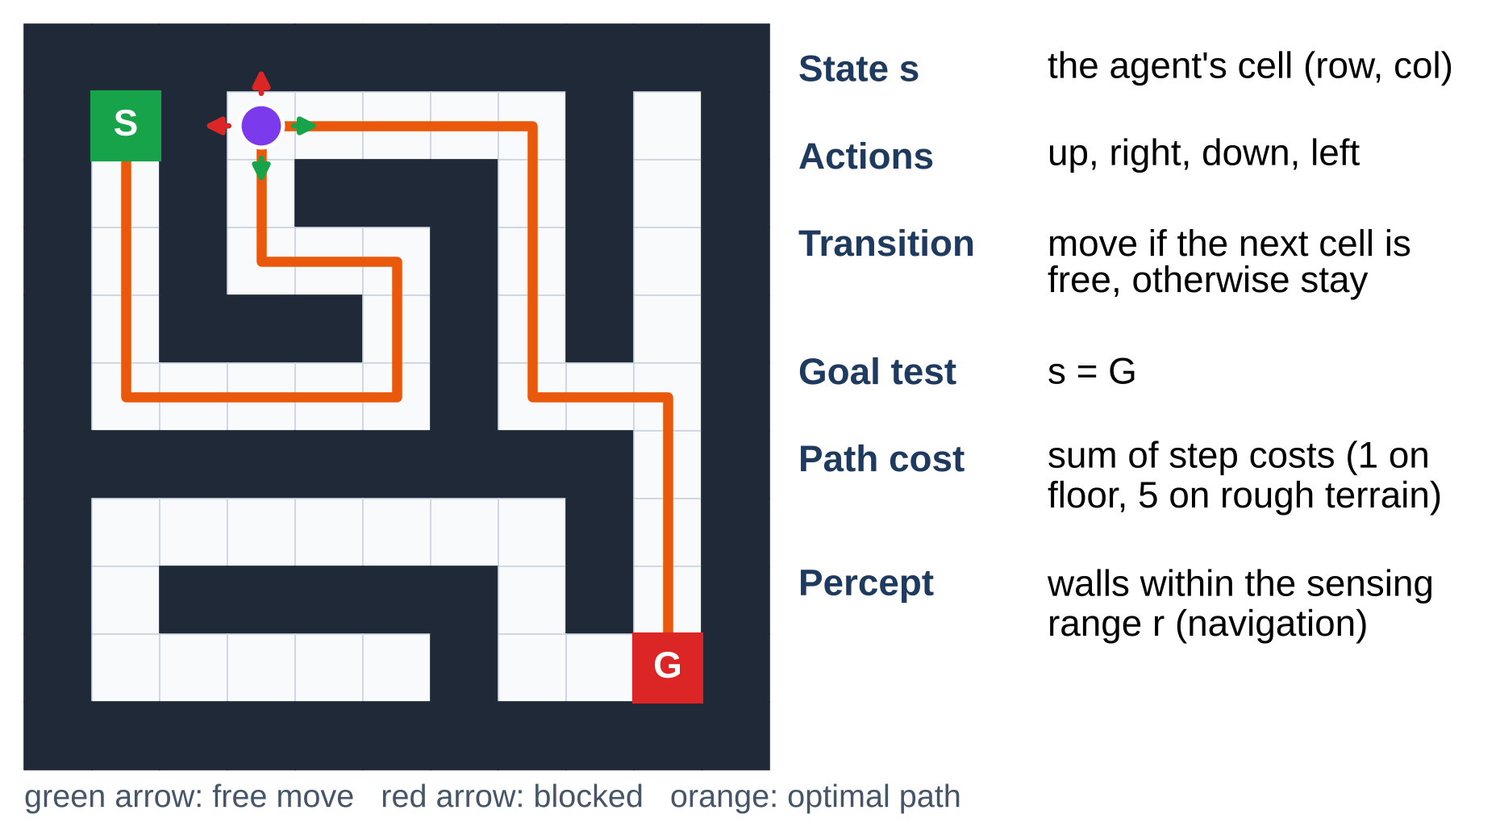
Figure 1.1 Maze as a State-Space Search Problem
The difficulty is scale and change. A 101 × 101 maze has between 5,000 and 7,700 free cells, and an uninformed search may examine nearly all of them before it reaches the goal: Breadth-First Search expanded 99 % of the free cells of a 101 × 101 open field in the experiments of Chapter 4. When the maze changes after planning, a fixed plan fails, and an agent that re-plans pays for the change twice: in extra steps, because it learns of a new wall only when it is near it and may have to walk back, and in extra computation, because every re-plan is another search. The project measures both costs and shows how they depend on the number of new walls and on how far the agent can sense.
Because the project is carried out in a Department of Cyber Security, the software is also treated as a system to be secured. The application reads maze files that may come from other people, and a careless loader can be crashed with an enormous or malformed file, while a maze that has been altered after it was saved — a wall moved in a shared benchmark maze, for example — silently changes every result computed on it. These risks are analysed in Section 3.4 and addressed in the implementation.

1.2 PROBLEM STATEMENT
Classical maze solvers apply one fixed strategy, typically Depth-First or Breadth-First Search, to a maze that is assumed to be fully known and never to change. Such solvers expand many cells that do not lie near the route, ignore the cost of different kinds of terrain and give no measured basis for choosing one algorithm over another. They also compute the path once: if the maze changes after the path has been planned, the agent following it walks into the new wall, and the solver offers no way to continue. How much a re-planning agent loses in such a maze, and how that loss depends on what the agent can sense, is rarely measured.
The problem addressed by this project is therefore: given a grid maze with a start cell, a goal cell and per-cell move costs, find the least-cost path efficiently; guide an agent along that path when walls appear after planning, using only what it can sense on the way; measure every method on the same set of generated mazes; and deliver the system as an interactive, visual tool that handles maze files safely.

1.3 OBJECTIVES
The objectives of the project are:
- To formulate maze navigation as a state-space search problem with states, actions, a transition model, step costs, a goal test and, for the moving agent, a percept limited by a sensing range.
- To implement A* search with an admissible heuristic, together with Breadth-First Search, Depth-First Search, Dijkstra’s algorithm and Greedy Best-First Search as baselines on the same maze model.
- To compare the Manhattan, Euclidean and zero heuristics for A*.
- To build a navigating agent that follows its A* plan, senses the walls within its range, records unexpected walls in a belief map and re-plans from its current cell when its route is blocked, and to compare it with an agent that keeps its fixed plan.
- To measure how the number of new walls and the sensing range affect the success, the detour cost and the re-planning effort of the navigating agent.
- To visualise the maze, the cells explored, the final path and the route the agent drives in a graphical interface.
- To compare the methods on path cost, nodes expanded, run time, success rate, detour cost and re-plans, using generated mazes of several types and sizes with fixed random seeds.
- To treat maze files as untrusted input, protect the application against malformed or oversized files and detect files that were changed after they were saved.

1.4 SCOPE
The scope of the project is set by the course, a team of two and one semester of work. It is divided into the work that is included and the work that is deliberately left out.

1.4.1 IN SCOPE
- Two-dimensional grid mazes with four-way movement, walls, one start, one goal and per-cell costs (floor 1, rough terrain 5).
- Four maze generators — perfect, braided, open-field and weighted — and a validated text format for loading and saving mazes, with a SHA-256 digest stored beside every saved maze.
- Search with Breadth-First Search (BFS), Depth-First Search (DFS), Dijkstra’s algorithm, Greedy Best-First Search and A* with the Manhattan, Euclidean and zero heuristics.
- Dynamic mazes in which cells on the planned route are closed or random walls are added after planning, handled by a fixed plan and by re-planning A* with a sensing range of one or more cells.
- A Pygame interface, an experiment runner with fixed seeds, automated tests, and a threat model with security controls.

1.4.2 OUT OF SCOPE
- Continuous or three-dimensional environments, diagonal and any-angle moves [7], and obstacles that move by their own policy.
- Incremental re-planning algorithms such as D* Lite [6], which reuse the previous search; the agent re-plans with a fresh A* search, and incremental methods are discussed as future work.
- Physical robots, noisy sensors and real map data.
- Several agents sharing one maze [8].
- Network services, user accounts and online storage; the application runs locally and stores nothing about the user.

1.5 SECURITY REQUIREMENTS / SECURITY CONSIDERATIONS
Although the system is an AI artefact, it is delivered as a desktop application that reads files, and it is analysed as such. It has no network service, no accounts and no personal data, which removes whole classes of risk. The remaining concerns are the maze files it reads, which may come from classmates or the internet, the integrity of mazes that are shared as benchmarks, the third-party packages it depends on, and the availability of the application when it is asked to do too much. Table 1.2 lists the security requirements derived from these concerns and their status in the current prototype.
Table 1.2 Security Requirements
No. | Requirement | Description | Status
SR1 | Input validation | Every maze file is checked for size, allowed symbols, rectangular shape, and exactly one start and one goal on free cells before use | Implemented
SR2 | Integrity | A SHA-256 digest is written beside each saved maze and checked on load; a changed file is rejected, and strict mode also rejects a file without a digest | Implemented
SR3 | No code from files | Mazes are plain text read by an allow-list parser; nothing in a file is deserialised, imported or executed | Implemented
SR4 | Availability | Maze size (201 × 201 from a file, 101 × 101 in the interface), the bytes read, the new walls, the sensing range and the steps of a navigation run are capped | Implemented
SR5 | Supply chain | Only three well-known dependencies (NumPy, Pygame, Matplotlib), pinned to exact versions from the official package index | Implemented
SR6 | Reproducibility | Experiments use fixed seeds and keep their raw results, so every figure can be regenerated and checked | Implemented
SR7 | Error handling | A rejected file is reported with a short reason, without a stack trace, and is never used | Implemented

1.6 SDG ALIGNMENT
The project relates to the United Nations Sustainable Development Goals [9] as shown in Table 1.3.
Table 1.3 SDG Alignment
Sustainable Development Goal | Relevance of the project
SDG 4 – Quality Education | An interactive tool that shows, cell by cell, how search algorithms and a re-planning agent behave supports the teaching of artificial intelligence.
SDG 9 – Industry, Innovation and Infrastructure | Path planning and re-planning around blocked routes underpin warehouse robots, automated guided vehicles and logistics.
SDG 11 – Sustainable Cities and Communities | The same methods route vehicles and people efficiently and re-route them around closures.

CHAPTER 2

LITERATURE REVIEW

2.1 EXISTING SYSTEM WITH SECURITY APPROACHES
This section reviews the research on which maze navigation is built, the systems that exist today and the way they handle security, and then sets out their limitations.

2.1.1 FOUNDATIONAL RESEARCH
Moore [1] described breadth-first search as a way of finding the shortest path through a maze: cells are visited in order of their distance in moves from the start, so the first time the goal is reached the path has the fewest moves. Dijkstra [2] generalised this to graphs with non-negative edge costs. His algorithm expands nodes in order of their cost from the start and is optimal, but it explores in every direction equally, so on a grid it examines a disc of cells around the start before it reaches a distant goal. Tarjan [10] analysed depth-first search, which follows one corridor as far as it goes before backtracking; it needs little memory but gives no guarantee about the length of the path it finds.
Hart, Nilsson and Raphael [3] added a heuristic estimate h(n) of the remaining cost and ordered the search by f(n) = g(n) + h(n). They proved that the resulting A* algorithm returns an optimal path whenever h never overestimates, and that no algorithm using the same heuristic information expands fewer nodes. On a four-connected grid the Manhattan distance is such a heuristic. Pearl [11] developed the theory of admissible and consistent heuristics, and Pohl [12] showed that weighting the heuristic more heavily than the path cost trades a bounded loss of optimality for a faster search. Korf [13] showed that iterative deepening gives the optimality of breadth-first search with the memory of depth-first search, a trade-off that matters for very large state spaces but not for the maze sizes studied here.
Planning in environments that change has its own line of work. Stentz’s D* [5] lets a robot that discovers that its map was wrong re-plan efficiently from its current position. Koenig, Likhachev and Furcy’s Lifelong Planning A* [14] and Koenig and Likhachev’s D* Lite [6] reuse the previous search instead of starting again, so a small change costs a small amount of work. Yamauchi [15] proposed frontier-based exploration, in which a robot with limited sensing repeatedly drives to the boundary between known and unknown space. For grids, Harabor and Grastien [16] showed that the many symmetric paths of a uniform-cost grid can be pruned with Jump Point Search, Nash et al. [7] gave Theta* for paths that are not restricted to grid edges, and Sturtevant [17] published the standard grid benchmarks on which such algorithms are compared. Russell and Norvig [4] give the agent framework and the task-environment properties used to describe the problem in Chapter 1.

2.1.2 EXISTING SYSTEMS
Existing maze solvers fall into three groups. Pathfinding visualisers such as PathFinding.js [18] animate A*, Dijkstra’s algorithm, BFS and related algorithms on a grid that the user draws, but they plan on a static, fully known map: if the user adds a wall, the search is simply run again from the start, and nothing is measured beyond what the animation shows. Micromouse robots explore a physical maze with flood-fill algorithms [19], updating their map as they discover walls — a form of navigation with sensing — but the approach is tuned to one competition maze format and is not compared with other planners. Typical course projects implement a single algorithm, usually DFS or BFS, and display the final path. Figure 2.1 shows the typical flow of such a basic solver.
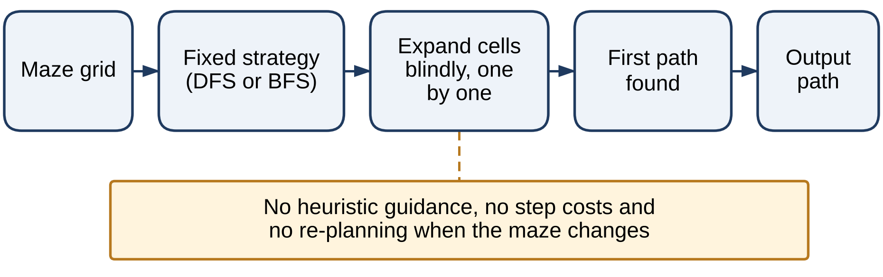
Figure 2.1 Typical Flow of a Basic Maze Solver
The solver applies one fixed strategy, expands cells without guidance from a heuristic, ignores the cost of different kinds of terrain, returns the first path it finds and stops. It does not check the path against the maze while an agent follows it, so it cannot react if the maze changes after the path has been computed.

2.1.3 SECURITY APPROACHES IN EXISTING SYSTEMS
Browser-based visualisers run inside the browser sandbox, read no files and keep no state, so their attack surface is small. Desktop solvers are different, because they load mazes from disk. Maze loaders in course projects rarely check the size or content of a file, so a malformed or very large file can crash the program or exhaust its memory, against the long-standing advice to validate all input with an allow-list before use [20]. Benchmark mazes and maps are shared as plain text files, and none of the systems reviewed checks that a maze is the one that was saved, so a wall moved by mistake or on purpose silently changes every result computed on it. A cryptographic digest such as SHA-256 [21] stored beside the file detects such a change at little cost.
Table 2.1 compares these systems with the proposed system across planning, reaction to change, measurement and the handling of files.
Table 2.1 Comparison of Existing Systems
System | Planning | Handles changes | Measured comparison | File handling
Pathfinding visualisers (e.g. PathFinding.js) | A*, Dijkstra, BFS and others | Search re-run by the user from the start | Visual only | No files (browser sandbox)
Micromouse flood fill | Flood fill on a partly known map | Updates its map while exploring | Run time on one maze | Embedded; not applicable
Typical course project | DFS or BFS | None | None | Unchecked maze files
Proposed system | BFS, DFS, Dijkstra, Greedy, A* with three heuristics | Sensing within range r and re-planning from the current cell | Four measured experiments | Validated files; SHA-256 digest; no code from files

2.1.4 LIMITATIONS OF EXISTING SYSTEMS
- Single strategy: most solvers implement one algorithm and give no basis for choosing between search methods.
- Static assumption: a computed path is not checked against the maze while the agent moves, so a new wall makes the solver fail.
- Unmeasured re-planning: where a search can be repeated after a change, its cost — the detour walked and the extra search effort — is not measured, and the effect of how far the agent can sense is not studied.
- Uniform costs: many solvers count moves only, so they cannot prefer an easy route to a short but difficult one.
- Unsafe files: maze files are loaded without validation, and a file changed after it was saved is not detected.

2.2 RESEARCH GAPS
From the literature and the systems reviewed above, four gaps were identified.
- Search algorithms are rarely compared on the same mazes with costs. Visualisers show the algorithms one at a time on a drawn grid, so few tools measure their effort, path cost and time on the same generated mazes, including mazes with rough terrain.
- Change after planning is rarely tested. The behaviour of a fixed plan and of a re-planning agent when walls appear on the route is seldom measured side by side.
- The role of sensing is not quantified. How the detour paid by a re-planning agent depends on its sensing range and on the number of new walls is not shown in teaching tools.
- Safe handling of maze files is not treated as a requirement in course-level solvers, and their integrity is not checked.
The project addresses these gaps by implementing all the search algorithms on one maze model, extending A* into a navigating agent that senses and re-plans, measuring every method in four controlled experiments that include dynamic mazes and a study of the sensing range, and validating and integrity-checking every file the application reads.

2.3 PROPOSED SYSTEM

2.3.1 OVERVIEW OF THE PROPOSED SYSTEM
The proposed system is a Python application with four main parts — a maze environment, a search engine, a navigator for dynamic mazes and a Pygame interface — supported by a secure file handler, an experiment runner and an automated test suite. Figure 2.2 shows how a maze flows through it.
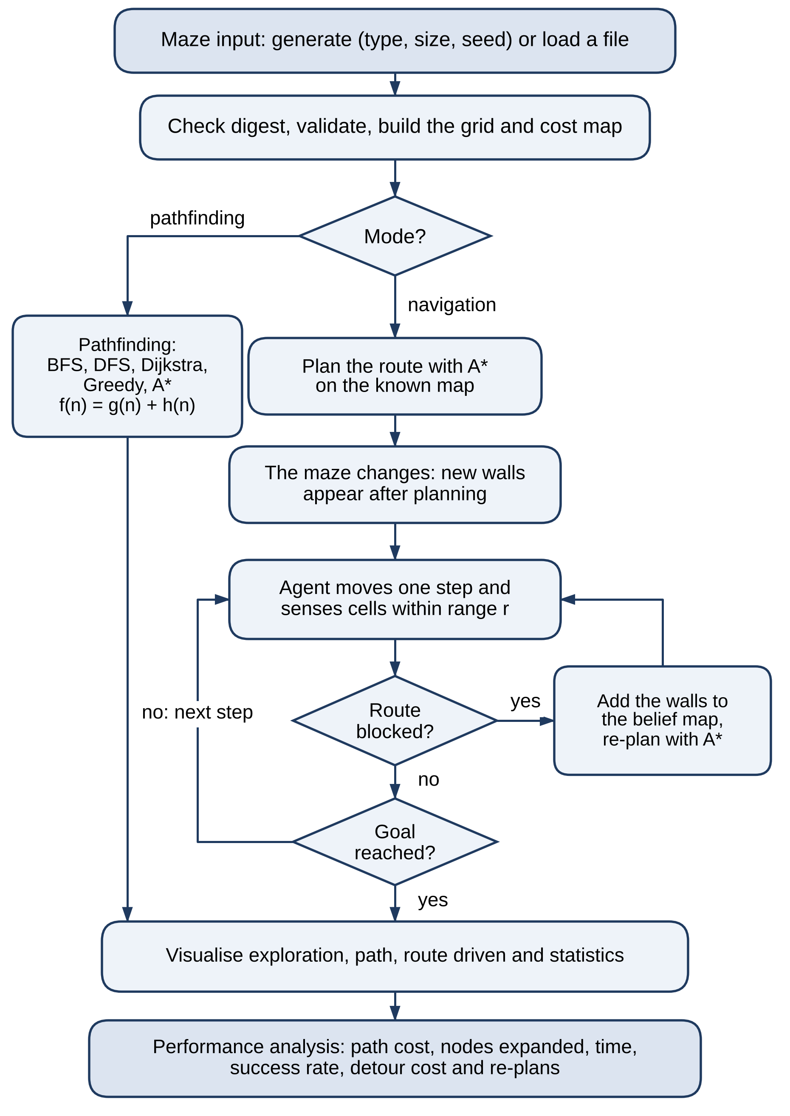
Figure 2.2 Flow of the Proposed System
A maze is generated from a type, size and seed, or loaded from a file whose digest is checked before it is validated and converted into a grid and a cost map. In pathfinding mode one of the five algorithms plans the path on the known map. In navigation mode A* plans the route, and then the maze changes: new walls appear after planning. The agent moves one step at a time and senses the cells within its range r. If a wall it did not expect blocks the rest of its route, it adds the wall to its belief map and re-plans with A* from its current cell; otherwise it keeps moving until it reaches the goal. The interface then shows the exploration, the path or the route driven, and the experiment runner records the path cost, nodes expanded, time, success rate, detour cost and number of re-plans.

2.3.2 OBJECTIVES OF THE PROPOSED SYSTEM
- Return an optimal path on every maze, checked against Dijkstra’s algorithm.
- Expand fewer cells than uninformed search by using an admissible heuristic.
- Reach the goal when walls appear after planning, using only what the agent senses on the way.
- Keep the detour paid for a change small, and show how it depends on the sensing range.
- Make every step visible and every result reproducible.
- Read only validated files, detect files changed after saving, and never execute content taken from a file.

2.3.3 ADVANTAGES OF THE PROPOSED SYSTEM
- Optimal and efficient: A* returned the optimal path in all 400 test mazes and expanded up to 87 % fewer cells than BFS on open fields.
- Cost-aware: on mazes with rough terrain it minimises the total cost rather than the number of moves; BFS paths were about 16 % costlier.
- Robust to change: re-planning A* reached the goal in all 80 dynamic runs, where a fixed plan failed in 66.
- Sensing pays off: with four new walls on 31 × 31 mazes, a sensing range of five cells instead of one cut the mean detour from 31 % to 16 % of the optimal cost.
- Transparent: the interface shows the order of exploration, the path, the original plan and the route driven.
- Secure by design: validated files, SHA-256 integrity digests, no code from files and resource limits.
CHAPTER 3

SYSTEM DESIGN

3.1 SYSTEM ARCHITECTURE
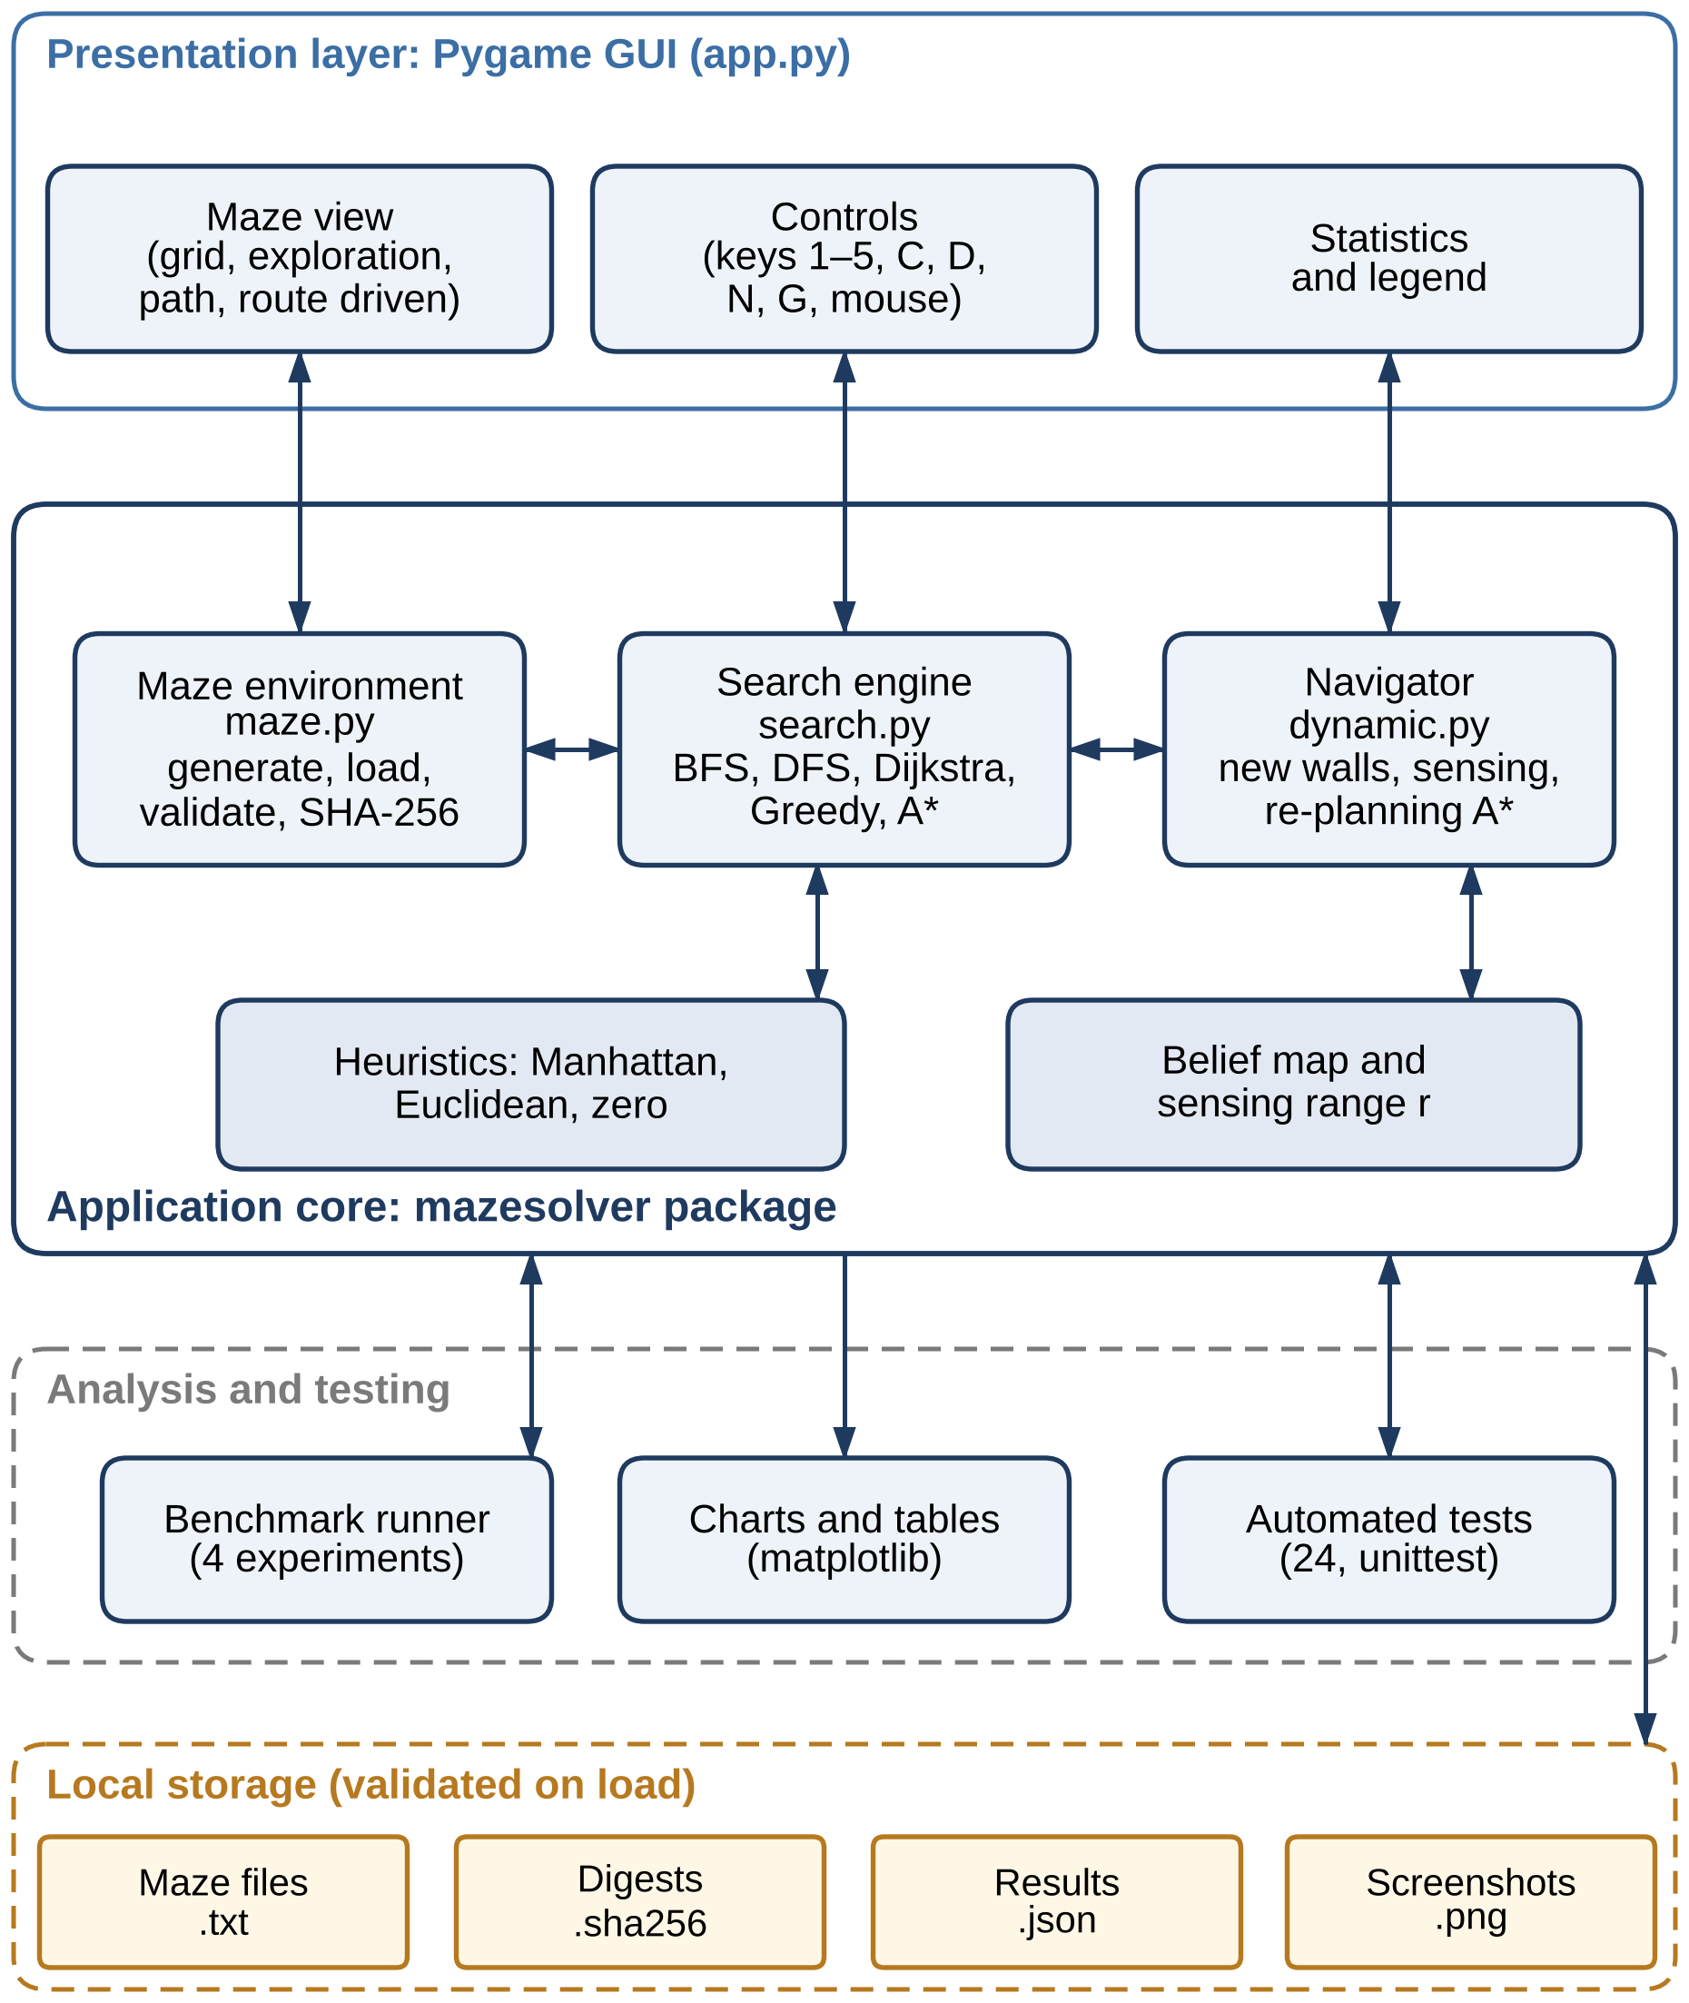
Figure 3.1 System Architecture
Figure 3.1 shows the architecture of the system. It runs entirely on the user’s computer and has four layers. The presentation layer is the Pygame interface, which draws the maze, takes keyboard and mouse input and shows the statistics. The application core is the mazesolver package: the maze environment with its validated loader and integrity digests, the search engine with its heuristics, and the navigator, which keeps a belief map, senses walls within a range r and re-plans with A*. The analysis and testing layer contains the benchmark runner, the chart script and the automated tests, which call the same core as the interface. The local storage layer holds maze files, their SHA-256 digests, raw results and screenshots, and every maze file is checked when it is read.
The design keeps the algorithms independent of the interface, so the experiment runner and the tests exercise exactly the code that the user sees animated. The system is written in Python and uses NumPy [22] for the grid and cost map, Pygame [23] for the interface and Matplotlib [24] for the result charts. The hardware and software requirements are given in Tables 3.1 and 3.2.
Table 3.1 Hardware Requirements
Component | Minimum | Recommended
Processor | Intel Core i3 or equivalent | Intel Core i5 / AMD Ryzen 5 or better
Memory | 4 GB RAM | 8 GB RAM
Storage | 256 GB HDD or SSD (the project needs about 100 MB) | SSD
Display | 1366 × 768 | 1920 × 1080 (the window is 1360 × 860)
Input devices | Keyboard and mouse | Keyboard and mouse

Table 3.2 Software Requirements
Category | Software | Purpose
Operating system | Windows 10/11 or Linux | Runs the application
Language | Python 3.11 or newer (tested on 3.13) | All code; hashlib for SHA-256
Numerical library | NumPy 2.5.3 | Grid and cost-map arrays
Interface | Pygame 2.6.1 | Maze display, animation and input
Charts | Matplotlib 3.11.2 | Result charts for the report
Testing | Python unittest | 24 automated tests
Tools | Visual Studio Code or PyCharm; Git | Development and version control

3.2 MODULE DESIGN
The system is divided into six modules. Table 3.3 maps each module to its source files; each module is then described in turn together with its Level-2 data flow diagram (DFD). The Level-0 and Level-1 diagrams that place the modules in context are given in Section 3.3.1.
Table 3.3 Module-to-File Mapping
No. | Module | Source files
M1 | Maze Environment and Representation | mazesolver/maze.py (model and generators)
M2 | Search Algorithms | mazesolver/search.py
M3 | Dynamic Navigation and Re-planning | mazesolver/dynamic.py
M4 | Visualisation and User Interface | app.py
M5 | Performance Analysis and Testing | bench/run_experiments.py, bench/plot_results.py, tests/test_mazesolver.py
M6 | Secure File Handling | mazesolver/maze.py (from_text, load, save, digest), app.py (--load, --strict)

3.2.1 MAZE ENVIRONMENT AND REPRESENTATION
The maze is a two-dimensional array in which 0 marks a free cell and 1 a wall, with a second array giving the cost of entering each cell (1 for floor and 5 for rough terrain), a start cell and a goal cell. Four generators build test mazes from a size and a seed: a perfect maze with exactly one route between any two cells, made by recursive backtracking; a braided maze, in which 12 % of the removable interior walls are opened to create loops; an open field with 25 % random obstacles; and a weighted maze, a braided maze with 20 % of its removable walls opened in which 30 % of the floor is rough terrain. Mazes can also be edited with the mouse, and saved or loaded through the secure file handler (Module 6) as text in which # is a wall, . floor, ~ rough floor, S the start and G the goal. Every maze, whether generated or loaded, is validated before use.
Figure 3.2 shows the Level-2 DFD of this module. Generated mazes (1.1), edits (1.5) and mazes imported through Module 6 (1.2) all reach the maze grid and cost map (D1). The neighbour function (1.4) serves the search algorithms with the free neighbouring cells of a cell and the cost of entering them. The sensing function (1.3) serves the navigator: given the agent’s cell and its sensing range r, it returns the walls of the true maze within that Manhattan distance.
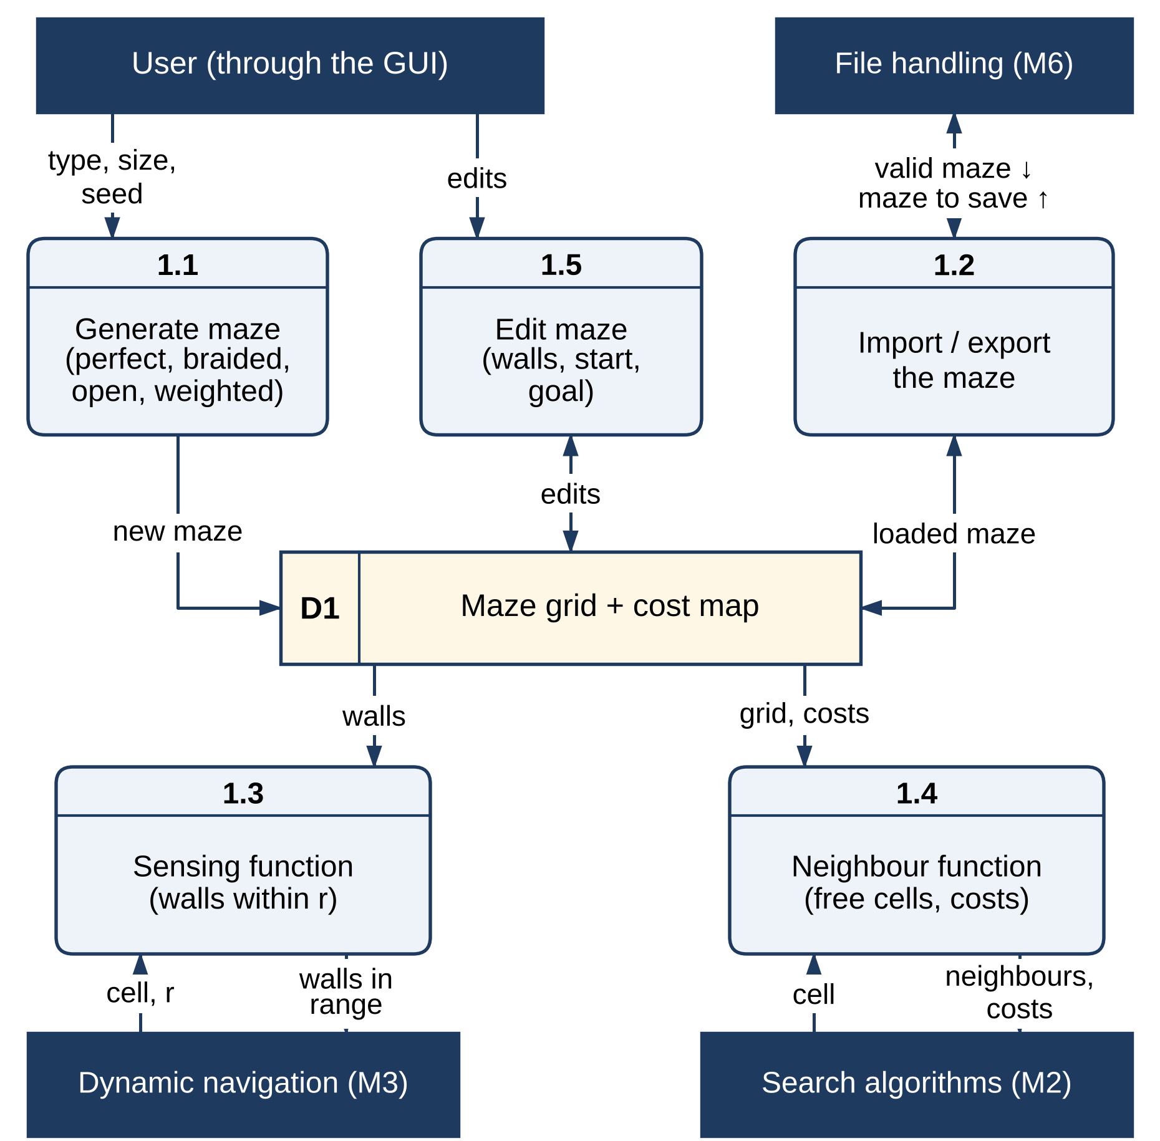
Figure 3.2 Level-2 DFD of Module 1 – Maze Environment and Representation

3.2.2 SEARCH ALGORITHMS
All five algorithms share one interface: they take a maze, a start and a goal, and return the path, its cost, the number of cells expanded and generated, the largest frontier, the order in which cells were expanded and the time taken. BFS uses a first-in first-out queue and DFS a stack. Dijkstra’s algorithm, Greedy Best-First Search and A* are one best-first procedure that orders a priority queue by f(n) = w_{g}·g(n) + w_{h}·h(n), with (w_{g}, w_{h}) equal to (1, 0), (0, 1) and (1, 1) respectively. Ties in f are broken in favour of the larger g, which leads A* along the current corridor instead of widening the search. The heuristic can be the Manhattan distance, the Euclidean distance or zero.
Figure 3.3 shows the flow of a search. The frontier is initialised with the start cell (2.1); the next node is selected by the rule of the algorithm (2.2) and tested against the goal (2.3); if it is not the goal, its free neighbours are expanded and their g values and parents updated (2.4) in the frontier and closed set (D2). When the goal is reached, the path is rebuilt from the parent links and returned with its statistics to the interface and the metrics module (2.5). The same search is called by the navigator, which passes its belief map and current cell instead of the true maze and the start.
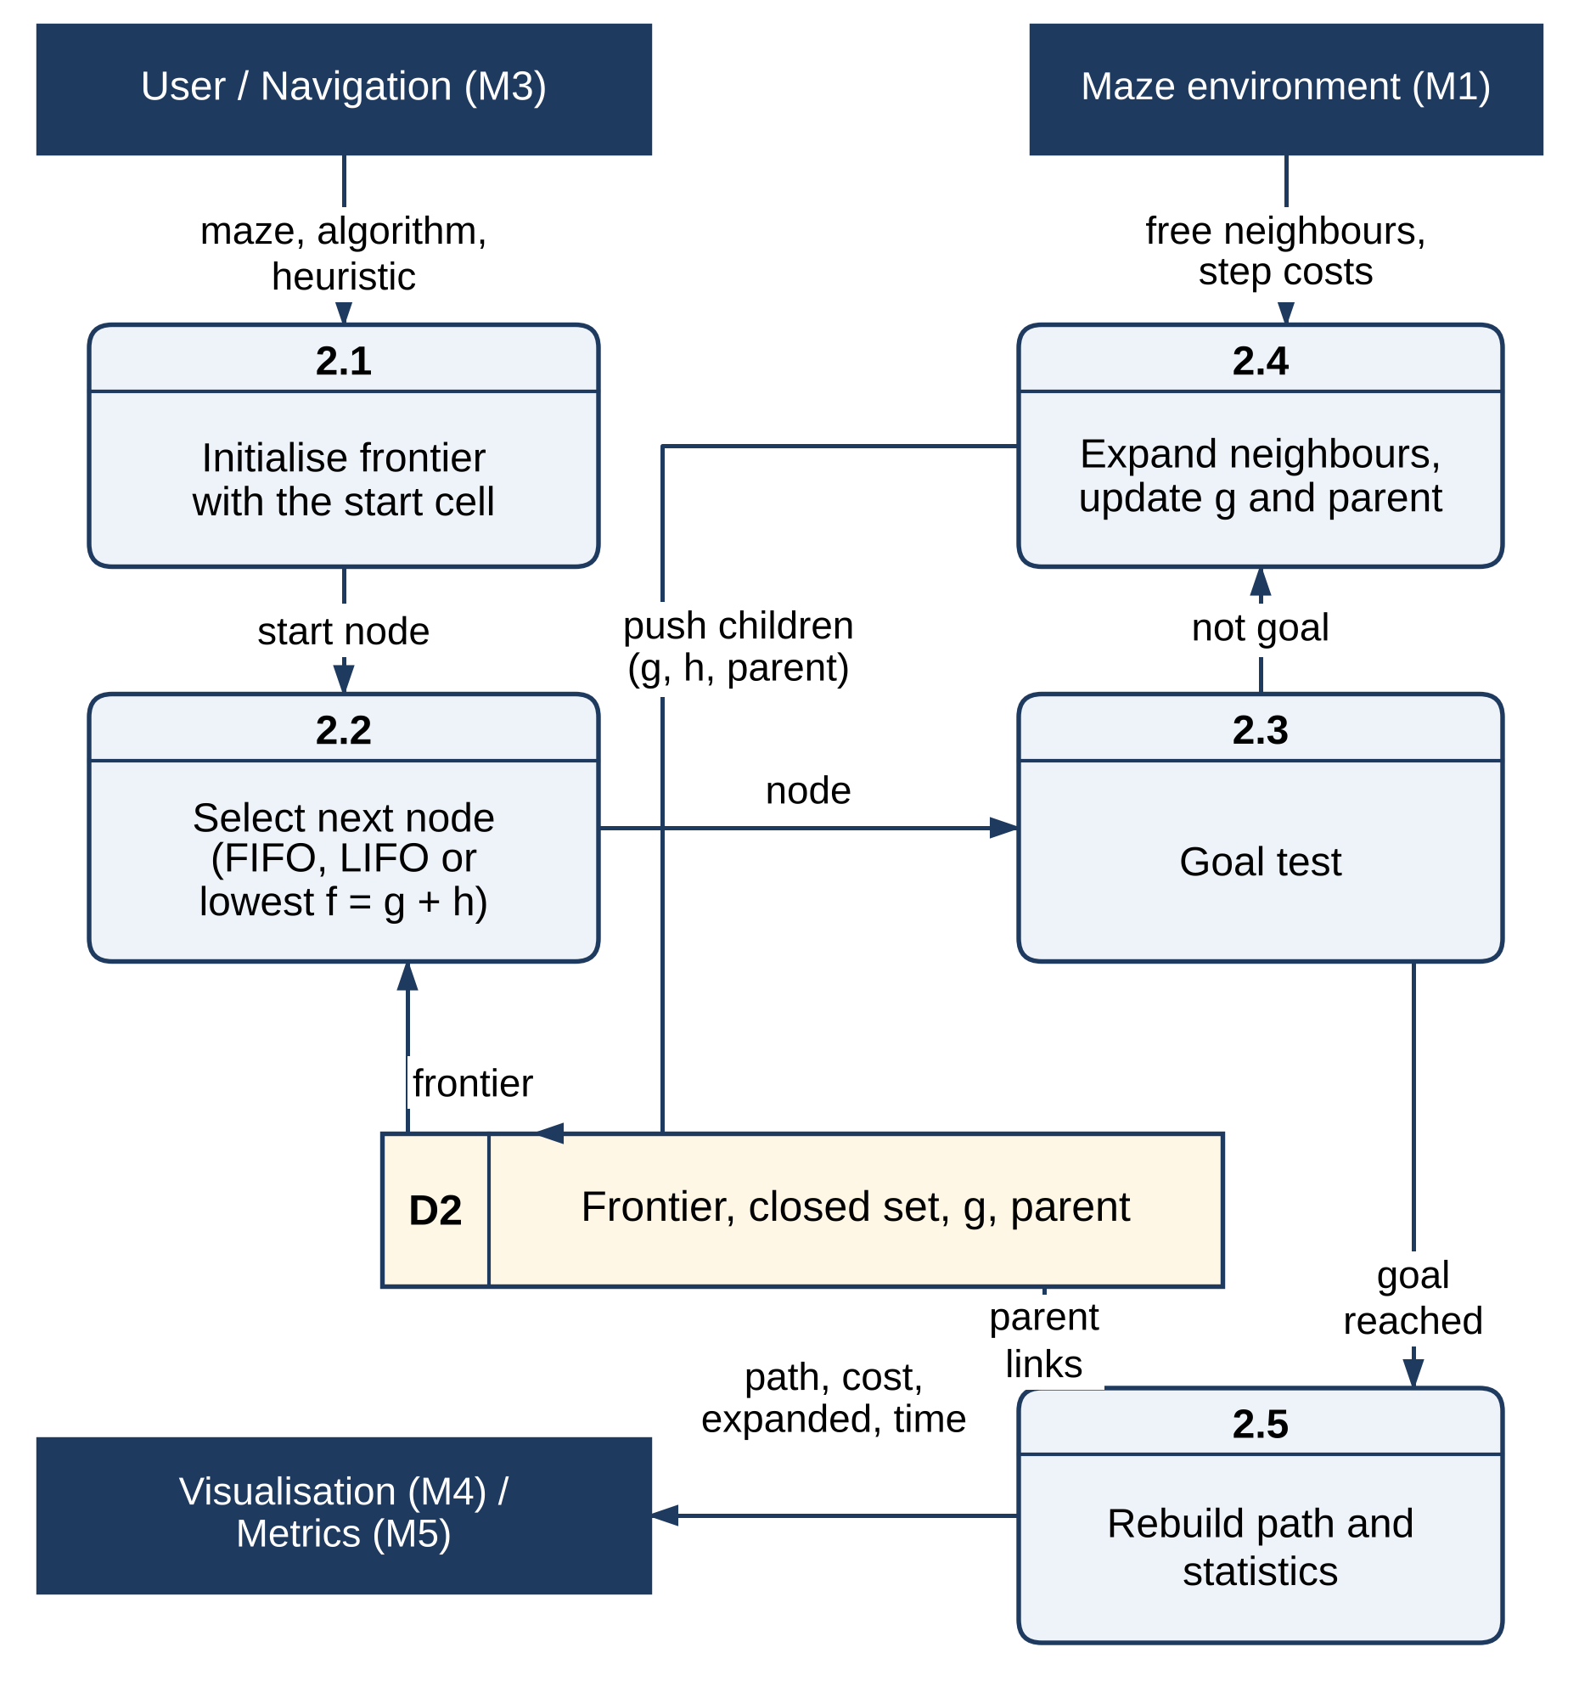
Figure 3.3 Level-2 DFD of Module 2 – Search Algorithms

3.2.3 DYNAMIC NAVIGATION AND RE-PLANNING
This module turns A* into a navigating agent. A dynamic scenario starts from a maze on which A* has planned a route. The maze is then changed in one of two ways, in both cases only where the goal stays reachable: cells of the planned route are closed (one cell is the “door” scenario), or random walls are added anywhere in the maze. The agent does not know about the change. It keeps a belief map, initially the map it planned on, and at every step it senses the cells within its sensing range r — all cells within a Manhattan distance r of its own, so r = 1 means its four neighbours — and copies any wall it finds there into the belief map. If a newly recorded wall lies on the rest of its plan, it re-plans with A* on the belief map from its current cell; otherwise it takes the next step of its plan. A run ends when the agent reaches the goal, when no path is left on the belief map, or after ten moves per free cell.
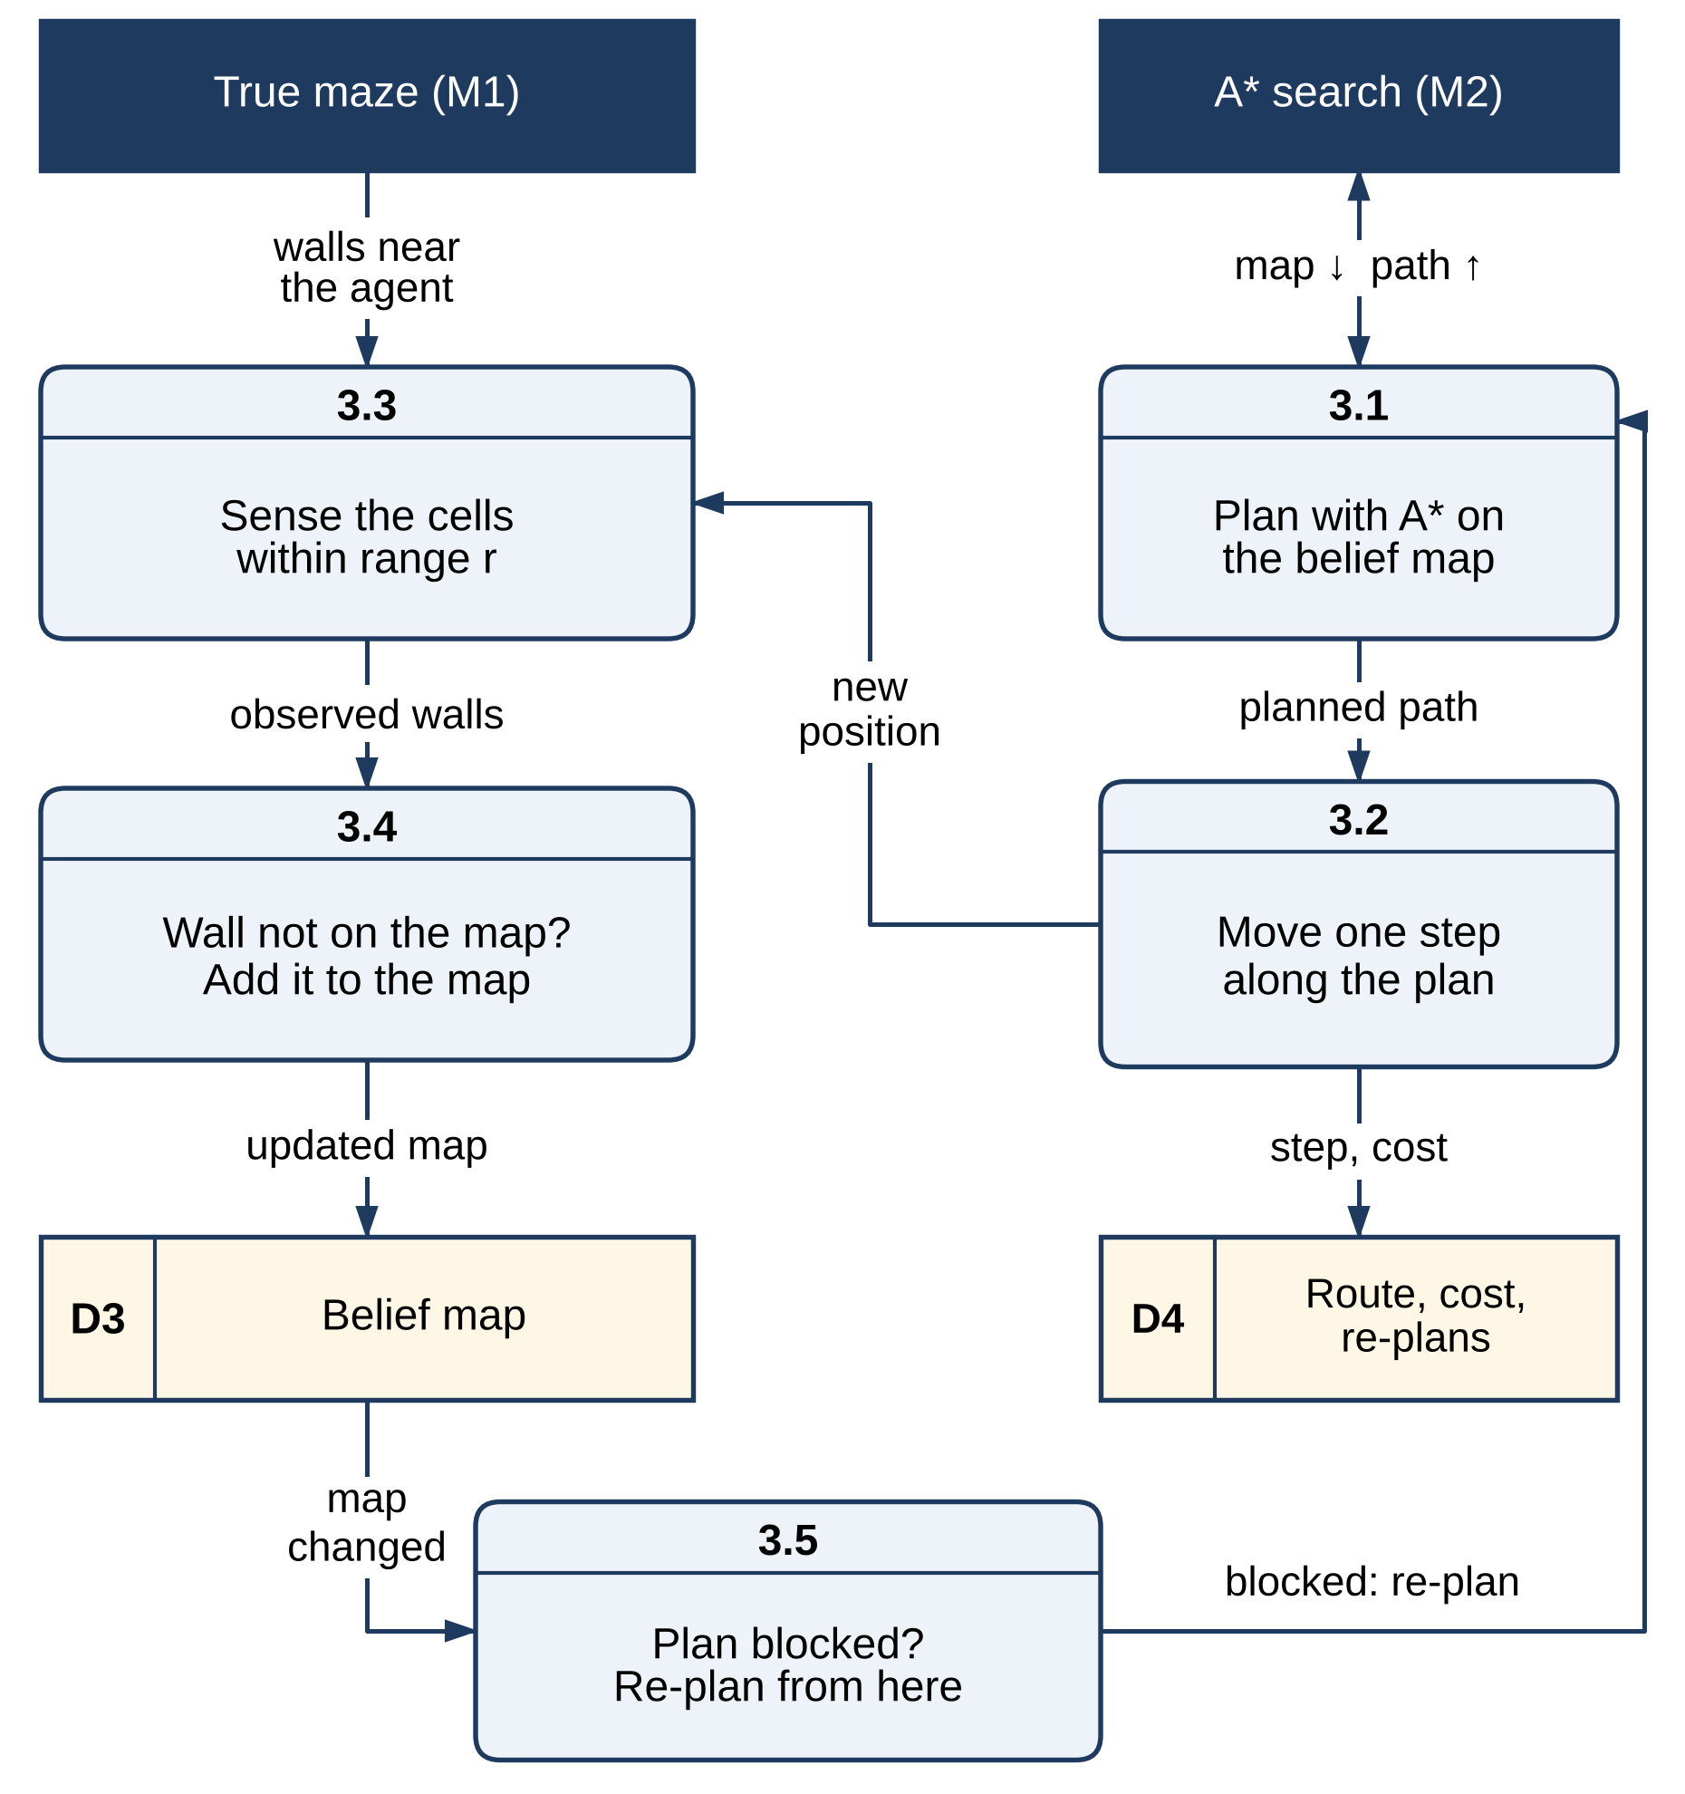
Figure 3.4 Level-2 DFD of Module 3 – Dynamic Navigation and Re-planning
Two baselines frame the result. A fixed plan follows the original A* route without sensing and fails at the first new wall on it. An oracle runs A* on the changed maze from the start, as if the agent had known about the change; its cost is the optimal cost of the changed maze, against which the detour of the navigating agent is measured. Figure 3.4 shows the data flow: A* plans on the belief map (3.1); the agent moves one step along the plan (3.2), recording its route and cost (D4); it senses the walls near it in the true maze (3.3); a wall that is not on the map is added to the belief map (3.4, D3); and when the plan is blocked, the module re-plans from the current cell (3.5).

3.2.4 VISUALISATION AND USER INTERFACE
The interface is a single Pygame window of 1360 × 860 pixels, with the maze on the left and a 440-pixel information panel on the right. Keys 1 to 5 run BFS, DFS, Dijkstra’s algorithm, Greedy search and A*; C compares four algorithms side by side on the same maze; D starts a dynamic scenario with one new wall on the route and N one with three; G generates a new maze, T changes its type and + and − its size; a mouse click toggles a wall, and S or E followed by a click moves the start or the goal; W saves the maze together with its SHA-256 digest. Search runs are animated cell by cell, explored cells are shaded and the final path is drawn on top. In a dynamic scenario the maze shows the original plan as a dashed grey line, the new walls as red crossed cells and the route the agent actually drove in purple, and the panel reports the original plan cost, the number of new walls, the sensing range, the outcome of the fixed plan, the cost travelled against the optimal cost of the changed maze, the number of re-plans and the nodes expanded by all plans. Command-line options load a maze (--load, with --strict to require a digest), set the number of new walls (--walls) and the sensing range (--sense), and render the window to a PNG file without a display, which produced the screenshots in this report.
Figure 3.5 shows the data flow. Keyboard and mouse input (4.1) updates the interface state (D5); the animator (4.3) takes the expansion order, the path and the route driven from the core modules and produces the frames that are drawn (4.2) and the statistics shown in the panel (4.4).
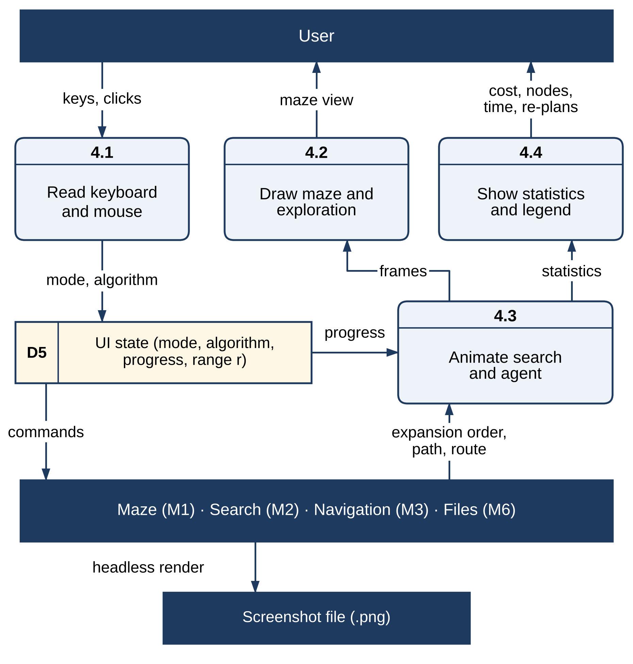
Figure 3.5 Level-2 DFD of Module 4 – Visualisation and User Interface

3.2.5 PERFORMANCE ANALYSIS AND TESTING
The experiment runner generates the test mazes from fixed seeds (5.1), runs the algorithms and the navigator on them and records their metrics (5.2) in JSON result files (D6). A separate script aggregates the results and plots the charts and tables used in Chapter 4 (5.3, D7). Twenty-four automated tests (5.4) check the maze model, the file loader and its digests, the search algorithms and the dynamic navigator, and must all pass before results are produced. Figure 3.6 shows this flow.
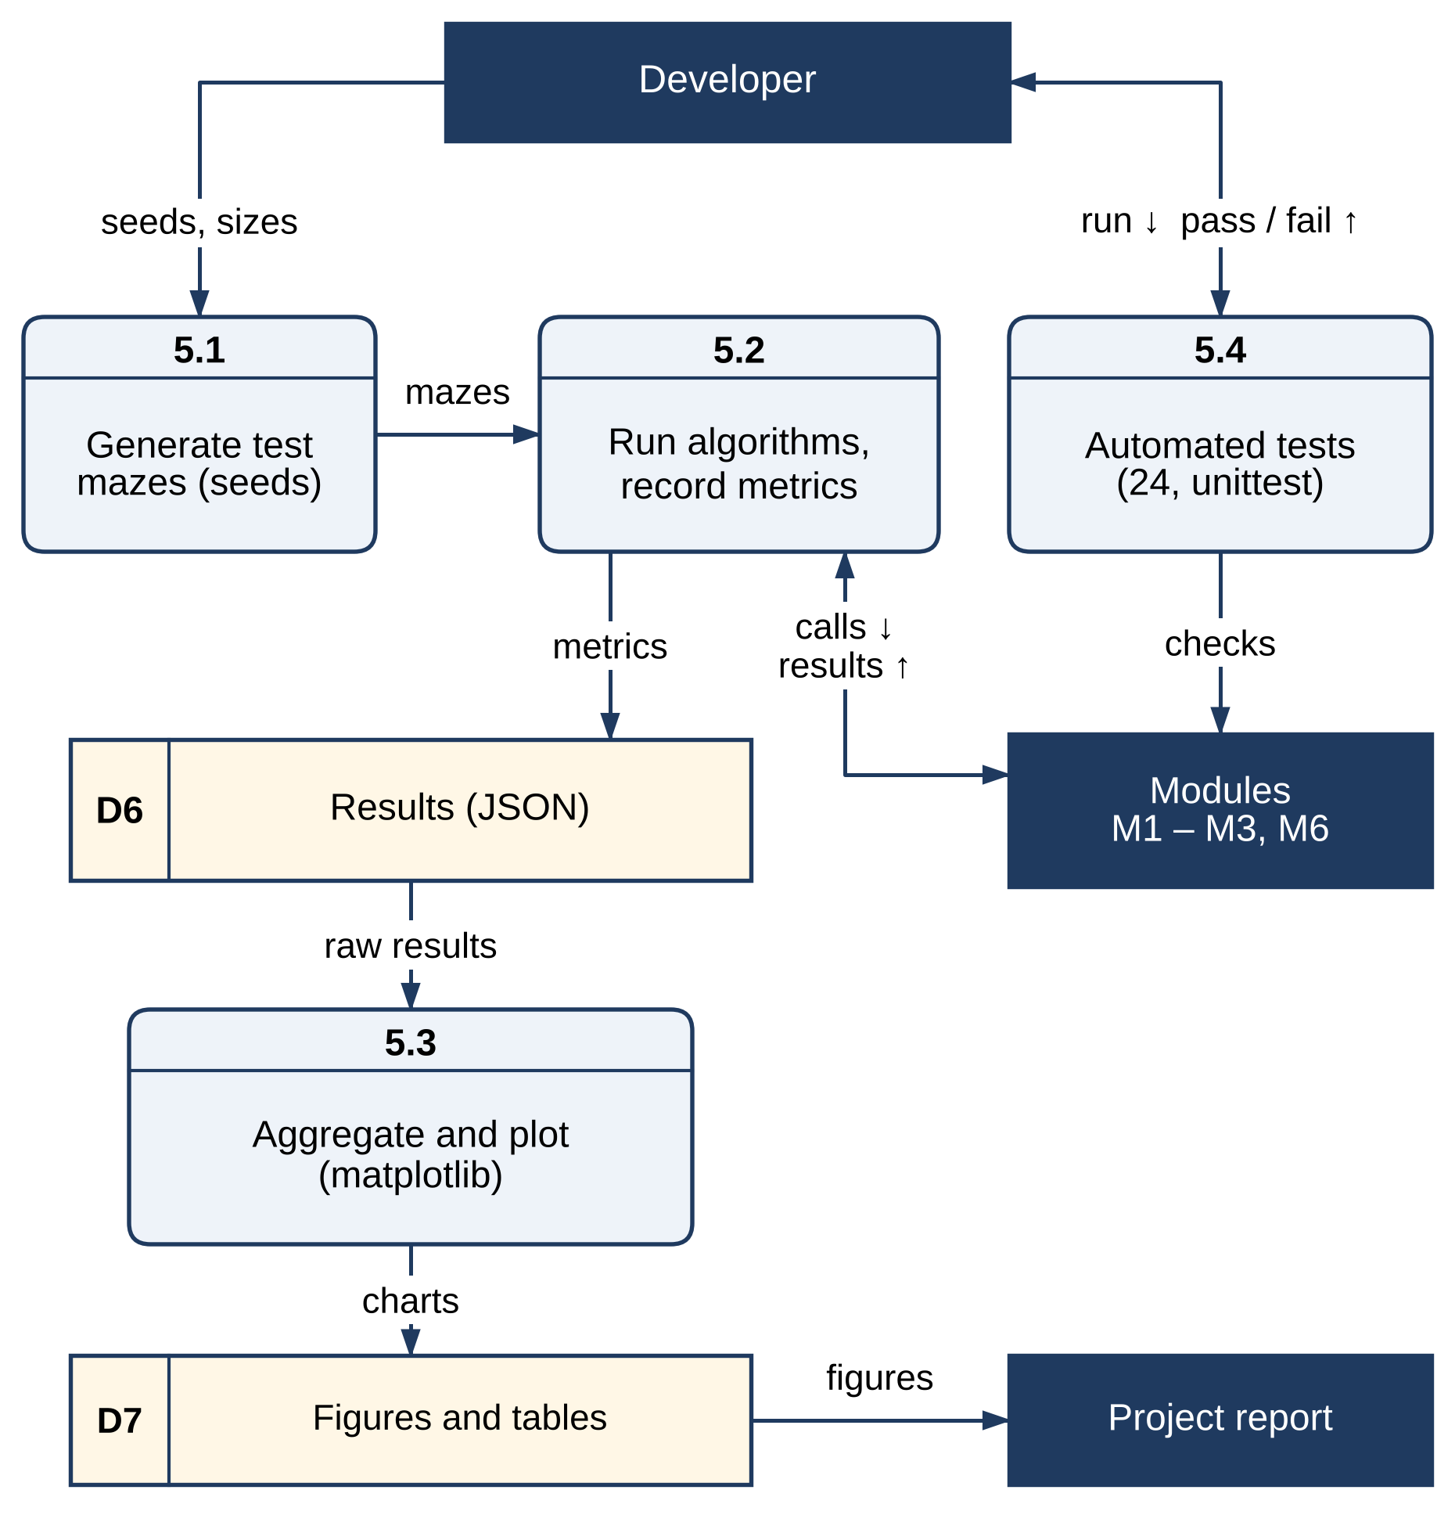
Figure 3.6 Level-2 DFD of Module 5 – Performance Analysis and Testing

3.2.6 SECURE FILE HANDLING
Every maze file crosses a trust boundary, so loading is a short pipeline in which each stage can reject the file. The file is read with a byte limit, so an enormous file is never read in full (6.1). If a digest file of the same name with the extension .sha256 exists, the SHA-256 digest of the text is computed and compared with it in constant time; a mismatch means the maze was changed after it was saved and the file is rejected (6.2). In strict mode a file without a digest is rejected as well. The text is then parsed with an allow-list of the five symbols # . ~ S G (6.3) and the result is validated: rows of equal length, a size of at most 201 × 201 cells, exactly one start and one goal, both on free cells (6.4). Only then does the maze reach Module 1. Any failure produces a one-line reason and exit code 2, and nothing from the file is used. Saving (6.5) writes the maze text and its digest together.
Figure 3.7 shows this pipeline with its two data stores, the maze files (D8) and their digests (D9), and the error report that collects the three ways a file can be rejected.
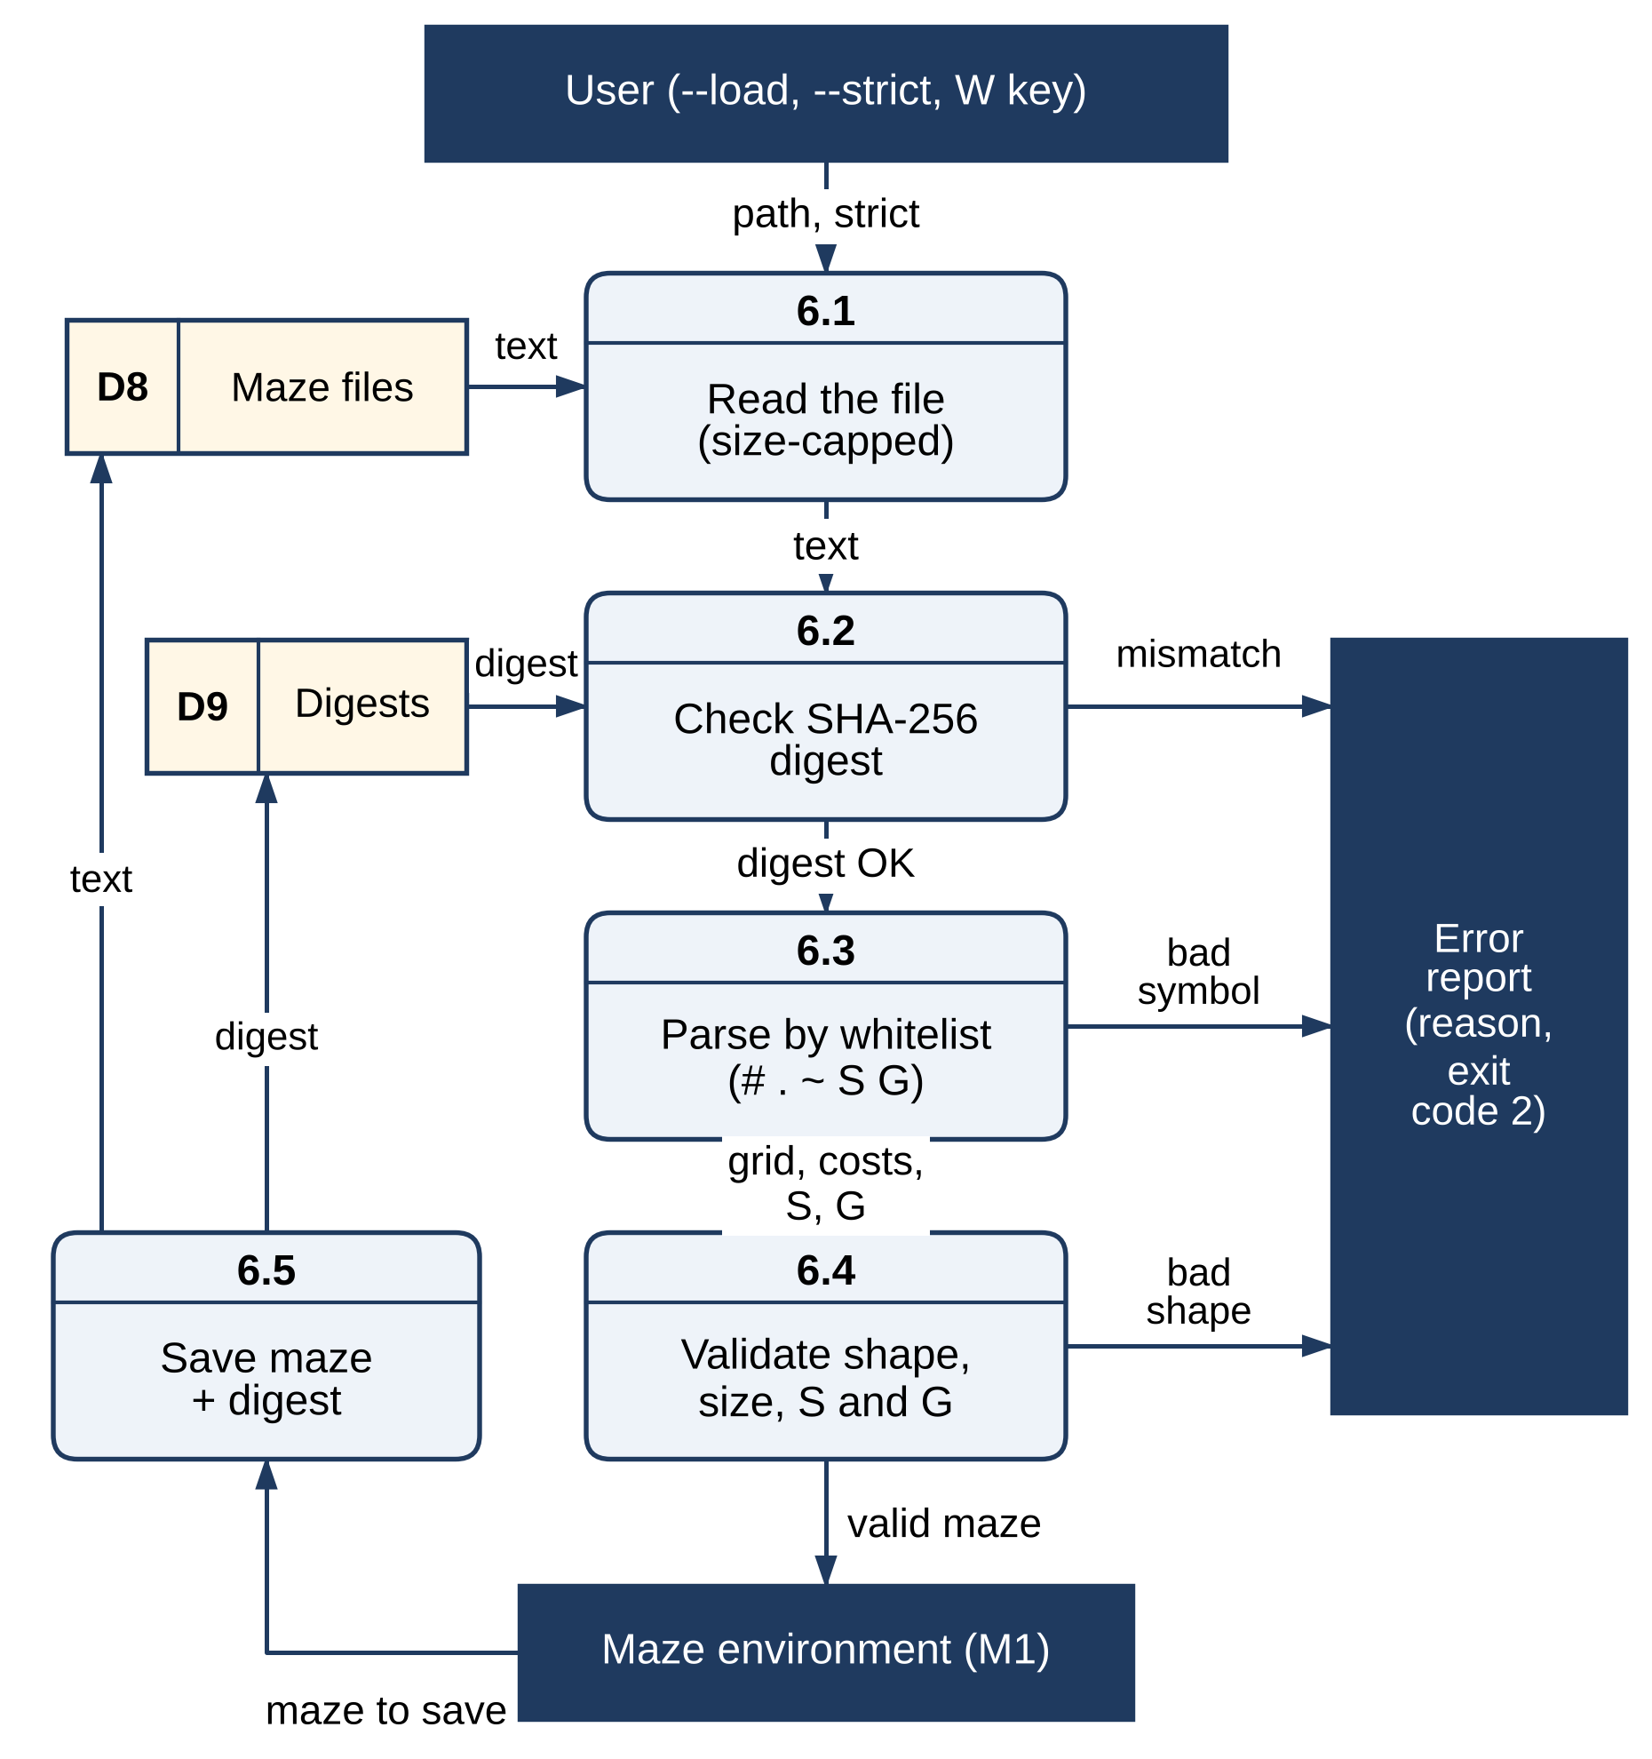
Figure 3.7 Level-2 DFD of Module 6 – Secure File Handling

3.3 DATA FLOW/UML DIAGRAMS
The behaviour of the system is described with data flow diagrams at Level 0 and Level 1, which place the six modules of Section 3.2 in context (the Level-2 diagram of each module was given with the module), and with three UML diagrams: a use case diagram, an activity diagram and a sequence diagram. In the data flow diagrams, dark rectangles are external entities, rounded boxes are numbered processes, light-yellow rectangles with an identifier on the left are data stores and labelled arrows are data flows.

3.3.1 DATA FLOW DIAGRAMS
Figure 3.8 is the context (Level-0) diagram. The whole application is a single process that exchanges data with three external entities: the user, who supplies maze settings, the choice of algorithm, edits, the number of new walls and the sensing range, and receives the animated search, the path, the route driven and the statistics; the developer or researcher, who supplies settings and tests and receives results and figures; and the file store, which holds maze files with their SHA-256 digests.
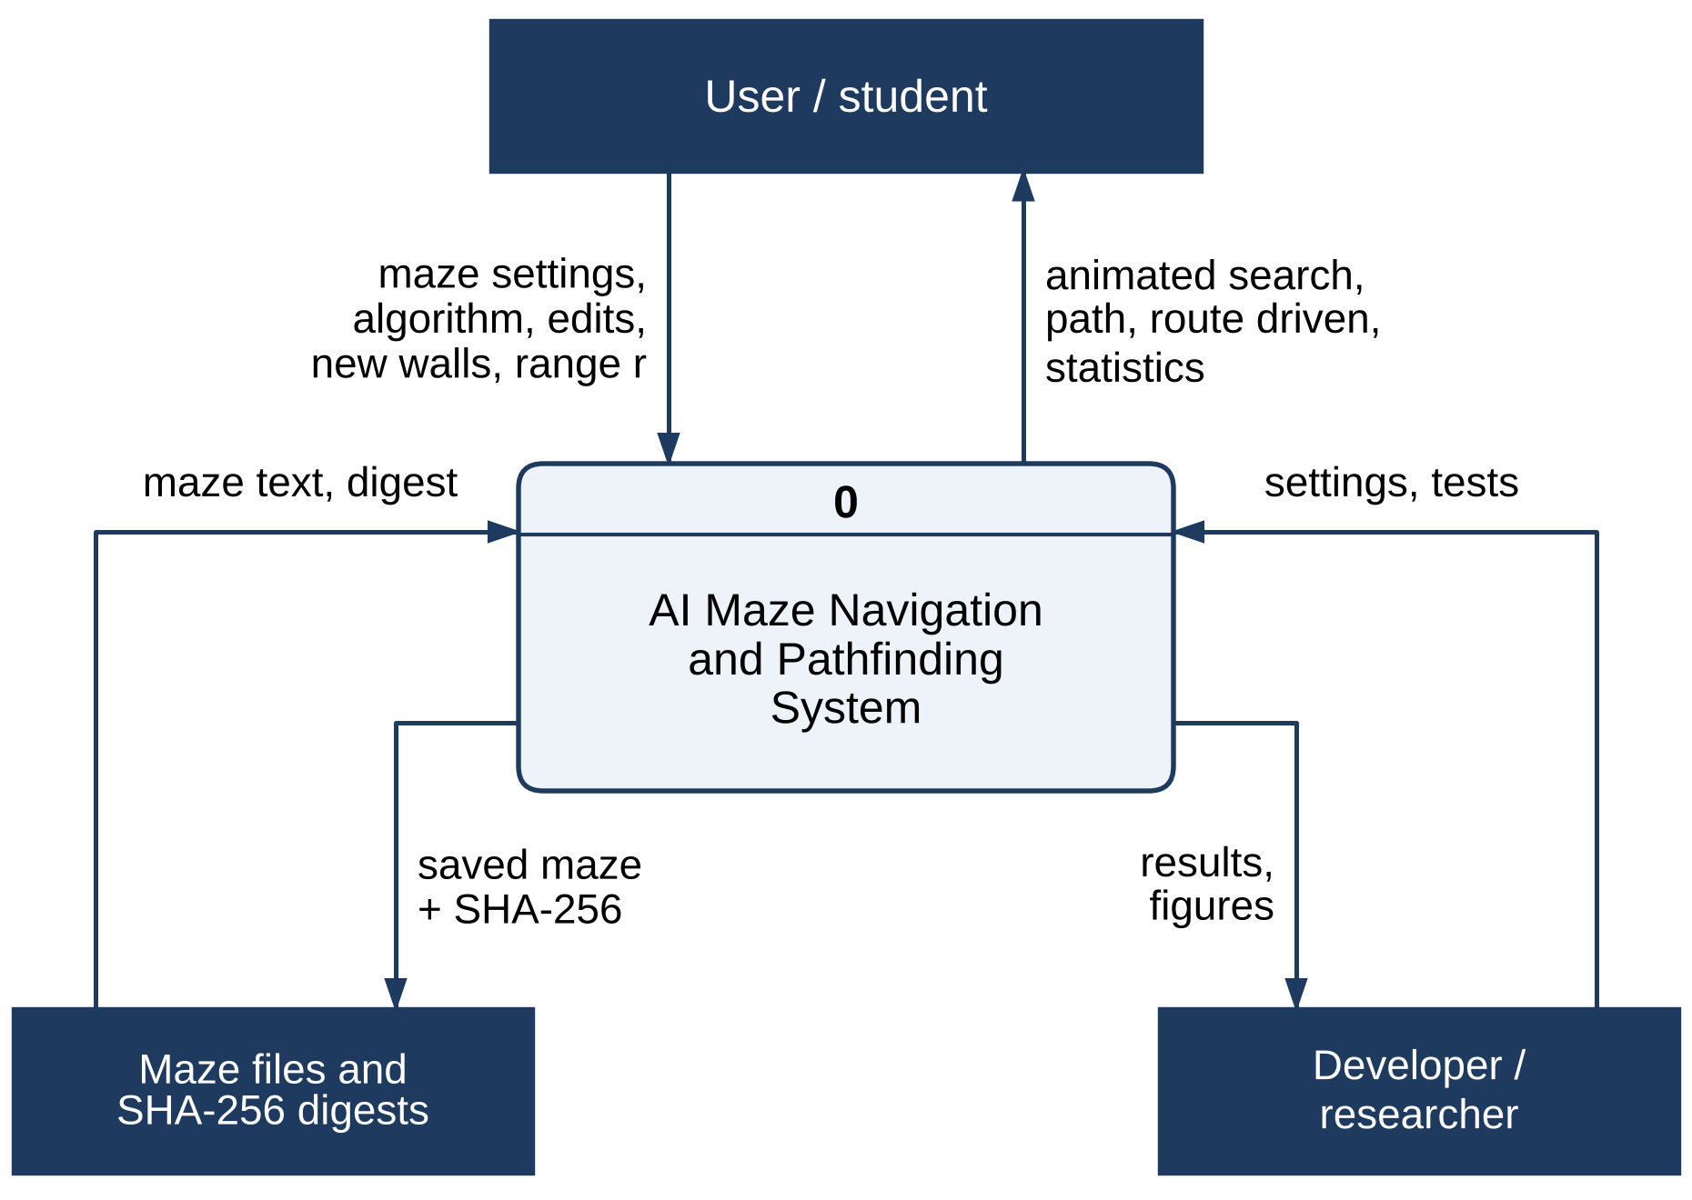
Figure 3.8 Data Flow Diagram – Level 0 (Context Diagram)
Figure 3.9 decomposes the system into the six modules of Section 3.2. The interface (4.0) passes settings and edits to the maze environment (1.0), run requests to the search algorithms (2.0) and dynamic scenarios to the navigator (3.0), and receives paths, node counts, routes and statistics. The search algorithms read the neighbours of each cell from the maze environment; the navigator asks the search algorithms for plans, senses walls through the maze environment and keeps its belief map (D3). The secure file handler (6.0) exchanges maze text and digests with the file store (D8) and passes only validated mazes to the maze environment. The developer runs the performance analysis (5.0), which drives the modules and writes the results (D6).
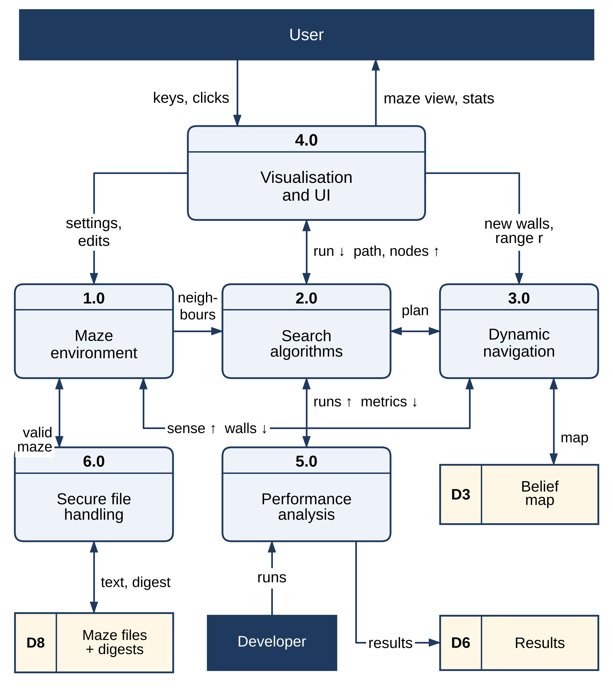
Figure 3.9 Data Flow Diagram – Level 1
The nine data stores that appear across the diagrams are: D1, the maze grid and cost map; D2, the frontier, closed set, g values and parent links of a search; D3, the navigator’s belief map; D4, the route driven, its cost and the number of re-plans; D5, the interface state (mode, algorithm, animation progress and sensing range); D6, the raw results in JSON; D7, the figures and tables produced from them; D8, the maze files; and D9, their SHA-256 digests. D1 to D5 live in memory while the application runs, D6 and D7 are produced only by the experiment runner, and D8 and D9 are files on disk.

3.3.2 USE CASE DIAGRAM
Figure 3.10 shows the two actors. The user generates a maze or loads and saves one — loading always includes validation of the digest and the symbols — edits walls, start and goal, runs a search algorithm, which includes recording its metrics, compares four algorithms, simulates a dynamic maze, navigates it with re-planning A*, sets the sensing range and views the statistics and the route. Simulating a dynamic maze and navigating it both include planning a path with A*. The developer runs the benchmark experiments and the automated tests.
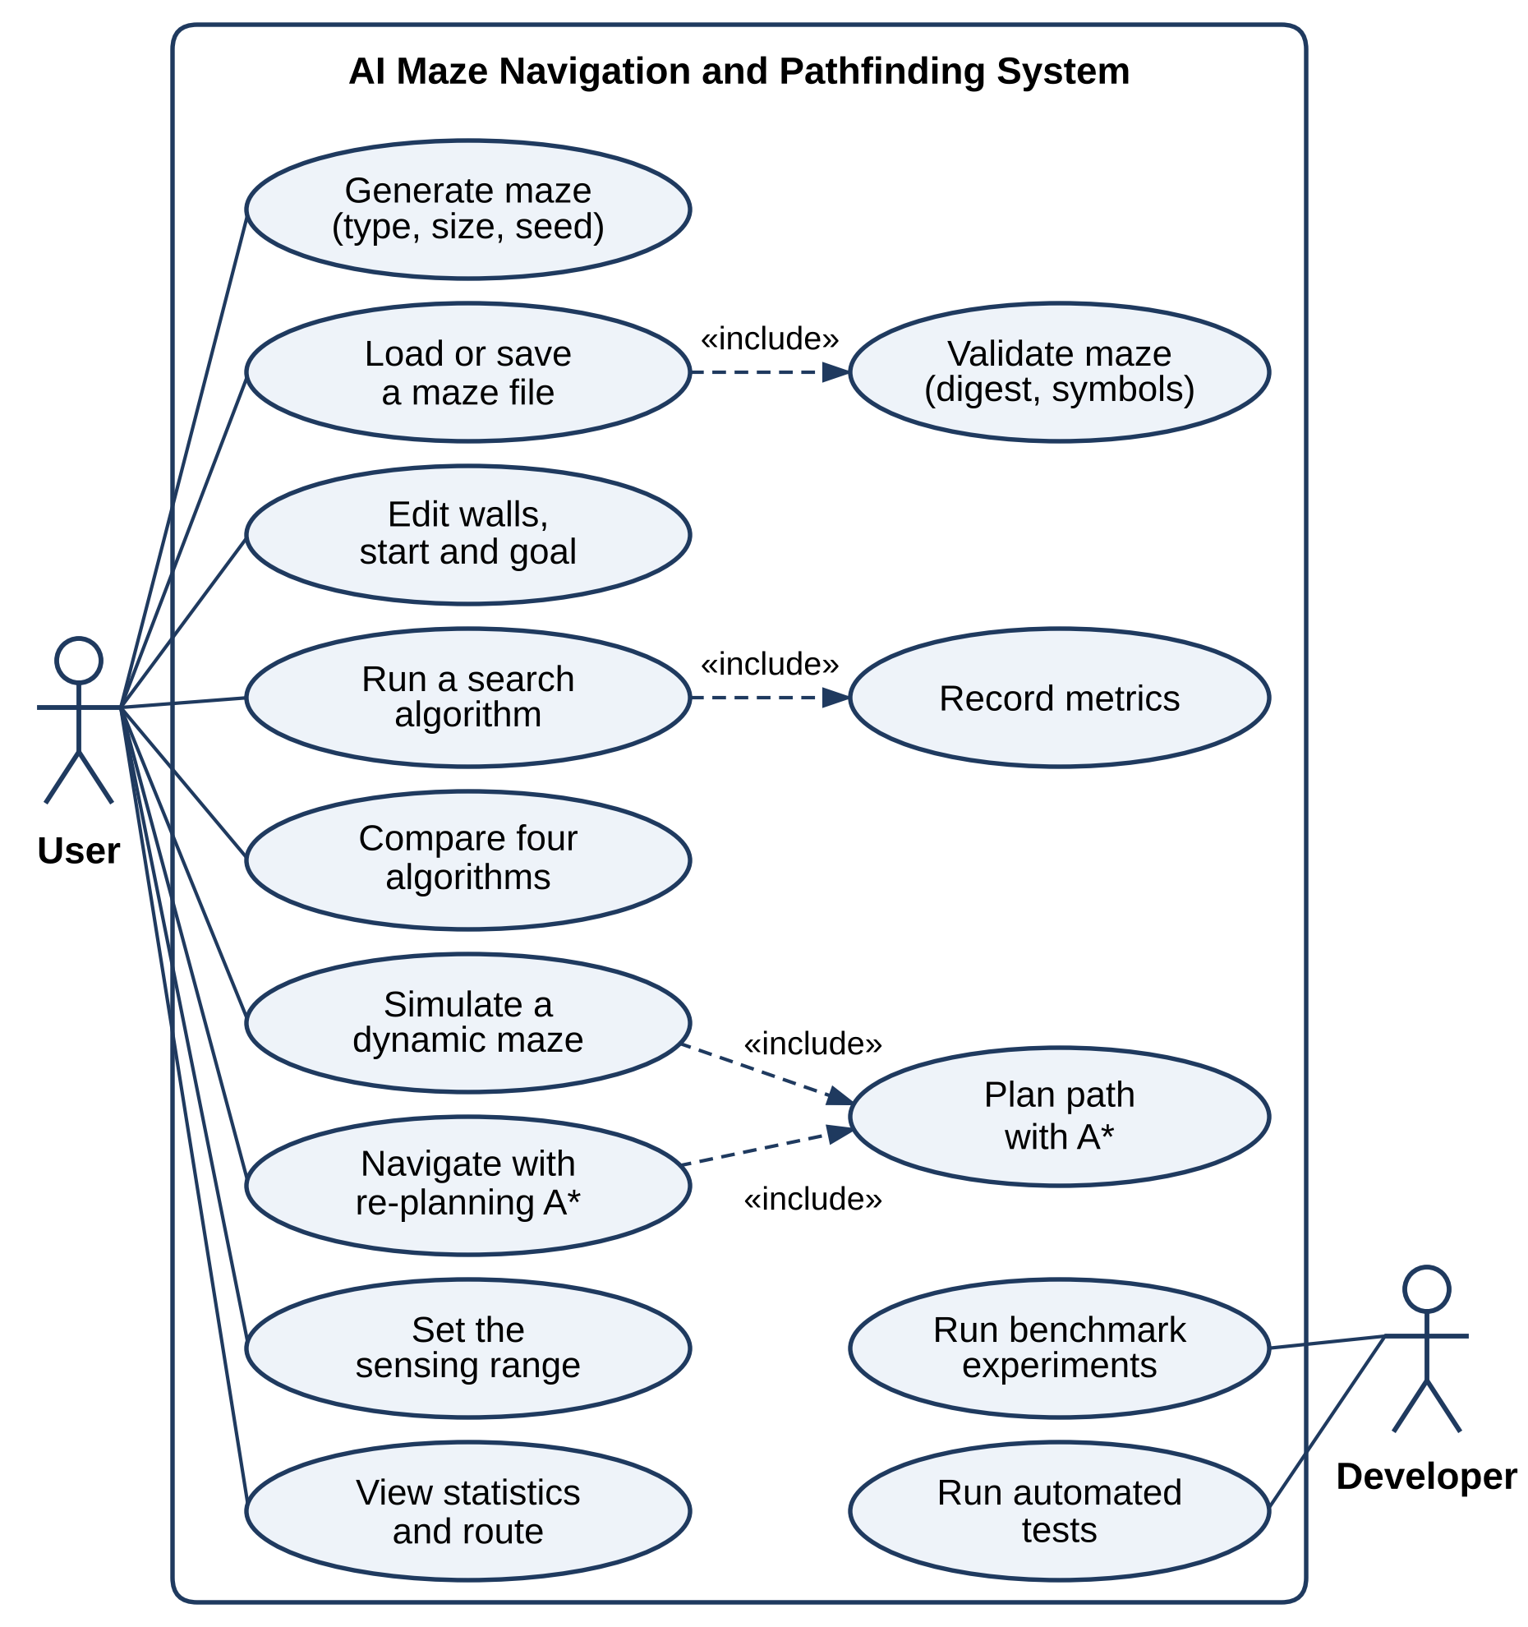
Figure 3.10 Use Case Diagram

3.3.3 ACTIVITY DIAGRAM
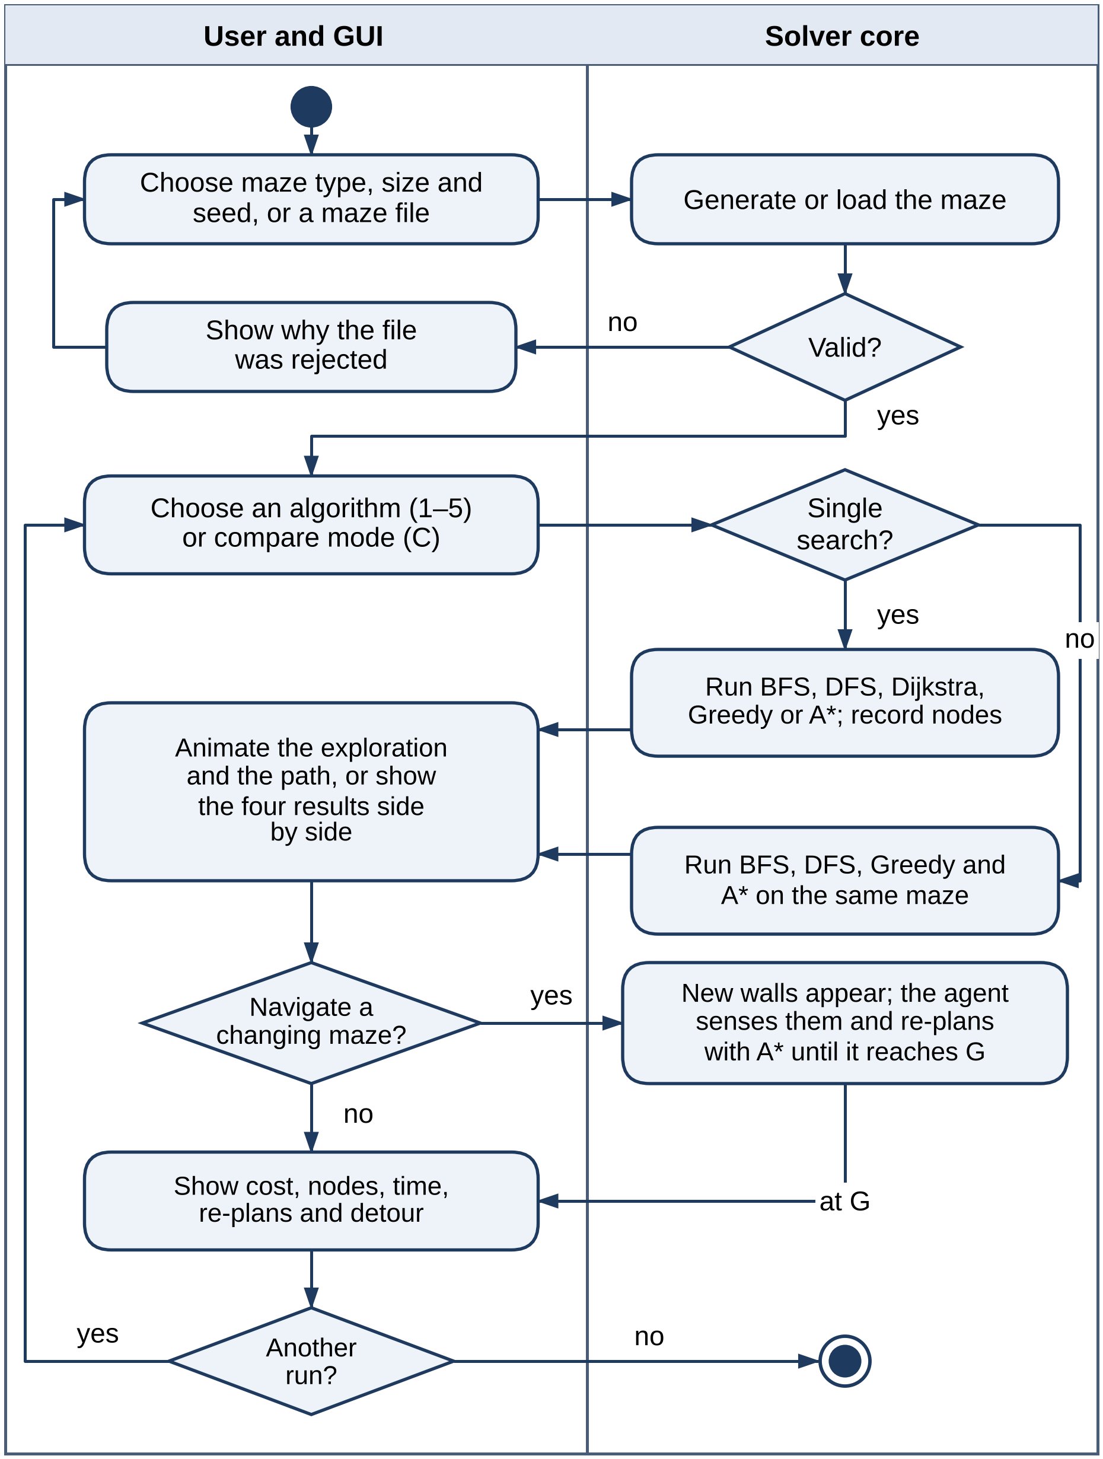
Figure 3.11 Activity Diagram
Figure 3.11 traces one session, with one swimlane for the user and the interface and one for the solver core. The user chooses a maze type, size and seed, or a maze file; the core generates or loads the maze and validates it, and a rejected file is explained so that the user can choose again. The user then chooses an algorithm or the comparison mode. For a single search the core runs the chosen algorithm and records its nodes; otherwise it runs BFS, DFS, Greedy search and A* on the same maze. The interface animates the exploration and the path, or shows the four results side by side. If the user asks to navigate a changing maze, new walls appear and the agent senses them and re-plans with A* until it reaches the goal. Finally the cost, nodes, time, re-plans and detour are displayed, and the user can start another run.
The diagram has three decision points. Validation comes first: a maze that fails a check never reaches the algorithms, and the user can correct the file or generate a maze instead. The single-search and comparison branches meet again at the display step, so a single result and a comparison are shown in the same way. The last decision marks the dynamic setting: the core does not restart the run when the maze changes but lets the agent update its map and re-plan from where it stands.

3.3.4 SEQUENCE DIAGRAM
Figure 3.12 shows the messages exchanged between the user, the interface, the maze environment, the search engine, the navigator and the belief map, numbered in the order in which they occur. The user chooses a maze and the interface generates it (1–3). When the user presses 5, the interface calls A* (4–5), which repeatedly asks the maze for the neighbours of the cell it pops and pushes them with f = g + h until the goal is popped (6–8), and returns the path, cost, expanded count and time for the animation (9–10). When the user presses N, the interface asks A* for a route (11–13), closes three cells of it (14) and starts the navigator on the original map and the changed maze (15). At every step the navigator senses the walls within its range (16–17); if a new wall blocks its plan, it adds the wall to the belief map and asks A* for a new path from its current cell (18–20); then it moves one step (21). Finally the route, its cost and the number of re-plans are returned, and the interface draws the route driven and the statistics (22–23).
Two combined fragments structure the diagram. The first loop is the inner loop of A*, which runs until the goal is popped; its iterations are the nodes expanded reported in Chapter 4. The second loop is the navigation loop, which runs until the agent reaches the goal, and the optional fragment inside it runs only when a newly sensed wall blocks the plan — never in a static maze, and at most once for every new wall in a dynamic one.
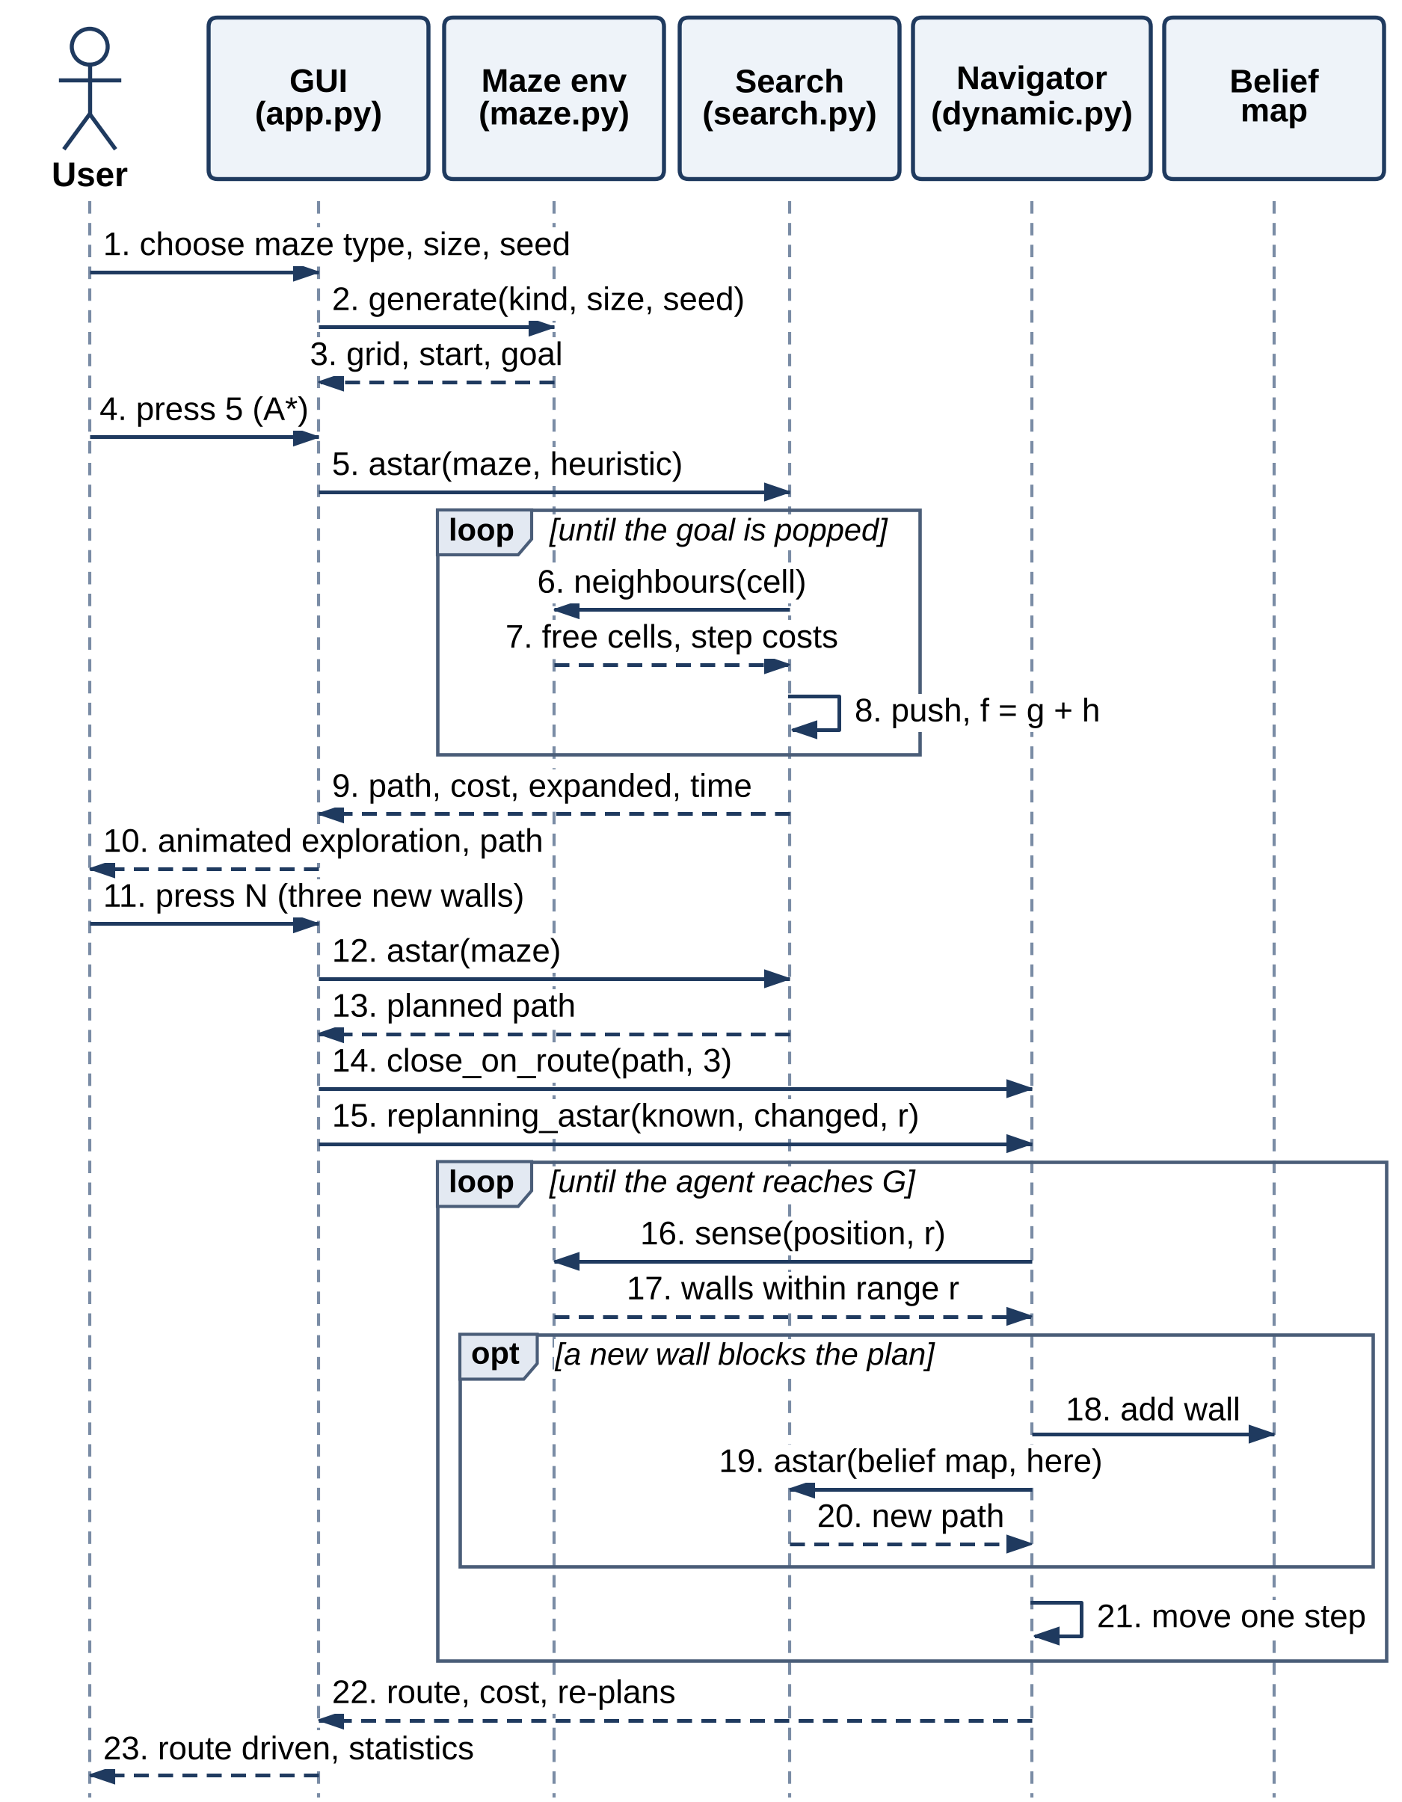
Figure 3.12 Sequence Diagram

3.4 THREAT MODEL AND ATTACK SURFACE
Figure 3.13 shows two trust boundaries — the application process on the user’s computer (TB1) and the local file system (TB2) — and five entry points: E1, keyboard, mouse and command-line input from the user; E2, the third-party packages installed from the Python Package Index; E3, maze files loaded from disk; E4, the SHA-256 digests read with them; and E5, the result files written and read by the experiment runner. Data crossing from TB2 into TB1 is the main concern, because a maze may have been downloaded or received from someone else.
Table 3.4 lists the threats identified at each entry point using the STRIDE categories [25] (spoofing, tampering, repudiation, information disclosure, denial of service and elevation of privilege), with an estimated risk and the mitigation adopted.
Table 3.4 STRIDE Threat Analysis
ID | Threat (STRIDE category) | Entry | Risk | Mitigation
T1 | Oversized maze file exhausts memory or processor time (denial of service) | E3 | Medium | At most 201 × 201 cells; the file is read with a byte limit and rejected before parsing if it is larger
T2 | Malformed maze: wrong symbols, ragged rows, missing or duplicate S and G, start inside a wall (tampering) | E3 | Medium | Strict parser with an allow-list of symbols and full validation of the grid
T3 | Maze changed after it was saved, for example a wall moved in a shared benchmark maze (tampering) | E3, E4 | Medium | SHA-256 digest written on save and compared on load in constant time; strict mode rejects files without a digest
T4 | File crafted to run code when it is loaded (elevation of privilege) | E3 | Low | Mazes are plain text read by an allow-list parser; nothing is deserialised, imported or evaluated
T5 | Compromised or typo-squatted package (spoofing, tampering) | E2 | Medium | Three well-known dependencies, exact pinned versions, official index only
T6 | Very large maze, many new walls or a long navigation run freezes the program (denial of service) | E1 | Low | Caps on maze size, new walls (10), sensing range (50) and steps per run (10 × free cells)
T7 | Edited result files misrepresent the experiments (repudiation) | E5 | Low | Results regenerated from fixed seeds by one script; figures built only from raw results
T8 | Error messages reveal file paths or internals (information disclosure) | E1, E3 | Low | A rejected file produces a one-line reason and no stack trace

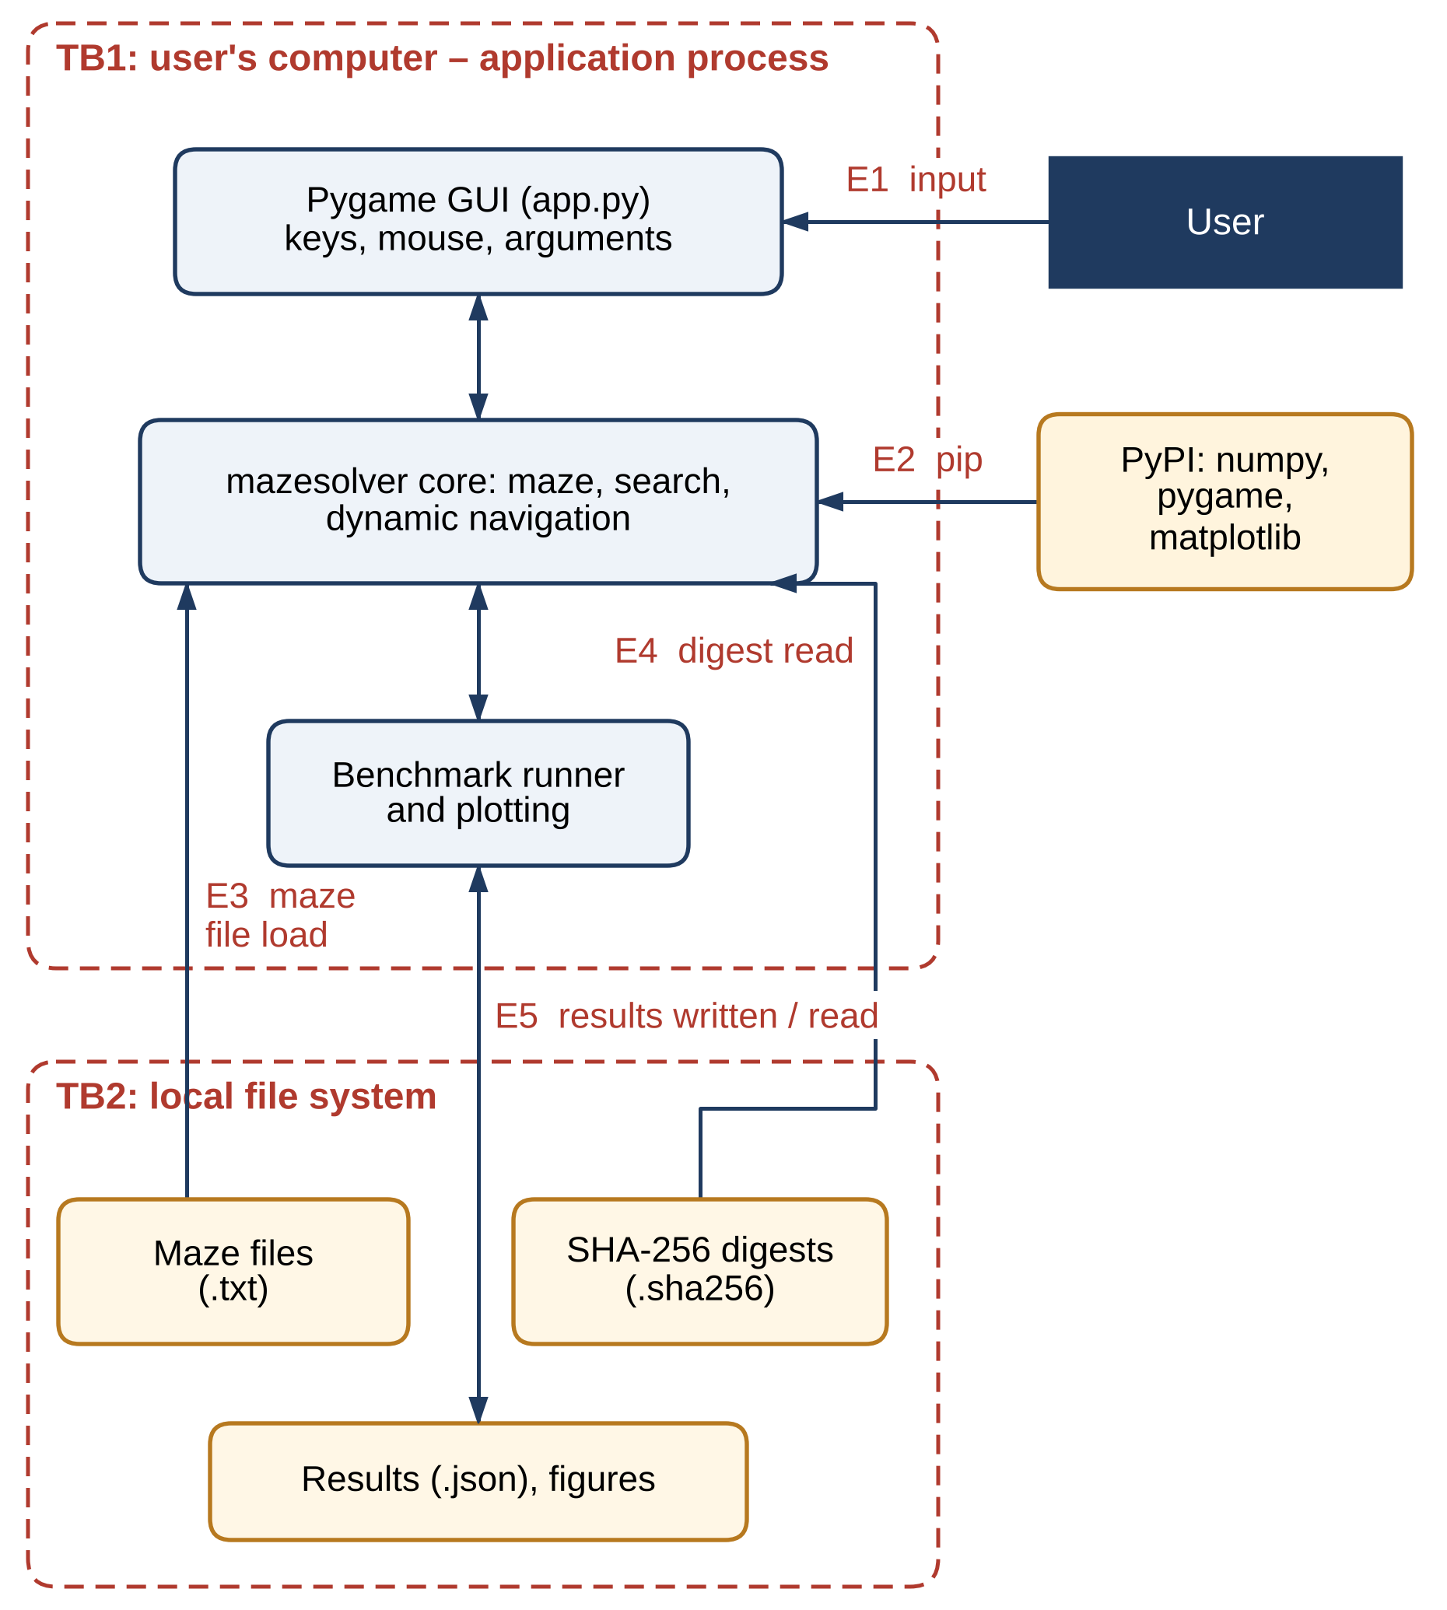
Figure 3.13 Attack Surface and Trust Boundaries

3.5 SECURITY CONTROLS
Table 3.5 groups the security controls by layer and shows which are implemented in the current prototype and which are planned for the final phase.
Table 3.5 Security Controls
Layer | Control | Status
Input | Allow-list parser for maze files: symbols # . ~ S G only, rectangular rows, exactly one S and one G, start and goal on free cells | Implemented
Input | Size limit of 201 × 201 cells and a byte limit applied while reading, before parsing | Implemented
Integrity | SHA-256 digest written beside each saved maze and compared on load with hmac.compare_digest | Implemented
Integrity | Strict mode (--strict) that rejects a maze without a digest | Implemented
Integrity | Keyed digest (HMAC) so that a forged digest is also detected | Planned
Code safety | Plain-text format only; no pickle, eval or import of file content | Implemented
Resources | Caps on maze size, new walls, sensing range and steps per navigation run | Implemented
Supply chain | Exact dependency versions in requirements.txt; installation from the official index | Implemented
Supply chain | Hash-checked installation (pip --require-hashes) and dependency auditing (pip-audit) | Planned
Testing | Automated tests for rejected files, a tampered maze file and strict mode | Implemented
Privacy | No network access, no accounts and no personal data | Implemented

CHAPTER 4

SYSTEM DESCRIPTION

4.1 DATA COLLECTION
The project needs no external dataset. Its data are mazes, produced by the four generators of Module 1 from a size and a random seed, so that every maze can be regenerated exactly. Table 4.1 describes the four maze families. Perfect mazes have exactly one route, so every complete search returns the same path and only the effort differs; braided mazes have loops and therefore several routes of different lengths; open fields have few walls and many equally short routes; and weighted mazes add rough terrain, so the route with the fewest moves is not always the cheapest.
Table 4.1 Maze Families Used in the Experiments
Family | Construction | Free cells at 61 × 61 | Start and goal | What it tests
Perfect | Recursive backtracker | 1,799 | Opposite corners inside the border | Effort when only one route exists
Braided | Perfect maze with 12 % of removable walls opened | 1,931 (mean) | As for perfect | Choice between routes of different length
Open field | 25 % random obstacles; regenerated until solvable | 2,792 (mean) | Grid corners | Value of the heuristic in open space
Weighted | Braided (20 %) with 30 % rough floor of cost 5 | 2,019 (mean) | As for perfect | Least cost against fewest moves

Sizes from 21 × 21 to 101 × 101 were used for the search experiments, and braided mazes of 21 × 21 and 31 × 31 for the navigation experiments, in which the agent walks the whole route cell by cell. Seeds 0–19 were used throughout. The dynamic scenarios are produced from the planned A* route in three ways, always only where the goal stays reachable: by closing one cell of the route (the “door”); by adding n/3 random walls anywhere in the maze (7 on 21 × 21 and 10 on 31 × 31); and, for the sensing experiment, by closing three cells of the route and adding random walls up to a total of 4, 8, 16 or 32 new walls.

4.2 DATA PREPROCESSING
Every maze passes through validation before any algorithm sees it. If a digest file exists beside a maze file, the SHA-256 digest of the text must match it. The text is checked for size before it is parsed; every row must have the same length; only the five symbols # . ~ S G are accepted; and there must be exactly one start and one goal. The text is then converted into two NumPy arrays — the wall grid (8-bit) and the cost map (16-bit) — and the start and the goal must lie inside the grid on free cells. Generated mazes pass through the same checks, so the algorithms can rely on a well-formed maze.
The maze is then treated as the search problem and navigation model summarised in Table 4.2. The state is the cell, and the four actions keep one fixed order (up, right, down, left) shared by the search algorithms, the navigator and the interface. Every move is charged the cost of the cell entered, so the least-cost path is the one with the smallest sum of entry costs. For navigation the agent additionally has a percept, a belief map and a rule for when to re-plan.
Table 4.2 Search Problem and Navigation Model
Element | Definition
State s | The agent’s cell (row, column)
Actions | Up, right, down, left
Transition | Move to the neighbouring cell if it is free; otherwise stay in place
Step cost | Cost of the cell entered: 1 on floor, 5 on rough terrain
Goal test | s = G
Heuristics | Manhattan |Δrow| + |Δcol| (default), Euclidean, zero
Percept (navigation) | Every wall within a Manhattan distance r of the agent; r = 1, 3 or 5 cells
Belief map | The map known when planning, plus every wall sensed since
Re-planning rule | Re-plan with A* from the current cell when a newly sensed wall lies on the rest of the plan
Run limit | 10 × (number of free cells) moves
Detour | Cost travelled ÷ optimal cost of the changed maze − 1, as a percentage

4.2.1 ALGORITHMS / METHODOLOGY
This section gives the core algorithms of the system as pseudo-code (Algorithms 1–5), followed by their complexity and the methodology of the experiments.

4.2.1.1 Pseudo-code of the Algorithms
Algorithm 1: A* Search (Best-First Search with f = g + h)
Input: maze M with entry costs c, start S, goal G, admissible heuristic h
Output: least-cost path from S to G, or failure
1: g[S] ← 0; parent[S] ← none; OPEN ← {(h(S), S)}; CLOSED ← ∅
2: while OPEN is not empty do
3: pop the node n with the lowest f = g[n] + h(n) (ties: larger g first)
4: if n ∈ CLOSED then continue
5: add n to CLOSED
6: if n = G then return the path rebuilt from parent[ ]
7: for each free neighbour m of n do
8: if m ∈ CLOSED then continue
9: g′ ← g[n] + c(m)
10: if g′ < g[m] then
11: g[m] ← g′; parent[m] ← n
12: push (g′ + h(m), m) onto OPEN
13: return failure
Dijkstra’s algorithm is the same procedure with h = 0; Greedy Best-First Search orders OPEN by h alone.

Algorithm 1 is shared by A*, Dijkstra’s algorithm and Greedy Best-First Search. Algorithm 2 gives BFS and DFS, Algorithm 3 creates the dynamic scenarios, Algorithm 4 is the fixed-plan baseline and Algorithm 5 the navigating agent.
Algorithm 2: Breadth-First Search (Queue) and Depth-First Search (Stack)
Input: maze M, start S, goal G; Output: a path from S to G, or failure
1: parent[S] ← none; F ← (S); CLOSED ← ∅
2: while F is not empty do
3: n ← remove the front of F (BFS) or the top of F (DFS)
4: if DFS then (if n ∈ CLOSED then continue; add n to CLOSED)
5: if n = G then return the path rebuilt from parent[ ]
6: for each free neighbour m of n do
7: if m has no parent yet (BFS), or m ∉ CLOSED (DFS) then
8: parent[m] ← n; add m to F
9: return failure

Algorithm 3: Changing the Maze after Planning
Input: maze M, planned path (p₀, …, p_{k}), scenario (door or walls), number of new walls n, random generator
Output: changed maze M′ and the cells that were closed
1: M′ ← copy of M; placed ← ∅
2: if scenario = door then C ← (p₂, …, p_{k−2}) else C ← every free cell except S and G
3: shuffle C
4: for each cell c of C while |placed| < n do
5: M′[c] ← wall
6: if BFS(M′) finds a path from S to G then add c to placed
7: else M′[c] ← free // the goal must stay reachable
8: return M′, placed

Algorithm 4: Following a Fixed Plan
Input: map K known when planning, true maze M
Output: success or failure, cost travelled and moves made
1: (p₀, …, p_{k}) ← A*(K, S, G); cost ← 0
2: for i ← 0 to k − 1 do
3: if M[p_{i+1}] = wall then return failure after i moves
4: cost ← cost + c_{M}(p_{i+1})
5: return success, cost, k

Algorithm 5: Re-planning A* with Sensing Range r
Input: map K known when planning, true maze M (walls may have been added since), sensing range r
Output: route travelled, its cost and the number of re-plans, or failure
1: B ← copy of K; pos ← S; plan ← A*(B, pos, G); replans ← 0; cost ← 0; steps ← 0
2: while pos ≠ G and steps < 10 × (number of free cells) do
3: changed ← false
4: for each cell n with |n_{row} − pos_{row}| + |n_{col} − pos_{col}| ≤ r do // sense
5: if M[n] = wall and B[n] = free then B[n] ← wall; changed ← true
6: if changed and a wall of B lies on the rest of plan then
7: plan ← A*(B, pos, G); replans ← replans + 1
8: if plan is failure then return failure
9: pos ← next cell of plan; cost ← cost + c_{M}(pos); steps ← steps + 1
10: return route, cost, replans

4.2.1.2 Complexity
For a maze with V free cells and E ≤ 4V possible moves, BFS and DFS run in O(V + E) time and memory. Dijkstra’s algorithm, Greedy Best-First Search and A* keep their frontier in a binary heap and run in O((V + E) log V) in the worst case. The Manhattan distance is consistent on a four-connected grid in which every move costs at least 1, so A* expands each cell at most once, and the number it actually expands depends on how closely h estimates the remaining cost: on an open field the estimate is nearly exact and A* expands little more than the cells around the path.
Navigation adds two costs. Sensing with range r examines at most 2r(r + 1) + 1 cells per move, so a run of T moves spends O(T·r²) on sensing, and finding the agent’s place on a plan of k moves costs O(k) per move. Every re-plan is one further A* search, so a run with R re-plans costs O((R + 1)(V + E) log V + T(r² + k)) in the worst case. R is at most the number of new walls, because a wall can trigger a re-plan only at the moment it is first recorded in the belief map.

4.2.1.3 Experimental Methodology
Four experiments were run with the parameters listed in Table A.1 of the Appendix, all from fixed seeds on one machine with Python 3.13:
- E1, search comparison: the five algorithms on 20 mazes of each family at sizes 21, 41, 61, 81 and 101 (400 mazes and 2,000 searches), recording the nodes expanded, the path cost against the optimal cost from Dijkstra’s algorithm and the time taken.
- E2, heuristics: A* with the zero, Euclidean and Manhattan heuristics on 20 braided and 20 open-field mazes of size 61 × 61.
- E3, dynamic mazes: on 20 braided mazes of size 21 × 21 and 31 × 31, A* plans a route and then one cell of the route is closed (door) or n/3 random walls are added (80 runs); the fixed plan and re-planning A* with a sensing range of one cell are compared with an oracle that plans on the changed maze.
- E4, sensing range: on 20 braided 31 × 31 mazes, three cells of the planned route are closed and random walls added up to a total of 4, 8, 16 or 32 new walls, and re-planning A* is run with sensing ranges of 1, 3 and 5 cells (240 runs).
A navigation run succeeds if the agent reaches the goal within ten moves per free cell. Its detour is the cost travelled divided by the optimal cost of the changed maze, minus one, given as a percentage; the optimal cost comes from the oracle, an A* search on the changed maze that knows every new wall. Its re-planning effort is the number of re-plans and the nodes expanded by all its A* searches together. Times are wall-clock times of the Python implementation and are used only to compare the algorithms with one another.

4.2.2 RESULTS AND DISCUSSION

4.2.2.1 Correctness
All 24 automated tests pass (Table A.2 in the Appendix). They confirm that every generator produces a valid, solvable maze; that a perfect maze is a tree and a braided maze has loops; that the loader rejects bad symbols, ragged rows, missing or duplicate start and goal markers, oversized files and a start inside a wall; that a saved maze has a matching digest, a maze changed after saving is rejected and strict mode rejects a file without a digest; that BFS, Dijkstra’s algorithm and A* agree on the optimal cost in unweighted mazes and A* agrees with Dijkstra’s algorithm in weighted ones; that the Manhattan heuristic never exceeds the true cost-to-go from any cell; that every path returned is a valid sequence of moves; that a fixed plan fails when its route is closed and succeeds when nothing changes; that re-planning reaches the goal at no less than the optimal cost; and that an agent whose sensing range covers the whole maze travels at exactly the optimal cost of the changed maze. In E1, A* and Dijkstra’s algorithm returned the optimal cost in all 400 mazes.

4.2.2.2 Search Algorithm Comparison
Table 4.3 gives the results on 61 × 61 mazes, the middle size of E1, and Figure 4.1 shows how the number of nodes expanded grows with the size of the maze; the results for all sizes are in Tables A.3 to A.5 of the Appendix.
Table 4.3 Search Algorithms on 61 × 61 Mazes (Mean of 20 Mazes)
Maze | Algorithm | Nodes expanded | Optimal paths | Cost ÷ optimal | Time (ms)
Perfect | BFS | 1,027 | 20 / 20 | 1.00 | 3.48
 | DFS | 1,128 | 20 / 20 | 1.00 | 3.77
 | Dijkstra | 1,027 | 20 / 20 | 1.00 | 4.24
 | Greedy | 701 | 20 / 20 | 1.00 | 3.14
 | A* | 951 | 20 / 20 | 1.00 | 4.32
Braided | BFS | 1,892 | 20 / 20 | 1.00 | 5.41
 | DFS | 530 | 0 / 20 | 2.38 | 1.72
 | Dijkstra | 1,892 | 20 / 20 | 1.00 | 7.85
 | Greedy | 232 | 0 / 20 | 1.28 | 1.07
 | A* | 1,016 | 20 / 20 | 1.00 | 4.53
Open field | BFS | 2,766 | 20 / 20 | 1.00 | 8.12
 | DFS | 806 | 0 / 20 | 4.43 | 2.94
 | Dijkstra | 2,766 | 20 / 20 | 1.00 | 11.74
 | Greedy | 181 | 0 / 20 | 1.19 | 0.94
 | A* | 451 | 20 / 20 | 1.00 | 2.30
Weighted | BFS | 2,013 | 0 / 20 | 1.16 | 5.87
 | DFS | 487 | 0 / 20 | 2.87 | 1.60
 | Dijkstra | 2,000 | 20 / 20 | 1.00 | 8.50
 | Greedy | 171 | 0 / 20 | 1.44 | 0.91
 | A* | 1,780 | 20 / 20 | 1.00 | 7.94

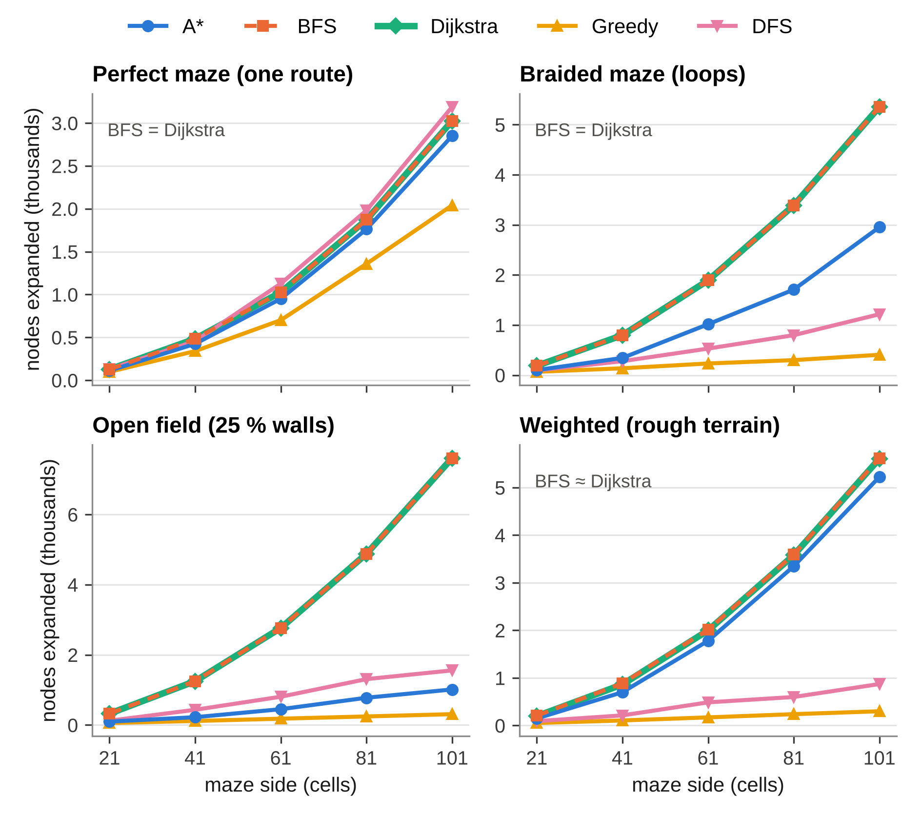
Figure 4.1 Nodes Expanded by Maze Size and Type (Mean of 20 Mazes)
Three patterns stand out. First, a perfect maze has only one route, so every algorithm returns it and the algorithms differ only in effort; even there A* expanded 7 % fewer cells than BFS (951 against 1,027), because the walls force the route far from the straight line and the heuristic helps little. Second, in mazes with several routes the heuristic pays off: on open fields A* expanded 451 cells against 2,766 for BFS and Dijkstra’s algorithm — 84 % fewer — and the saving grows with size, to 87 % at 101 × 101. Third, the cheap strategies are not reliable: DFS expanded few cells but its paths on 61 × 61 open fields cost 4.4 times the optimum, and Greedy Best-First Search, the cheapest of all in nodes, returned an optimal path in none of the 20 braided, open or weighted 61 × 61 mazes, at 19–44 % above the optimal cost (Figure 4.2).
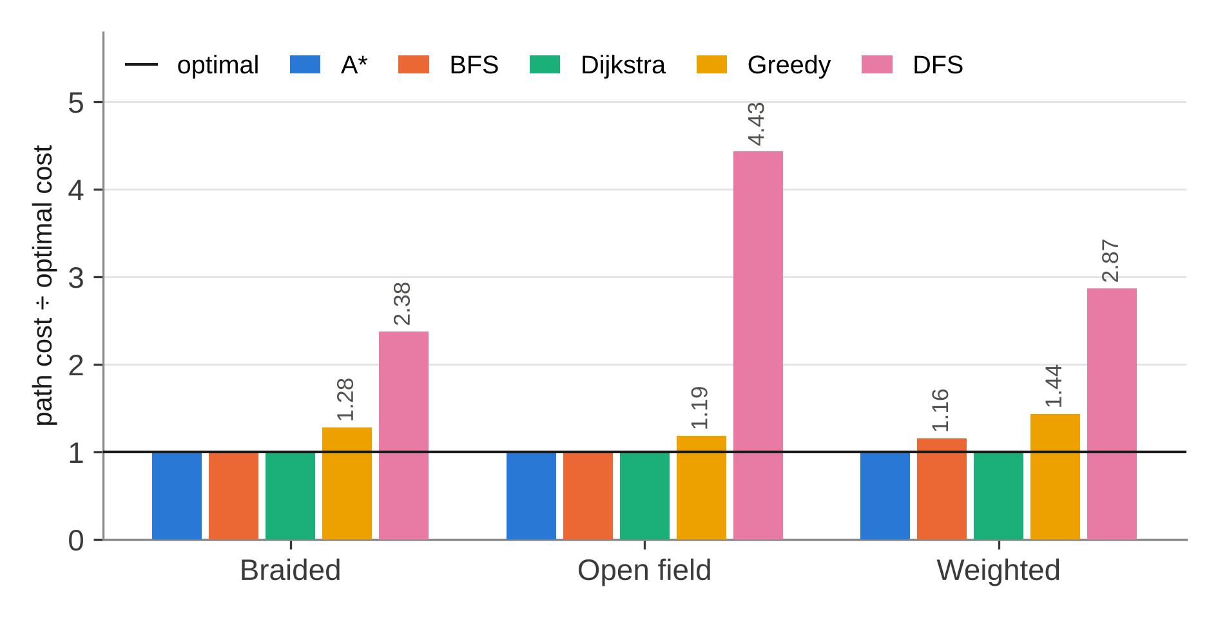
Figure 4.2 Path Cost Relative to the Optimal Cost on 61 × 61 Mazes
Rough terrain separates moves from cost. On weighted mazes BFS minimises the number of moves, not their cost, and its paths were 16 % costlier than optimal at 61 × 61, where it was optimal in none of the 20 mazes. Dijkstra’s algorithm and A* both returned the optimal cost; A* expanded 11 % fewer cells, a smaller saving than on open fields, because the Manhattan heuristic assumes that every remaining cell costs 1 and so underestimates more where rough cells are common.
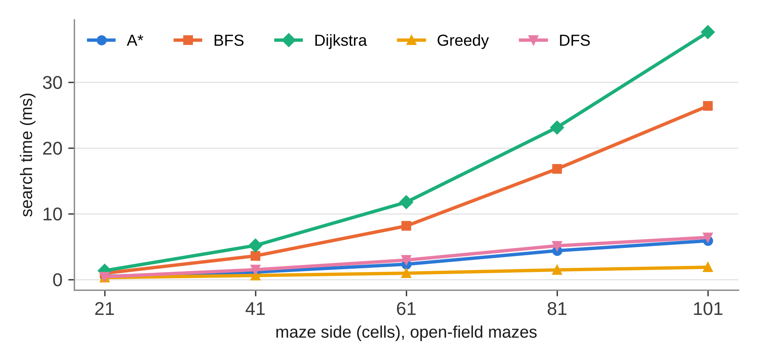
Figure 4.3 Search Time by Maze Size on Open-Field Mazes
Time follows the number of nodes expanded, but not exactly (Figure 4.3). Each A* expansion costs more than a BFS expansion because of the heap and the heuristic, so on perfect mazes A* (4.32 ms) was slower than BFS (3.48 ms) at 61 × 61 despite expanding fewer cells. On open fields, where it expands far fewer, it was 3.5 times faster than BFS (2.30 ms against 8.12 ms) and 5.1 times faster than Dijkstra’s algorithm.

4.2.2.3 Heuristic Comparison
Table 4.4 and Figure 4.4 compare three heuristics for A*. All three returned the same optimal costs, as admissibility guarantees. The zero heuristic turns A* into Dijkstra’s algorithm. The Euclidean distance, which is admissible but weaker than the Manhattan distance on a four-connected grid, saved 24 % of the expansions on braided mazes and 15 % on open fields. The Manhattan distance, which is exact on an open grid without obstacles, saved 46 % and 84 % respectively and was the fastest in both families.
Table 4.4 A* with Three Heuristics on 61 × 61 Mazes (Mean of 20 Mazes)
Heuristic | Braided: nodes | Braided: time (ms) | Open field: nodes | Open field: time (ms)
Zero (h = 0) | 1,892 | 9.84 | 2,766 | 12.73
Euclidean | 1,437 | 6.68 | 2,349 | 12.27
Manhattan | 1,016 | 4.77 | 451 | 2.60

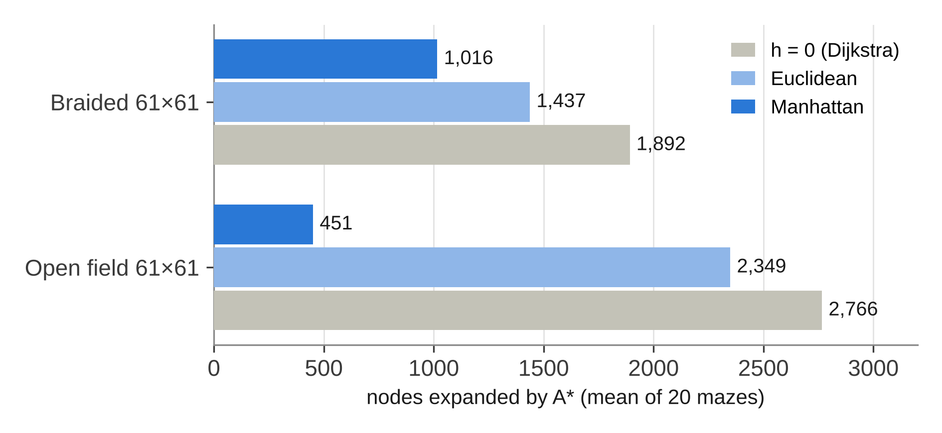
Figure 4.4 Nodes Expanded by A* with Three Heuristics

4.2.2.4 Navigation in Dynamic Mazes
Table 4.5 and Figure 4.5 summarise E3. A fixed plan failed whenever the change touched its route: in every door scenario, after a mean of 21 moves on 21 × 21 and 39 on 31 × 31, and in 13 of the 20 runs of each random-wall scenario — 66 failures in 80 runs. Re-planning A* reached the goal in all 80 runs, usually after a single re-plan.
Table 4.5 Fixed Plan and Re-planning A* in Dynamic Mazes (20 Mazes per Scenario, Sensing Range 1)
Scenario | New walls | Fixed plan reaches G | Re-planning reaches G | Detour: mean (median) | Runs at optimal cost | Re-plans: mean (max) | Nodes: re-plan / oracle
21 × 21, door | 1 | 0 / 20 | 20 / 20 | 23 % (14 %) | 3 / 20 | 1.00 (1) | 187 / 112
21 × 21, walls | 7 | 7 / 20 | 20 / 20 | 23 % (5 %) | 9 / 20 | 1.10 (4) | 204 / 108
31 × 31, door | 1 | 0 / 20 | 20 / 20 | 18 % (7 %) | 5 / 20 | 1.00 (1) | 389 / 264
31 × 31, walls | 10 | 7 / 20 | 20 / 20 | 12 % (5 %) | 8 / 20 | 0.95 (3) | 365 / 234

Re-planning paid for the change in two ways. First, its route cost a mean of 12–23 % more than the optimal cost of the changed maze, with medians of 5–14 %, because an agent that senses only its four neighbours learns of a new wall only when it is next to it and must then walk back to a junction. The detour was small when the wall was met close to a junction and large when it closed the far end of a long corridor, which explains the spread in Figure 4.5, up to 169 % in one 21 × 21 run; only 25 of the 80 runs ended at the optimal cost. Second, it searched more: all its plans together expanded 1.5–1.9 times as many cells as a single A* search on the changed maze, because every re-plan starts from scratch.
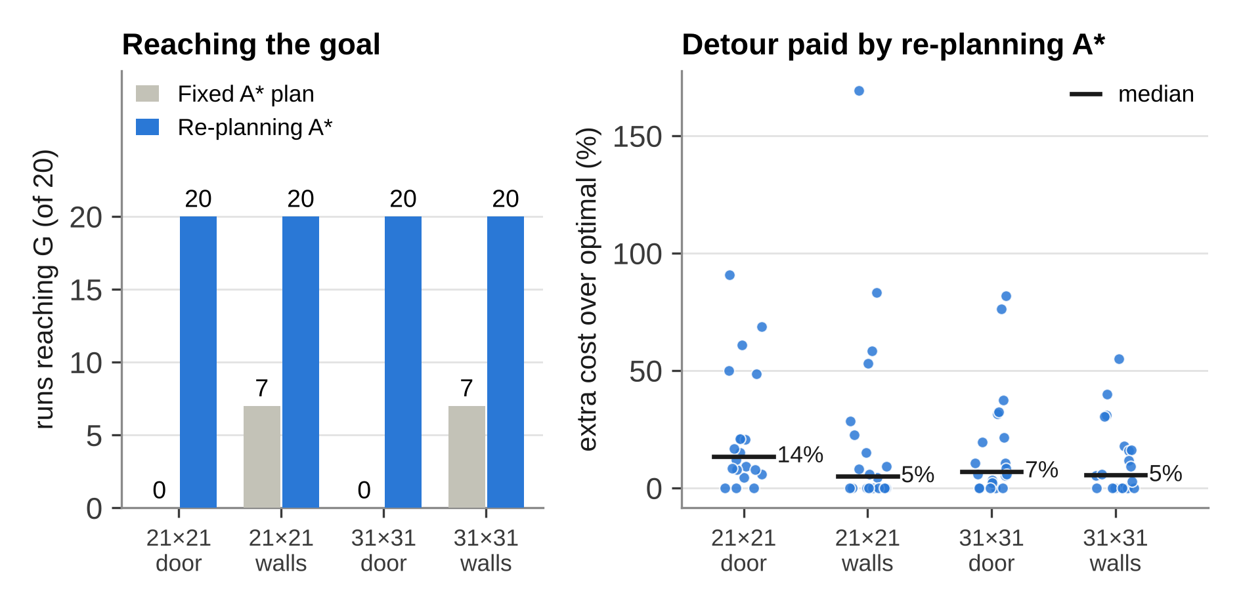
Figure 4.5 Fixed Plan and Re-planning A* after the Maze Changes

4.2.2.5 Sensing Range and Number of New Walls
E4 asks how much of that detour is caused by the agent’s short sight. On 31 × 31 braided mazes three cells of the planned route were closed and further random walls added up to 4, 8, 16 or 32 new walls, and the agent was run with sensing ranges of 1, 3 and 5 cells (Table 4.6 and Figure 4.6). It reached the goal in all 240 runs, while the fixed plan, whose route was always cut, failed in every one.
Table 4.6 Re-planning A* by Number of New Walls and Sensing Range r (31 × 31, 20 Mazes per Cell)
New walls | Detour, r = 1: mean (median) | Detour, r = 3: mean (median) | Detour, r = 5: mean (median) | Re-plans, r = 1 | Re-plans, r = 3 | Re-plans, r = 5
4 | 31 % (30 %) | 21 % (15 %) | 16 % (12 %) | 2.20 | 2.25 | 2.25
8 | 44 % (32 %) | 34 % (23 %) | 24 % (12 %) | 2.65 | 2.50 | 2.30
16 | 60 % (38 %) | 35 % (22 %) | 27 % (18 %) | 3.70 | 3.25 | 3.15
32 | 44 % (41 %) | 39 % (37 %) | 27 % (19 %) | 4.80 | 4.75 | 4.45

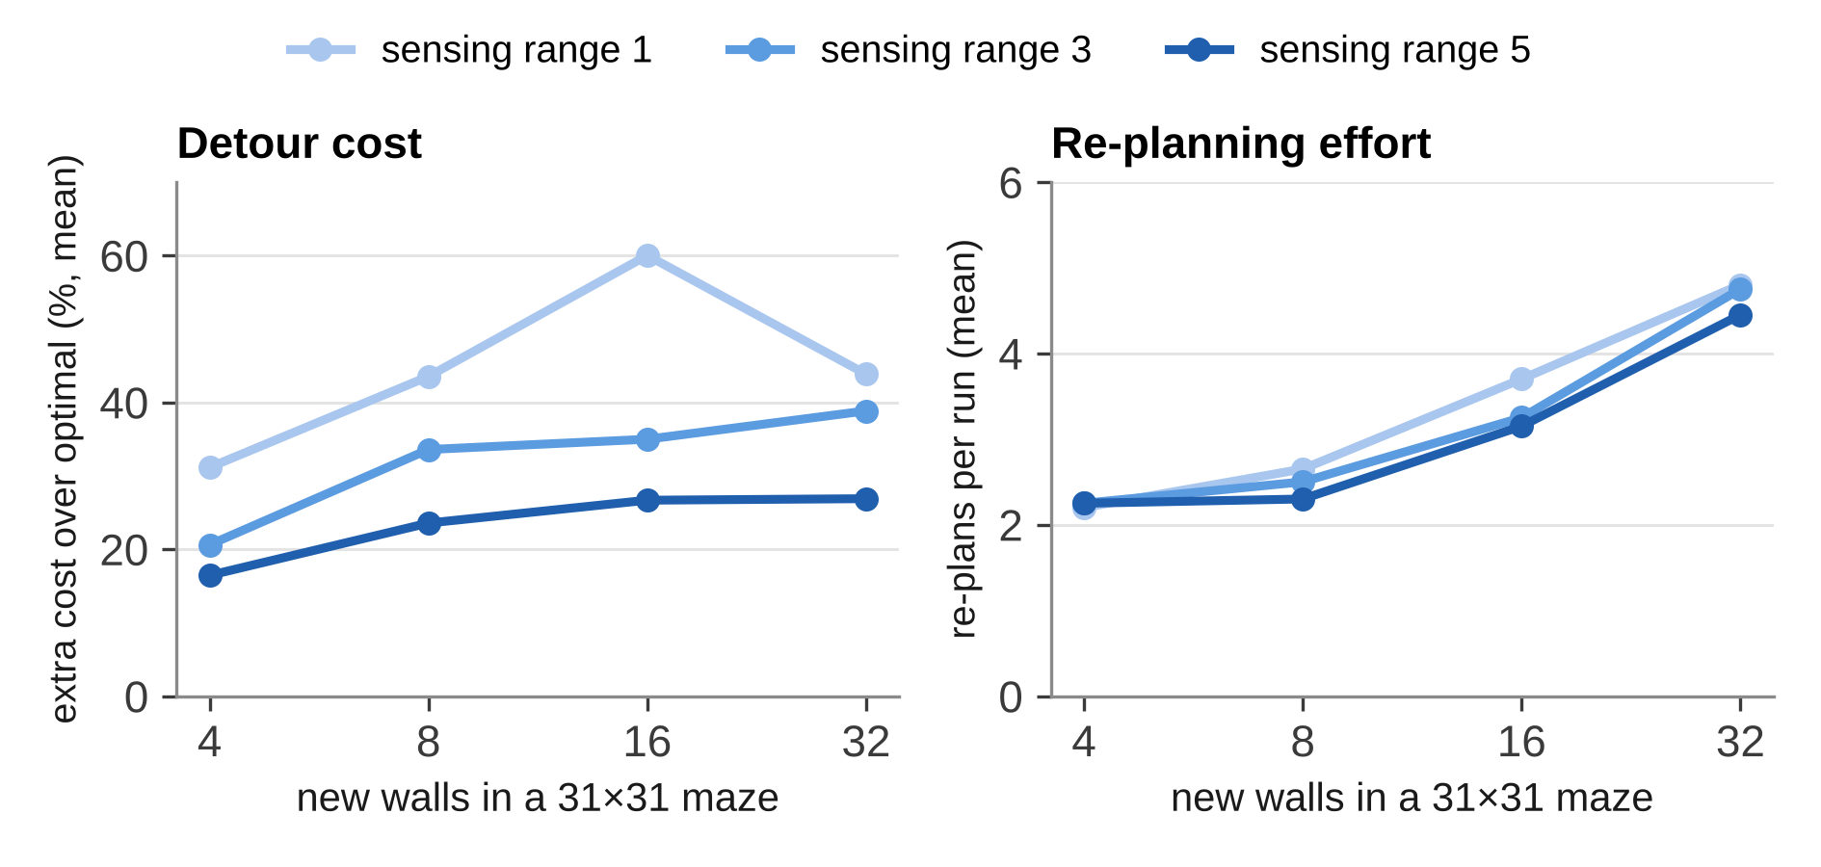
Figure 4.6 Detour Cost and Re-planning Effort by Sensing Range
The sensing range had the larger effect on the detour. With four new walls the mean extra cost fell from 31 % with r = 1 to 21 % with r = 3 and 16 % with r = 5, and with sixteen walls from 60 % to 35 % and 27 %; over all four wall counts, a range of five cells instead of one cut the mean detour by 39–56 %. A longer range lets the agent see a closed corridor before it enters it, so it turns at the junction instead of at the wall. The means are sensitive to a few long detours — with r = 1 the mean for 16 walls exceeds that for 32 because of one run with a 266 % detour — but the medians rise steadily with the number of walls, from 30 % to 41 % for r = 1.
The number of new walls had the larger effect on the effort. The mean number of re-plans rose from about 2.2 with four walls to 4.5–4.8 with thirty-two, and the cells expanded by all plans together from 544–571 to 940–988. The sensing range changed the effort by at most 11 %, because a wider view finds the same walls earlier rather than finding more of them. In this setting, sensing farther costs almost nothing in computation and roughly halves the distance wasted on a change.

4.2.2.6 Working Prototype
Figures 4.7 to 4.12 show the working prototype. Each screenshot was rendered by the application itself at its full window size of 1360 × 860 pixels.
Figure 4.7 shows A* on a 31 × 31 weighted maze. Explored cells are shaded blue, rough terrain is sand-coloured, and the orange path bends around patches of rough terrain where a detour is cheaper than crossing them. The panel reports a path of 82 moves at the optimal cost of 182 after 310 expansions in 1.10 ms.
Figure 4.8 captures the animation of BFS on a 31 × 31 braided maze part-way through: 214 of its 476 expansions are done, the earliest cells are the palest, and the explored region grows evenly in every direction from the start, whether or not it leads towards the goal.
Figure 4.9 is the comparison view on the same braided maze. BFS expands 476 cells to find the optimal cost of 76; DFS finds a path of cost 94 after 103 expansions; Greedy search expands only 92 cells, but its path costs 80; and A* expands 290 cells and returns the optimal 76.
Figure 4.10 shows navigation on that maze after one cell of the planned route (the red crossed cell) has been closed. The fixed plan, drawn as a dashed grey line, is blocked after 57 moves; the re-planning agent senses the wall, re-plans once and reaches the goal along the purple route at a cost of 78, against an optimal 76 on the changed maze.
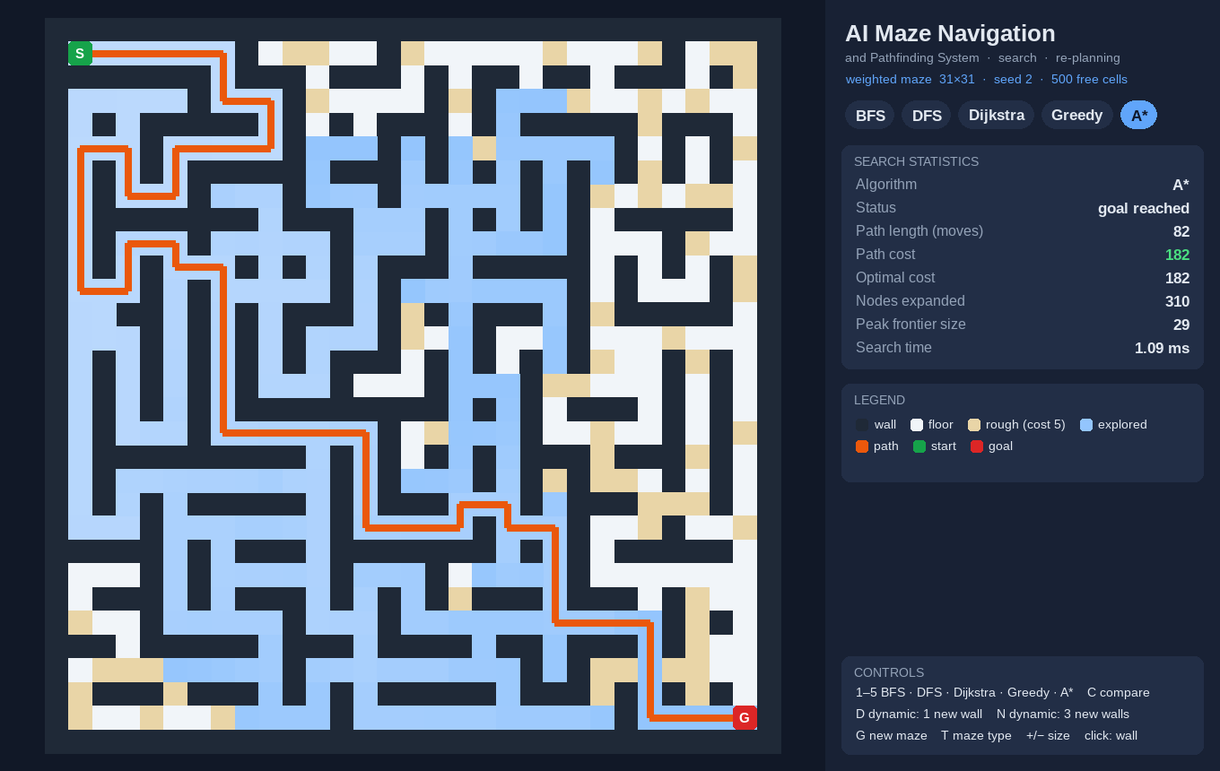
Figure 4.7 Prototype – A* on a Weighted 31 × 31 Maze
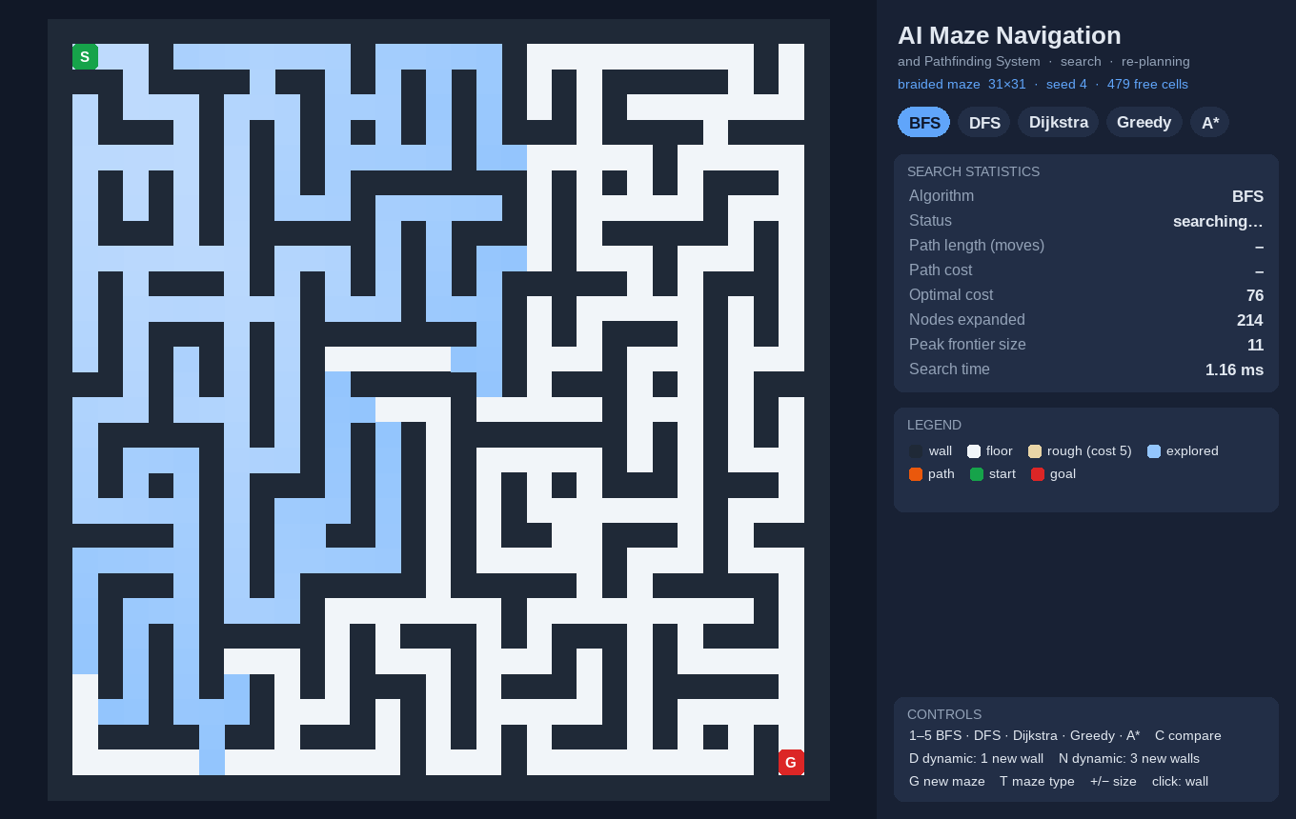
Figure 4.8 Prototype – Breadth-First Search Part-Way Through
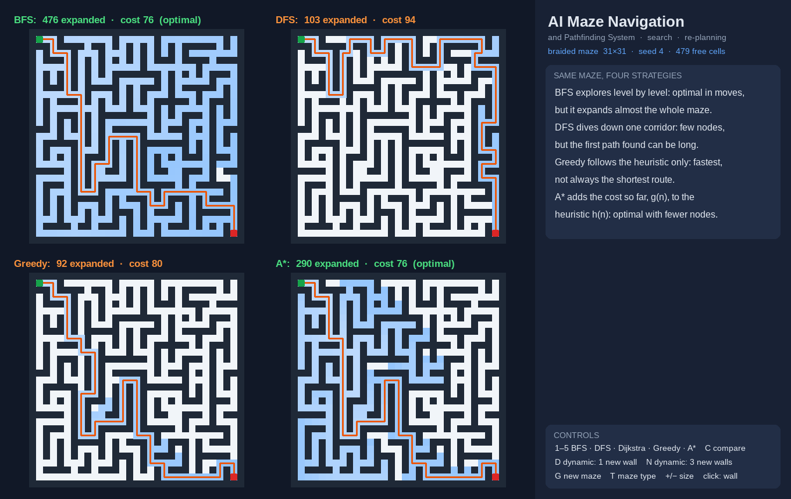
Figure 4.9 Prototype – Four Algorithms on the Same Maze
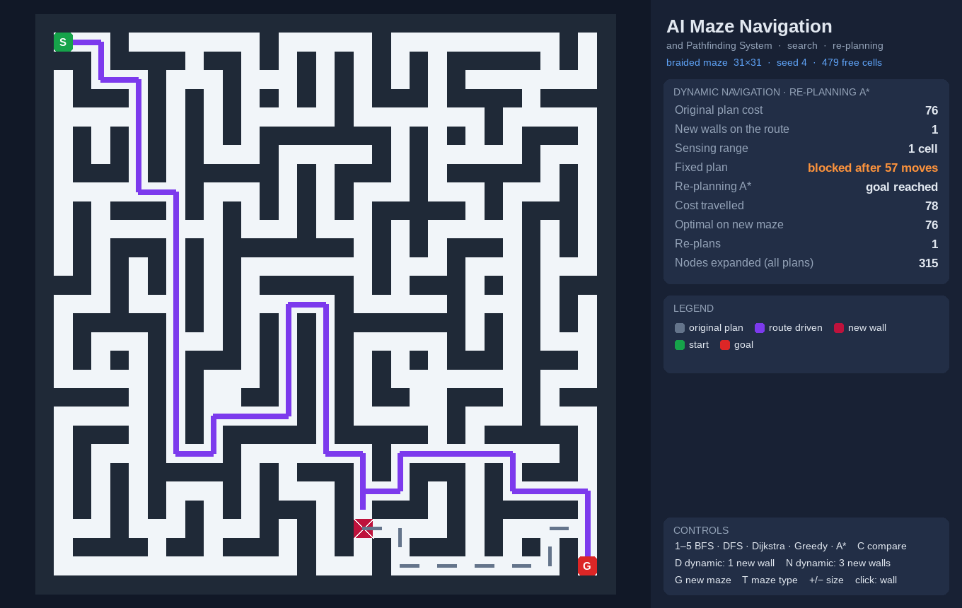
Figure 4.10 Prototype – Re-planning A* after One New Wall
Figures 4.11 and 4.12 show a harder case on another 31 × 31 braided maze, in which three cells of the planned route are closed. With a sensing range of one cell (Figure 4.11) the agent walks up to each new wall before turning back, re-plans three times and travels a cost of 126 against an optimal 82. With a range of five cells (Figure 4.12) it sees the walls earlier, turns back sooner and travels 104, with the same three re-plans and almost the same search effort (298 nodes against 297).
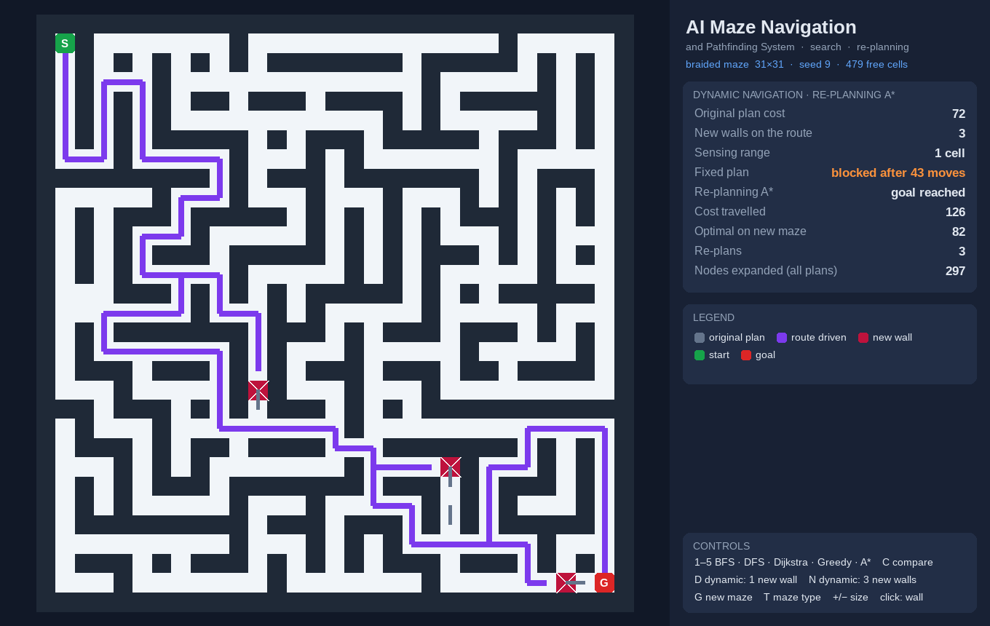
Figure 4.11 Prototype – Three New Walls, Sensing Range 1
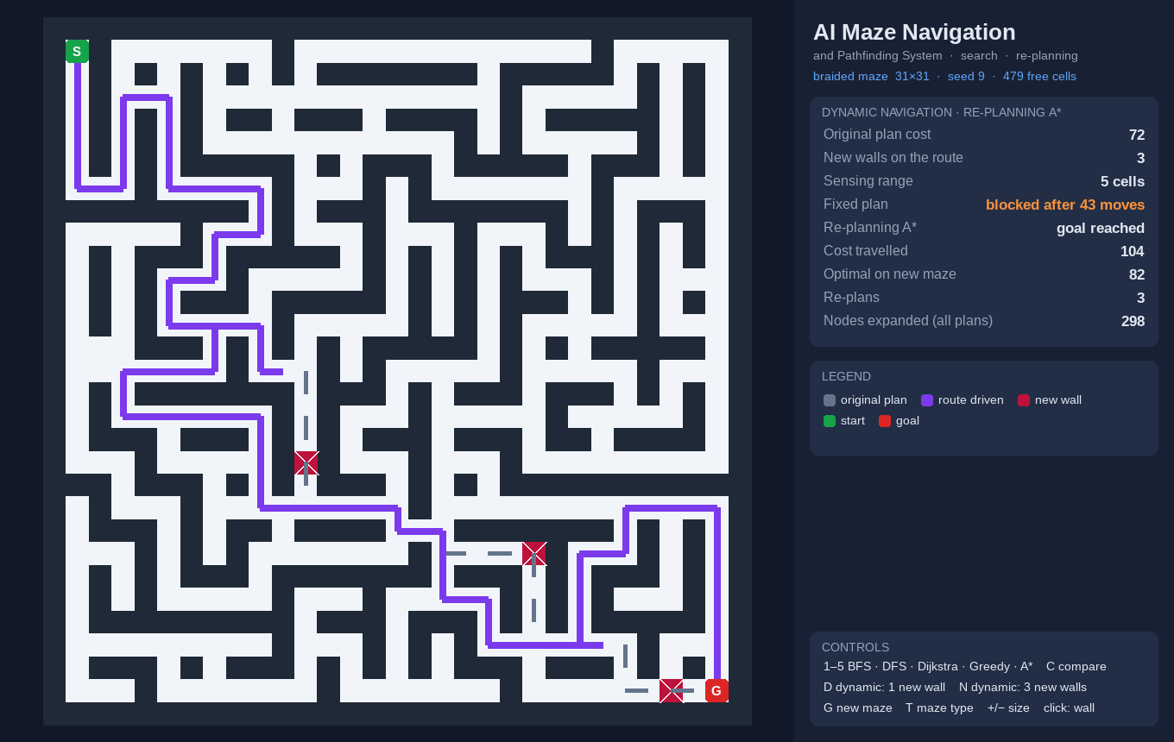
Figure 4.12 Prototype – Three New Walls, Sensing Range 5

4.2.2.7 Limitations Observed
- The Manhattan heuristic underestimates on rough terrain, so A* saves only about 11 % of the expansions on weighted mazes.
- Re-planning A* plans from scratch after every change and expanded 1.5–1.9 times the cells of a single search; incremental algorithms such as D* Lite would reuse the earlier work.
- With a sensing range of one cell a wall is discovered only on arrival, which explains the mean detours of 12–23 % in E3; a longer range helps, but the agent still cannot see round corners.
- The model assumes that walls only appear: cells that open, moving obstacles and several agents are not handled.
- Python timings include interpreter overhead and are meaningful only for comparing the algorithms with one another.
- The SHA-256 digest detects accidental or careless changes to a maze file, but someone who can rewrite both the file and its digest can forge them, and a file without a digest is accepted unless strict mode is used; a keyed digest is needed for that case.
CHAPTER 5

CONCLUSION

5.1 SUMMARY OF THE WORK
The project built an AI-based maze navigation and pathfinding system that plans routes with five search algorithms on one maze model and extends A* into an agent that navigates a maze which changes after planning. It was measured on 400 generated mazes for search, 80 dynamic scenarios and 240 runs of a sensing-range study. A* returned the optimal path in every maze and expanded up to 87 % fewer cells than Breadth-First Search on open fields, while Greedy Best-First Search and Depth-First Search, though cheaper in nodes, returned paths up to 53 % and 478 % costlier than optimal. On mazes with rough terrain, only Dijkstra’s algorithm and A* minimised the true cost, and the Manhattan heuristic saved the most expansions of the three heuristics tested.
When walls appeared after planning, a fixed plan failed in 66 of 80 runs, while re-planning A* reached the goal in all of them at a mean of 12–23 % above the optimal cost of the changed maze, after about one re-plan. The detour comes from short sight: raising the sensing range from one cell to five cut the mean detour by 39–56 % with almost no extra computation, whereas more new walls mainly raised the number of re-plans. The security analysis identified maze files as the main attack surface, and allow-list parsing, validation, SHA-256 integrity digests and resource limits address the threats found.
The results show that heuristic search gives optimal and efficient routes when the map is known, and that the same search, placed inside a loop of moving, sensing and re-planning, lets an agent reach its goal reliably when the maze changes under it — at a cost in distance that depends mostly on how far the agent can see.

5.2 FUTURE WORK
The work can be extended in the following directions:
- Incremental re-planning with D* Lite [6], so that the search effort spent before a change is reused after it.
- Jump Point Search [16], bidirectional search and weighted A* [12] for faster search on large grids, and evaluation on the standard benchmark maps [17].
- Eight-directional and any-angle movement with Theta* [7] for smoother, more realistic routes.
- Partial observability: an agent that starts with no map and explores with frontier-based exploration [15].
- Moving obstacles and several agents sharing one maze, coordinated with Conflict-Based Search [8].
- Building a maze from a photograph or scan of a drawn maze, and an explainability view that shows f, g and h for every cell.
- A keyed (HMAC) digest for saved mazes, hash-checked installation of dependencies, automated dependency auditing and fuzz testing of the maze parser.
- A web version of the visualiser for classroom use.

REFERENCES
[1] E. F. Moore, “The shortest path through a maze,” in Proc. International Symposium on the Theory of Switching, Cambridge, MA, USA: Harvard University Press, 1959, pp. 285–292.
[2] E. W. Dijkstra, “A note on two problems in connexion with graphs,” Numerische Mathematik, vol. 1, pp. 269–271, 1959.
[3] P. E. Hart, N. J. Nilsson, and B. Raphael, “A formal basis for the heuristic determination of minimum cost paths,” IEEE Transactions on Systems Science and Cybernetics, vol. 4, no. 2, pp. 100–107, 1968.
[4] S. Russell and P. Norvig, Artificial Intelligence: A Modern Approach, 4th ed. Hoboken, NJ, USA: Pearson, 2021.
[5] A. Stentz, “Optimal and efficient path planning for partially-known environments,” in Proc. IEEE International Conference on Robotics and Automation (ICRA), San Diego, CA, USA, 1994, pp. 3310–3317.
[6] S. Koenig and M. Likhachev, “D* Lite,” in Proc. 18th National Conference on Artificial Intelligence (AAAI), Edmonton, Canada, 2002, pp. 476–483.
[7] A. Nash, K. Daniel, S. Koenig, and A. Felner, “Theta*: Any-angle path planning on grids,” in Proc. 22nd AAAI Conference on Artificial Intelligence, Vancouver, Canada, 2007, pp. 1177–1183.
[8] G. Sharon, R. Stern, A. Felner, and N. R. Sturtevant, “Conflict-based search for optimal multi-agent pathfinding,” Artificial Intelligence, vol. 219, pp. 40–66, 2015.
[9] United Nations General Assembly, “Transforming our world: The 2030 Agenda for Sustainable Development,” Resolution A/RES/70/1, 2015.
[10] R. Tarjan, “Depth-first search and linear graph algorithms,” SIAM Journal on Computing, vol. 1, no. 2, pp. 146–160, 1972.
[11] J. Pearl, Heuristics: Intelligent Search Strategies for Computer Problem Solving. Reading, MA, USA: Addison-Wesley, 1984.
[12] I. Pohl, “Heuristic search viewed as path finding in a graph,” Artificial Intelligence, vol. 1, no. 3–4, pp. 193–204, 1970.
[13] R. E. Korf, “Depth-first iterative-deepening: An optimal admissible tree search,” Artificial Intelligence, vol. 27, no. 1, pp. 97–109, 1985.
[14] S. Koenig, M. Likhachev, and D. Furcy, “Lifelong Planning A*,” Artificial Intelligence, vol. 155, no. 1–2, pp. 93–146, 2004.
[15] B. Yamauchi, “A frontier-based approach for autonomous exploration,” in Proc. IEEE International Symposium on Computational Intelligence in Robotics and Automation (CIRA), Monterey, CA, USA, 1997, pp. 146–151.
[16] D. Harabor and A. Grastien, “Online graph pruning for pathfinding on grid maps,” in Proc. 25th AAAI Conference on Artificial Intelligence, San Francisco, CA, USA, 2011, pp. 1114–1119.
[17] N. R. Sturtevant, “Benchmarks for grid-based pathfinding,” IEEE Transactions on Computational Intelligence and AI in Games, vol. 4, no. 2, pp. 144–148, 2012.
[18] X. Xu, “PathFinding.js: A comprehensive path-finding library for grid based games,” GitHub repository. [Online]. Available: https://github.com/qiao/PathFinding.js
[19] S. Mishra and P. Bande, “Maze solving algorithms for micro mouse,” in Proc. IEEE International Conference on Signal Image Technology and Internet Based Systems (SITIS), Bali, Indonesia, 2008, pp. 86–93.
[20] OWASP Foundation, “Input Validation Cheat Sheet,” OWASP Cheat Sheet Series. [Online]. Available: https://cheatsheetseries.owasp.org/cheatsheets/Input_Validation_Cheat_Sheet.html
[21] National Institute of Standards and Technology, “Secure Hash Standard (SHS),” FIPS PUB 180-4, Gaithersburg, MD, USA, Aug. 2015.
[22] C. R. Harris et al., “Array programming with NumPy,” Nature, vol. 585, no. 7825, pp. 357–362, 2020.
[23] Pygame Community, “Pygame 2 documentation.” [Online]. Available: https://www.pygame.org/docs/
[24] J. D. Hunter, “Matplotlib: A 2D graphics environment,” Computing in Science & Engineering, vol. 9, no. 3, pp. 90–95, 2007.
[25] A. Shostack, Threat Modeling: Designing for Security. Indianapolis, IN, USA: Wiley, 2014.

APPENDIX

A.1 EXPERIMENT PARAMETERS
Table A.1 lists the parameters used in every experiment of Chapter 4. All of them can be changed in bench/run_experiments.py and in mazesolver/dynamic.py.
Table A.1 Parameters Used in the Experiments
Parameter | Value
Maze sizes (search, E1, E2) | 21, 41, 61, 81 and 101 cells per side
Maze sizes (navigation) | 21 and 31 cells per side (E3); 31 cells per side (E4)
Seeds | 0–19 in every experiment
Braid fraction | 0.12 for braided mazes; 0.20 for weighted mazes
Open-field obstacle density | 0.25
Rough terrain | 30 % of the floor of weighted mazes, entry cost 5
Heuristic (default) | Manhattan distance; ties in f broken towards the larger g
Dynamic scenarios (E3) | One cell of the A* route closed (door), or n/3 random walls (7 on 21 × 21, 10 on 31 × 31)
Sensing study (E4) | Three cells of the route closed plus random walls up to 4, 8, 16 or 32 new walls; sensing range 1, 3 or 5
Cells that may be closed on a route | p₂ to p_{k−2} of a route (p₀, …, p_{k}); never the first or last two cells
Sensing range (E3 and interface default) | 1 cell, that is, the four neighbours of the agent
Re-planning step limit | 10 × (number of free cells)
Random generators | random.Random(31·seed + n) in E3 and random.Random(97·seed + k) in E4
Interface limits | Maze side 11–101; new walls 1–10; sensing range 1–50
File limits | At most 201 × 201 cells; reading stops after 201 × 203 + 1 characters

A.2 DETAILED EXPERIMENTAL RESULTS
The tables below give the automated test suite (Table A.2) and the detailed results referred to in Chapter 4: nodes expanded (Table A.3), path cost relative to the optimum (Table A.4) and search time (Table A.5) for every maze family and size, and further details of the dynamic scenarios (Table A.6) and of the sensing study (Table A.7).
Table A.2 Automated Test Suite (24 Tests, All Passing)
No. | Test (class: method) | What it checks
1 | TestMaze: generators produce solvable valid mazes | All four generators give valid mazes that BFS can solve
2 | TestMaze: perfect maze is a tree | A perfect maze has exactly free cells − 1 passages (one route)
3 | TestMaze: braided maze has loops | A braided maze has more passages than a tree
4 | TestMaze: text round trip | Saving to text and parsing again keeps walls, costs, start and goal
5 | TestMaze: file round trip | Saving to a file and loading it again keeps the maze
6 | TestMaze: loader rejects bad characters | A file with a symbol outside # . ~ S G is rejected
7 | TestMaze: loader rejects ragged rows | Rows of different length are rejected
8 | TestMaze: loader needs one start and goal | Two starts, or no goal, are rejected
9 | TestMaze: loader rejects oversized maze | A maze wider than 201 cells is rejected
10 | TestMaze: start inside wall rejected | A start placed on a wall is rejected
11 | TestSearch: optimal algorithms agree on unweighted mazes | BFS, Dijkstra and A* return the same cost on unweighted mazes
12 | TestSearch: astar matches dijkstra on weighted mazes | A* returns the optimal cost on weighted mazes
13 | TestSearch: bfs is not cost optimal with rough terrain | BFS is costlier than optimal on some weighted mazes
14 | TestSearch: all paths are valid | Every path starts at S, ends at G and moves between free neighbours
15 | TestSearch: manhattan heuristic is admissible | h(n) never exceeds the true cost-to-go from any cell
16 | TestSearch: astar expands no more than dijkstra | A* expands no more cells than Dijkstra on open fields
17 | TestSearch: unreachable goal returns no path | Every algorithm reports failure when G cannot be reached
18 | TestMazeFileIntegrity: saved maze has matching digest | Saving writes a .sha256 digest that matches the maze on loading
19 | TestMazeFileIntegrity: tampered maze file is rejected | A maze changed after saving (one floor cell made a wall) is rejected
20 | TestMazeFileIntegrity: strict mode needs a digest | A file without a digest loads normally but is rejected in strict mode
21 | TestDynamic: static plan fails when route is closed | A fixed plan fails when its route is closed
22 | TestDynamic: replanning reaches goal after change | Re-planning A* reaches G after new walls, at no less than the optimal cost
23 | TestDynamic: static plan succeeds when nothing changes | A fixed plan reaches G at the optimal cost when the maze is unchanged
24 | TestDynamic: full sensing range gives the optimal cost | With a range covering the maze, the agent travels at the optimal cost

Table A.3 Nodes Expanded for Every Maze Family and Size (Mean of 20 Mazes)
Maze | Size | BFS | DFS | Dijkstra | Greedy | A*
Perfect | 21 | 127 | 132 | 127 | 98 | 112
 | 41 | 484 | 456 | 484 | 340 | 425
 | 61 | 1,027 | 1,128 | 1,027 | 701 | 951
 | 81 | 1,871 | 1,981 | 1,871 | 1,358 | 1,763
 | 101 | 3,026 | 3,188 | 3,026 | 2,040 | 2,850
Braided | 21 | 186 | 94 | 186 | 66 | 100
 | 41 | 798 | 278 | 798 | 137 | 344
 | 61 | 1,892 | 530 | 1,892 | 232 | 1,016
 | 81 | 3,389 | 798 | 3,389 | 300 | 1,707
 | 101 | 5,353 | 1,216 | 5,353 | 406 | 2,953
Open field | 21 | 325 | 123 | 325 | 58 | 98
 | 41 | 1,250 | 434 | 1,250 | 116 | 223
 | 61 | 2,766 | 806 | 2,766 | 181 | 451
 | 81 | 4,878 | 1,308 | 4,878 | 245 | 777
 | 101 | 7,606 | 1,557 | 7,606 | 310 | 1,013
Weighted | 21 | 206 | 92 | 197 | 53 | 149
 | 41 | 886 | 213 | 863 | 106 | 700
 | 61 | 2,013 | 487 | 2,000 | 171 | 1,780
 | 81 | 3,594 | 599 | 3,579 | 238 | 3,348
 | 101 | 5,619 | 872 | 5,607 | 299 | 5,223

Table A.4 Path Cost Relative to the Optimum (Cost ÷ Optimal, Mean of 20 Mazes)
Maze | Size | BFS | DFS | Dijkstra | Greedy | A*
Braided | 21 | 1.000 | 1.433 | 1.000 | 1.134 | 1.000
 | 41 | 1.000 | 2.019 | 1.000 | 1.245 | 1.000
 | 61 | 1.000 | 2.379 | 1.000 | 1.283 | 1.000
 | 81 | 1.000 | 2.862 | 1.000 | 1.283 | 1.000
 | 101 | 1.000 | 3.044 | 1.000 | 1.384 | 1.000
Open field | 21 | 1.000 | 2.345 | 1.000 | 1.167 | 1.000
 | 41 | 1.000 | 3.692 | 1.000 | 1.204 | 1.000
 | 61 | 1.000 | 4.434 | 1.000 | 1.189 | 1.000
 | 81 | 1.000 | 5.256 | 1.000 | 1.220 | 1.000
 | 101 | 1.000 | 5.776 | 1.000 | 1.228 | 1.000
Weighted | 21 | 1.107 | 1.964 | 1.000 | 1.254 | 1.000
 | 41 | 1.175 | 2.438 | 1.000 | 1.409 | 1.000
 | 61 | 1.160 | 2.872 | 1.000 | 1.438 | 1.000
 | 81 | 1.144 | 3.185 | 1.000 | 1.504 | 1.000
 | 101 | 1.168 | 3.604 | 1.000 | 1.527 | 1.000

On perfect mazes every algorithm returns the single route, so all ratios are 1.000 and are omitted.
Table A.5 Search Time in Milliseconds (Mean of 20 Mazes)
Maze | Size | BFS | DFS | Dijkstra | Greedy | A*
Perfect | 21 | 0.47 | 0.49 | 0.51 | 0.46 | 0.49
 | 41 | 1.48 | 1.70 | 2.09 | 1.40 | 1.72
 | 61 | 3.48 | 3.77 | 4.24 | 3.14 | 4.32
 | 81 | 5.47 | 7.34 | 7.69 | 5.93 | 7.37
 | 101 | 9.10 | 10.53 | 12.33 | 8.46 | 12.46
Braided | 21 | 0.57 | 0.31 | 0.77 | 0.32 | 0.42
 | 41 | 2.34 | 0.93 | 3.24 | 0.62 | 1.53
 | 61 | 5.41 | 1.72 | 7.85 | 1.07 | 4.53
 | 81 | 9.84 | 2.67 | 14.25 | 1.49 | 7.64
 | 101 | 14.72 | 3.84 | 21.65 | 1.78 | 12.54
Open field | 21 | 0.93 | 0.40 | 1.33 | 0.28 | 0.46
 | 41 | 3.57 | 1.47 | 5.16 | 0.59 | 1.12
 | 61 | 8.12 | 2.94 | 11.74 | 0.94 | 2.30
 | 81 | 16.81 | 5.11 | 23.11 | 1.44 | 4.36
 | 101 | 26.37 | 6.38 | 37.60 | 1.85 | 5.87
Weighted | 21 | 0.66 | 0.31 | 0.78 | 0.23 | 0.61
 | 41 | 2.45 | 0.67 | 3.32 | 0.48 | 2.85
 | 61 | 5.87 | 1.60 | 8.50 | 0.91 | 7.94
 | 81 | 11.12 | 2.00 | 15.38 | 1.17 | 15.66
 | 101 | 16.91 | 2.93 | 23.57 | 1.42 | 23.64

Table A.6 Dynamic Scenarios in Detail (E3, Mean of 20 Mazes)
Scenario | Optimal cost before the change | Optimal cost after the change | Cost travelled by re-planning A* | Fixed plan blocked after (moves) | Largest detour
21 × 21, door | 46.1 | 51.4 | 63.6 | 20.8 | 91 %
21 × 21, walls | 46.1 | 52.9 | 65.5 | 19.5 | 169 %
31 × 31, door | 71.8 | 77.4 | 91.6 | 38.7 | 82 %
31 × 31, walls | 71.8 | 78.2 | 88.0 | 34.0 | 55 %

The fixed-plan column is the mean over the runs in which the plan was blocked.
Table A.7 Sensing Study in Detail (E4, 31 × 31, 20 Mazes per Row)
New walls | Sensing range r | Re-planning reaches G | Runs at optimal cost | Largest detour | Nodes expanded (mean) | Moves (mean) | Optimal cost after the change
4 | 1 | 20 / 20 | 0 / 20 | 82 % | 544 | 108.9 | 83.4
 | 3 | 20 / 20 | 4 / 20 | 62 % | 559 | 100.2 | 83.4
 | 5 | 20 / 20 | 4 / 20 | 55 % | 571 | 96.7 | 83.4
8 | 1 | 20 / 20 | 1 / 20 | 128 % | 680 | 127.1 | 88.1
 | 3 | 20 / 20 | 1 / 20 | 111 % | 654 | 118.2 | 88.1
 | 5 | 20 / 20 | 3 / 20 | 78 % | 648 | 109.1 | 88.1
16 | 1 | 20 / 20 | 0 / 20 | 266 % | 918 | 148.2 | 94.7
 | 3 | 20 / 20 | 0 / 20 | 124 % | 827 | 127.4 | 94.7
 | 5 | 20 / 20 | 0 / 20 | 108 % | 818 | 119.8 | 94.7
32 | 1 | 20 / 20 | 0 / 20 | 98 % | 988 | 143.5 | 99.4
 | 3 | 20 / 20 | 1 / 20 | 129 % | 975 | 136.3 | 99.4
 | 5 | 20 / 20 | 1 / 20 | 109 % | 940 | 125.1 | 99.4

The fixed plan reached the goal in none of the 240 runs, because three cells of its route were always closed.

A.3 REPOSITORY STRUCTURE
Table A.8 lists the folders and files of the project and what each contains.
Table A.8 Repository Structure
Path | Contents
mazesolver/maze.py | Maze model, the four generators, the validated text loader and saver, SHA-256 digests
mazesolver/search.py | BFS, DFS and the best-first search used for Dijkstra, Greedy and A*; heuristics; distance map
mazesolver/dynamic.py | Closing cells of a route, adding random walls, the fixed plan, sensing and re-planning A*
app.py | Pygame interface; command-line options for loading files, dynamic scenarios and rendering screenshots
bench/run_experiments.py | Experiments E1, E2, E3 and E4
bench/plot_results.py | Charts of Chapter 4 from the raw results
results/ | Raw experiment results in JSON
tests/test_mazesolver.py | The 24 automated tests
requirements.txt | Exact versions of NumPy, Pygame and Matplotlib
README.md | Installation, controls, commands and security notes

A.4 SOURCE CODE – BEST-FIRST SEARCH AND A* (search.py)
def best_first(maze: Maze, start=None, goal=None,
heuristic="manhattan", w_g=1.0, w_h=1.0, name="A*")
-> SearchResult:
"""Generic best-first search with f(n) = w_g * g(n) +
w_h * h(n).

w_g=1, w_h=1 -> A*; w_g=1, w_h=0 -> Dijkstra (
uniform-cost); w_g=0, w_h=1 -> Greedy best-first.
Ties on f are broken in favour of the larger g (
deeper node), which reduces expansions.
"""
start, goal = start or maze.start, goal or maze.goal
h = HEURISTICS[heuristic] if isinstance(heuristic,
str) else heuristic
t0 = time.perf_counter()
res = SearchResult(name)
g = {start: 0}
parent = {start: None}
counter = 0
open_heap = [(w_h * h(start, goal), 0, counter,
start)]
closed = set()
while open_heap:
res.max_frontier = max(res.max_frontier, len(
open_heap))
f, neg_g, _, cell = heapq.heappop(open_heap)
if cell in closed:
continue
closed.add(cell)
res.expanded += 1
res.order.append(cell)
if cell == goal:
res.path = _path(parent, goal)
break
for nxt, step in maze.neighbours(cell):
if nxt in closed:
continue
ng = g[cell] + step
if ng < g.get(nxt, float("inf")):
g[nxt] = ng
parent[nxt] = cell
counter += 1
res.generated += 1
heapq.heappush(open_heap, (w_g * ng + w_h
* h(nxt, goal), -ng, counter, nxt))
res.cost = _cost(maze, res.path) if res.path else 0
res.time_ms = (time.perf_counter() - t0) * 1000
return res

def astar(maze, start=None, goal=None,
heuristic="manhattan"):
return best_first(maze, start, goal, heuristic, 1.0,
1.0, "A*")

def dijkstra(maze, start=None, goal=None):
return best_first(maze, start, goal, zero, 1.0, 0.0,
"Dijkstra")

def greedy(maze, start=None, goal=None,
heuristic="manhattan"):
return best_first(maze, start, goal, heuristic, 0.0,
1.0, "Greedy")

A.5 SOURCE CODE – SENSING AND RE-PLANNING A* (dynamic.py)
def sense(true: Maze, belief: Maze, pos, radius=1):
"""Copy every wall of ``true`` within Manhattan
distance ``radius`` of ``pos`` into ``belief``.

Returns True if the belief map changed."""
changed = False
r0, c0 = pos
for r in range(max(0, r0 - radius), min(true.rows, r0
+ radius + 1)):
span = radius - abs(r - r0)
for c in range(max(0, c0 - span), min(true.cols,
c0 + span + 1)):
if true.grid[r, c] == WALL and belief.grid[r,
c] != WALL:
belief.grid[r, c] = WALL
changed = True
return changed

def replanning_astar(known: Maze, true: Maze,
max_steps=None, sense_range=1):
"""Plan with A*, move, sense the cells in range, and
re-plan from the current cell when the plan is
blocked."""
belief = known.copy()
pos = belief.start
trace, cost, replans = [pos], 0, 0
plan = astar(belief, pos)
expanded = plan.expanded
max_steps = max_steps or 10 * true.free_cells()
steps = 0
while pos != true.goal and steps < max_steps:
# sense the cells in range and record any wall
that was not on the map
changed = sense(true, belief, pos, sense_range)
if changed and any(belief.grid[cell] == WALL for
cell in plan.path[plan.path.index(pos):]):
plan = astar(belief, pos)
replans += 1
expanded += plan.expanded
if not plan.found:
return RunResult(False, cost, steps,
replans, expanded, trace)
nxt = plan.path[plan.path.index(pos) + 1]
pos = nxt
cost += int(true.cost[nxt])
steps += 1
trace.append(pos)
return RunResult(pos == true.goal, cost, steps,
replans, expanded, trace)

A.6 SOURCE CODE – VALIDATED MAZE LOADER AND DIGESTS (maze.py)
def from_text(text: str, name: str = "maze") -> Maze:
"""Parse a maze from text ('#' wall, '.' floor, '~'
rough floor, 'S' start, 'G' goal).

Input is treated as untrusted: size, characters,
shape and the start/goal markers are all checked.
"""
if len(text) > (MAX_SIDE + 2) * MAX_SIDE:
raise ValueError("maze file is too large")
lines = [ln.rstrip("\r") for ln in text.strip(
"\n").split("\n")]
if not lines or any(len(ln) != len(lines[0]) for ln
in lines):
raise ValueError("maze rows must all have the
same length")
bad = set("".join(lines)) - ALLOWED
if bad:
raise ValueError(f"unexpected characters in maze:
{''.join(sorted(bad))!r}")
flat = "".join(lines)
if flat.count("S") != 1 or flat.count("G") != 1:
raise ValueError("maze needs exactly one S and
one G")
grid = np.array([[1 if ch == "#" else 0 for ch in ln]
for ln in lines], dtype=np.uint8)
cost = np.array([[ROUGH_COST if ch == "~" else 1 for
ch in ln] for ln in lines], dtype=np.int16)
start = goal = None
for r, ln in enumerate(lines):
for c, ch in enumerate(ln):
if ch == "S":
start = (r, c)
elif ch == "G":
goal = (r, c)
return Maze(grid, start, goal, cost, name)

def digest(text: str) -> str:
"""SHA-256 digest of a maze file's text, stored next
to the file as ``<file>.sha256``."""
return hashlib.sha256(text.encode("utf-8")).hexdigest(
)

def load(path: str, require_digest: bool = False) -> Maze:
"""Load and validate a maze file.

If ``<path>.sha256`` exists the file must match it (a
changed file is rejected); with
``require_digest=True`` a file without a digest is
rejected too.
"""
with open(path, "r", encoding="utf-8") as f:
text = f.read(MAX_SIDE * (MAX_SIDE + 2) + 1)
side = path + ".sha256"
if os.path.exists(side):
with open(side, "r", encoding="ascii",
errors="replace") as f:
want = f.read(64).strip()
if not hmac.compare_digest(want, digest(text)):
raise ValueError("SHA-256 digest does not
match %s (the file changed after it was
saved)"
% os.path.basename(side))
elif require_digest:
raise ValueError("no SHA-256 digest (%s) next to
the maze file" % os.path.basename(side))
return from_text(text, name=path)

def save(maze: Maze, path: str):
"""Write the maze as text and its SHA-256 digest to
``<path>.sha256``."""
text = maze.to_text()
with open(path, "w", encoding="utf-8", newline="\n")
as f:
f.write(text)
with open(path + ".sha256", "w", encoding="ascii") as
f:
f.write(digest(text) + "\n")

A.7 SOURCE CODE – CHANGING THE MAZE AND THE FIXED PLAN (dynamic.py)
def close_on_route(maze: Maze, path, rng: random.Random,
count=1):
"""Return a copy of ``maze`` with ``count`` cells of
``path`` turned into walls, keeping the goal
reachable."""
m = maze.copy()
candidates = [cell for cell in path[2:-2]]
rng.shuffle(candidates)
placed = []
for cell in candidates:
if len(placed) == count:
break
m.grid[cell] = WALL
if bfs(m).found:
placed.append(cell)
else:
m.grid[cell] = 0
return m, placed

def random_walls(maze: Maze, rng: random.Random, count=5,
avoid=()):
"""Return a copy of ``maze`` with ``count`` random
free cells turned into walls, keeping the goal
reachable."""
m = maze.copy()
free = [(r, c) for r in range(m.rows) for c in range(
m.cols)
if m.grid[r, c] == 0 and (r, c) not in (
m.start, m.goal) and (r, c) not in avoid]
rng.shuffle(free)
placed = []
for cell in free:
if len(placed) == count:
break
m.grid[cell] = WALL
if bfs(m).found:
placed.append(cell)
else:
m.grid[cell] = 0
return m, placed

def follow_static_plan(known: Maze, true: Maze):
"""Execute the A* plan computed on ``known`` without
ever re-planning."""
plan = astar(known)
cost = 0
for cell, nxt in zip(plan.path, plan.path[1:]):
if true.grid[nxt] == WALL:
idx = plan.path.index(cell)
return RunResult(False, cost, idx, 0,
plan.expanded, plan.path[: idx + 1])
cost += int(true.cost[nxt])
return RunResult(True, cost, plan.length, 0,
plan.expanded, plan.path)

A.8 REPRODUCING THE RESULTS
The following commands install the dependencies, run the tests, repeat the four experiments (under a minute on a laptop), redraw the charts and start the interface.
python -m venv .venv
source .venv/bin/activate # Windows:
.venv\Scripts\activate
pip install -r requirements.txt
python -m unittest discover -s tests -v
python bench/run_experiments.py # writes results/*.json
python bench/plot_results.py # writes figures/*.png
python app.py # interactive window
python app.py --load maze.txt # open a saved maze (
add --strict to require its digest)
python app.py --mode dynamic --walls 3 --sense 5

